LANDSCAPES AND ENVIRONMENT
ENVIRONMENTAL ENVIRONMENT :
The Podlasie Voivodship has to a large extent preserved in a natural state, with high and unique values ​​in the country and Europe, the natural environment - mainly large complexes of natural forests and lakes and swampy valleys of rivers with valuable and diverse vegetation. These areas are characterized by the highest degree of naturalness of vegetation and the highest biodiversity.
The high biotic potential of the region is demonstrated by the richness of fauna and flora as well as the presence of numerous protected and rare species of plants and animals, as well as a significant number of areas defined by the status of protection.
The high degree of naturalness of the voivodship also results from the land use structure itself, in which areas recognized as biologically active, ie meadows, pastures, forests, shelters, water and wastelands dominate.
In addition, the Podlaskie Voivodeship is characterized by relatively clean atmospheric air and low environmental pollution.
The area of ​​the Podlaskie Voivodship, due to the high values ​​of the natural environment, is part of the functional macro-region "Green Lungs of Poland".
Soil conditions:
In the Podlaskie Voivodship there are soils developed from post-glacial sands and gravels, clays and dusts as well as modern peat deposits, silts, alluvial and deluvial deposits and aeolian sands. The largest proportion is occupied by soils made of sands and clays in the type of brown and podzolic soils, followed by black soil and bog soil.

Climatic conditions:
The main climate indicator is air temperature and precipitation. The average annual temperature in the Podlasie Voivodship is almost everywhere lower than 70C, and in the Suwałki region it reaches the value below 60C (map No. 11).
The average January temperature drops below - 40C, while the average temperature of the warmest month is 170C - 180C, which makes the annual temperature amplitude, which is a measure of the degree of continentalism, in the Podlasie province a few degrees higher than in the west and reaches 220C - 230C .
The sums of annual precipitation in the Podlasie Voivodship do not differ from the average values for the whole country (map No. 12). They range from 550 mm to 700 mm, showing dependence on the terrain surface.
The average number of days with rainfall varies from 170 to 190 during the year. The month with the lowest number of days with precipitation is May, and sometimes April (12-13 days), while the highest number of days with precipitation show November, December and January.
The first snow appears in the Podlasie Voivodship between October 26 and November 6, and the last one between April 16-26. Snow cover is on average from 76 to 96 days per year.
Days with a storm are a dozen or so a year, with the highest intensity falling from June to August, giving 3-5 days a month. The town with relatively frequent storms belongs to Białowieża (ca. 23 days a year), while a small number of them is Augustów (9 days a year). Days with fog can happen during the 45-47 years, mainly in late autumn and early winter.
The climatic distinction of the Podlasie voivodship is expressed by its relative continentalism, ie the length of winter, the relatively short pre-dawn period, the shortest growing season in Poland and the lowest annual average temperature (from 5.6 to 7 0C). These climate features make it relatively less favorable for agriculture.

The Green Lungs of Poland :
Apart from a foundation's promotional name, this term describes a functional area, the idea of which was formulated in the 1980s, which aims at integrating nature preservation with sustainable economic development in the most eco-friendly region of north-eastern Poland. The Green Lungs area initially incorporated five former voivodeships: Białostockie, Łomżyńskie, Olsztyńskie, Ostrołęckie and Suwalskie. Today, the area includes 55 counties with a total of 61,000 square km (19% of Poland's total landmass). There are numerous wildlife conservation entities here: 4 national parks, 13 landscape parks and 263 nature reserves - about 40% of the Green Lungs of Poland are under various forms of preservation.
Climate: Łomża
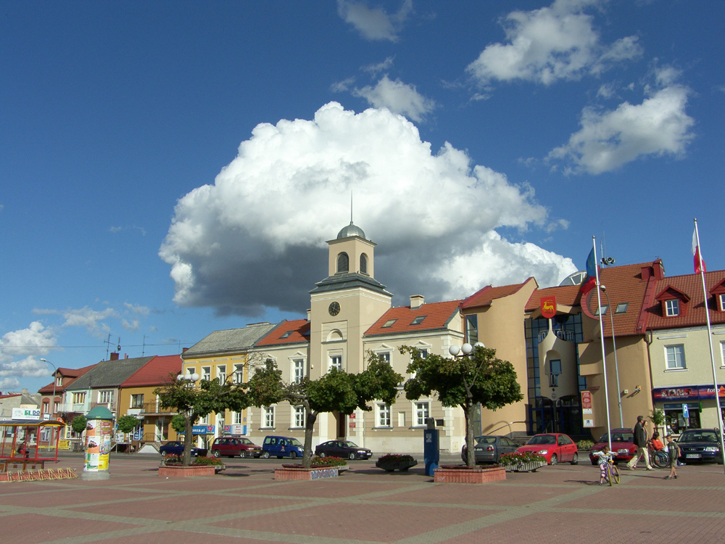
In this area, the climate is moderate cold. The rainfall in Łomża is significant, occurring even during dry months. The area is classified as Dfb by Köppen and Geiger. In this area, the average temperature is 7.0 ° C. In this area, the average annual rainfall is 567 mm.

Climate graph Łomża:
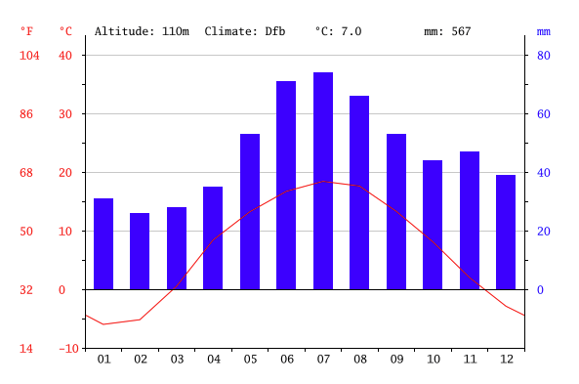
Precipitation is the lowest February, with an average rainfall of 26 mm. In July, the precipitation reaches its peak, with an average of 74 mm.
Temperature graph Łomża: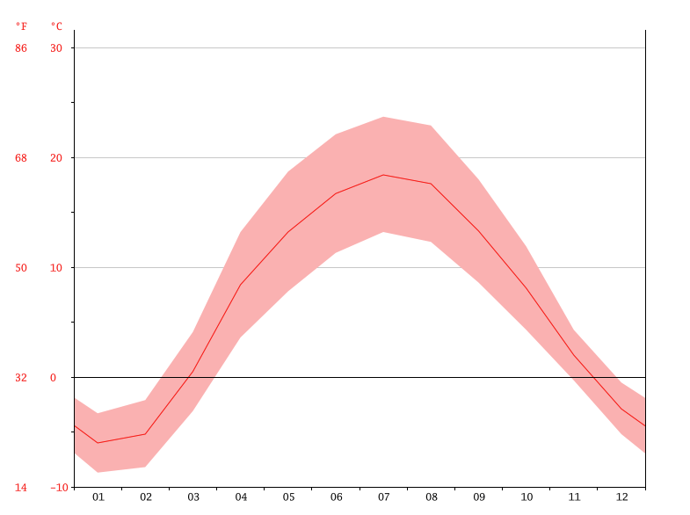
The average temperature of 18.4 ° C makes July the warmest month of the year. With an average of -6.0 ° C, January is the coldest month.

Climate table Łomża:
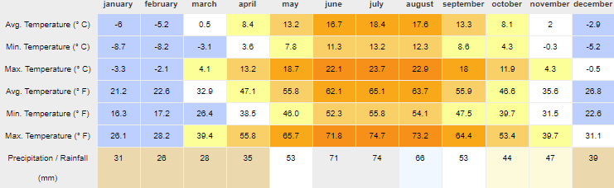
Between the driest month and the smallest month, there is a difference in the size of 48 mm of rainfall. Temperature fluctuations are 24.4 ° C.
Landscape Łomża :

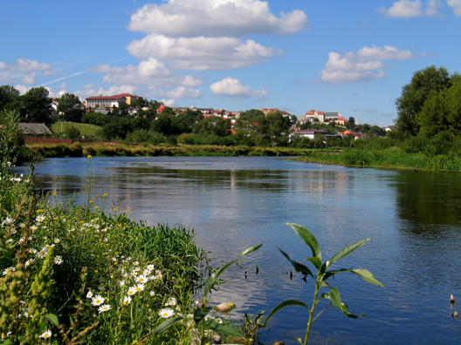
Panorame of Łomża and Narew river
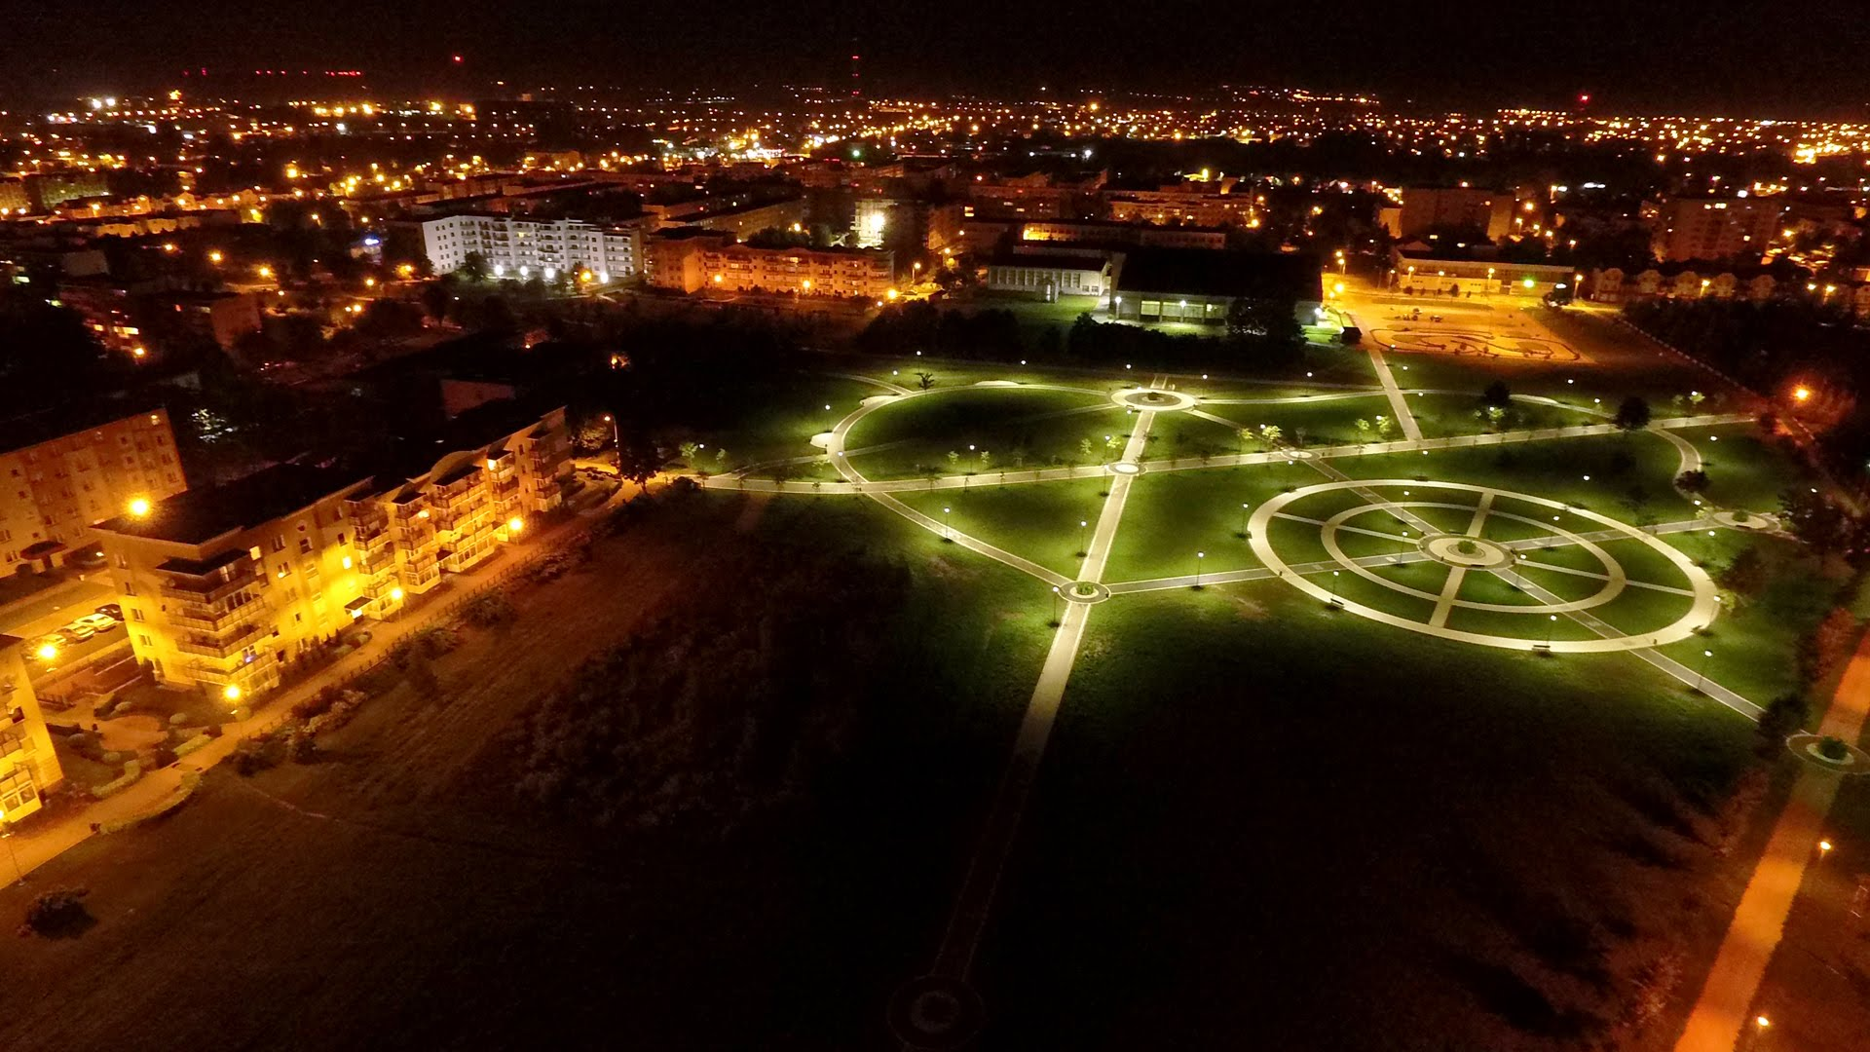
Park of John Paul II in Łomża
https://www.youtube.com/watch?v=CeKSv97b4dk
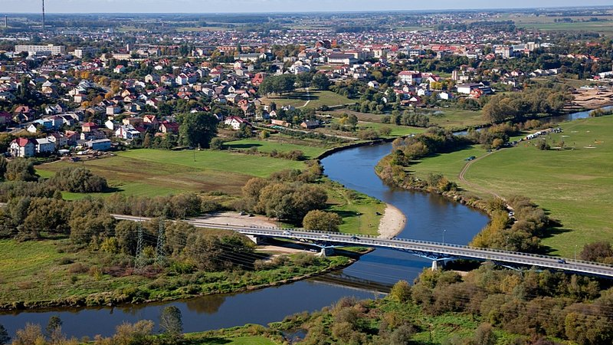
Bird's-eye view of Łomża

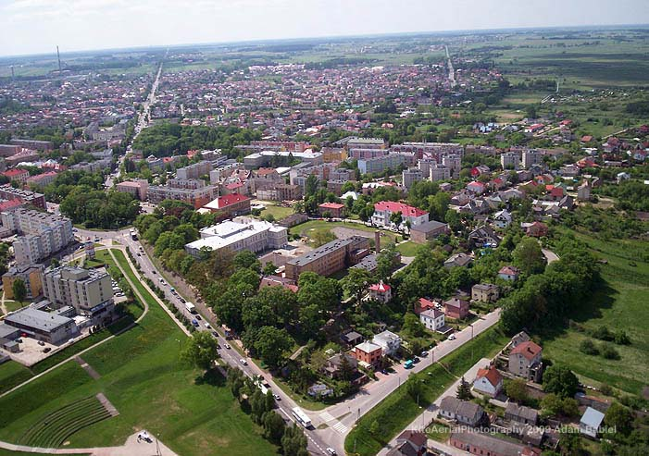
Bird's-eye view of Łomża
Sources:
http://spacer.um.lomza.pl/ ------ A virtual walk around Łomża
Travel guide by Rafał Zubkowicz
https://www.youtube.com/watch?v=Y1L-RgxnPeU
https://www.4lomza.pl/fotogaleria.php?id=67270
https://pl.climate-data.org/location/724/
http://sciaga.pl/tekst/6100-7-wojewodztwo_podlaskie
Patryk Nerowski i Kamil Łuba

