Number of inhabitants

Country (Poland) - 38 422 346 (30.06.2016) 5,17% of Europe
City (Łomża) – 62716 (30.06.2016) 5,28% of region
Region (Podlaskie) – 1187587 (30.06.2016) 3,13% of Poland

 | Number of inhibitians | Data | % of the population
Country(Poland) | 38 422 346 | 30.06.2016 | 5,17% (of Europe)
City(Łomża) | 62716 | 30.06.2016 | 5,28% (of region)
Region(Podlaskie) | 1187587 | 30.06.2016 | 3,13% (of Poland)

Evolution of the population since 2000

Year | Number of inhabitants
2000 | 65112
2001 | 65265
2002 | 63902
2003 | 63757
2004 | 63880
2005 | 63819
2006 | 63387
2007 | 63036
2008 | 63304
2009 | 63357
2010 | 63221
2011 | 63070
2012 | 62812
2013 | 62750
2014 | 62779
2015 | 62737
2016 | 62716

 | Births | Deaths | Birthrate
2000 | 641 | 379 | 262
2001 | 567 | 375 | 192
2002 | 558 | 360 | 198
2003 | 545 | 408 | 137
2004 | 546 | 397 | 149
2005 | 579 | 430 | 149
2006 | 535 | 451 | 84
2007 | 606 | 441 | 165
2008 | 593 | 465 | 128
2009 | 648 | 438 | 210
2010 | 635 | 460 | 175
2011 | 585 | 415 | 170
2012 | 552 | 480 | 72
2013 | 531 | 461 | 70
2014 | 589 | 431 | 158
2015 | 534 | 487 | 47
2016 | 570 | 479 | 91

Population pyramid in Łomża (2014)

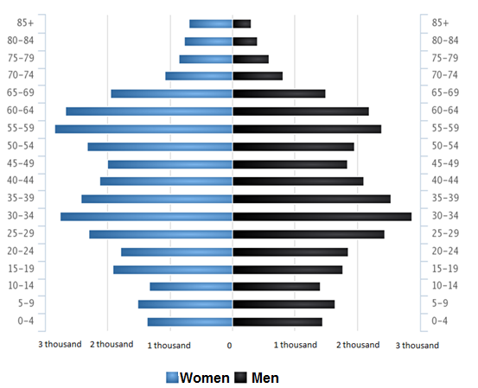

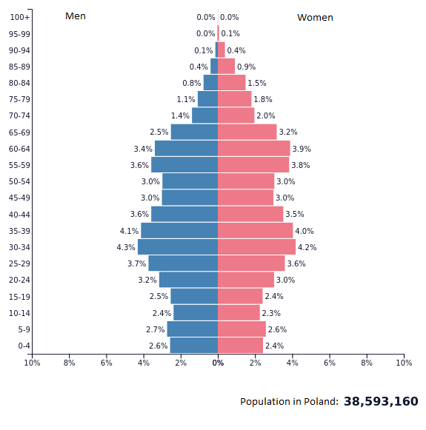
Pyramid of population in Poland (2014)

Median age

There are 38 427 000 people in Poland. The average life expectancy of a Polish resident is 38.2 years. A Polish woman lives on average for 40 years and a man of 36.5 years.
In Łomża lives 62 802 people. More than 52% of residents are women and more than 47 % are men. The average age of women is 42.5 years and the averange of men is 39.3 years. The average age of residents is 41 years old.

Fertility rate ( births per woman)

The natural increase in Poland is negative and amounts to -0.05%. In 2016 registered over 382 thousand births. Łomża has a positive natural increment of 91. Answer add to the natural increase of 1.5 per 1000 inhabitants of Łomża. In 2016, 570 children were born, including 48.1% of girls and 51.9% of boys.

Life expectancy
The average life expectancy is determined by many different economic indicators.
According to the latest data of the Central Statistical Office of 2016 in Poland, men lived on average 73.9 years and women 81.9 years. However, there is still a large discrepancy between the average life expectancy in individual voivodships. The Podlasie Voivodship is a place where, according to the Central Statistical Office, people live the longest.

H.D.I

Poland is on the 36th place in the ranking of highly developed countries.The social development index of Poland is 0.855. Compared to other countries, it is relatively high.
There are both small enterprises and large corporations operating in Poland. In the Łomża county as well as in Lomza itself, there are many enterprises that provide jobs for local residents. One of the largest companies are: Browar Łomża Sp. z o.o., Pepees S.A., Okręgowa Spółdzielnia Mleczarska in Piątnica, Sonarol Sp.j. Najda.

Links:

http://stat.gov.pl/spisy-powszechne/nsp-2011/nsp-2011-wyniki/ludnosc-stan-i-struktura-demograficzno-spoleczna-nsp-2011,16,1.html
http://hdr.undp.org/en/data
http://hdr.undp.org/en/reports/
http://www.polskawliczbach.pl/Lomza
http://www.polskawliczbach.pl/podlaskie

