Transportation in Łomża
Road transport:

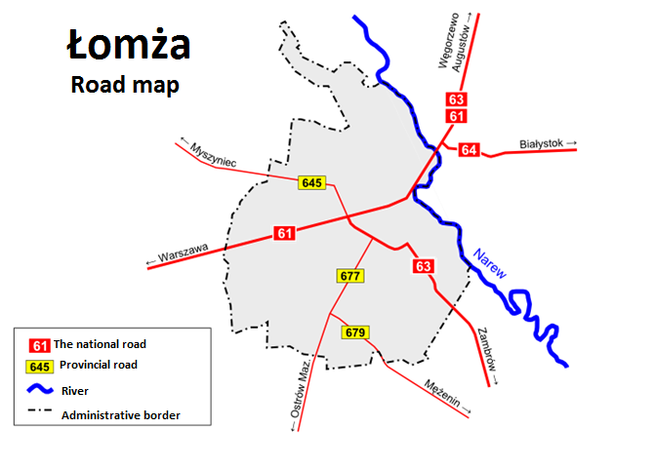
Bus transport: Łomża has 13 bus lines, managed by MPK Łomża, with a total length of 239km. Out of the thirteen bus lines operated by the Municipal Transport Company [MPK], six run beyond the administrative borders of Łomża and reach farther, interesting destinations. In addition, the town has a railway station and bus station. In intercity transport plays a major role company Nova Bus, Żak Express and Plus Bus providing connections other cities.

Railway transport: Passenger transport by railway Łomża - Ostrołęka - Łomża functioned until January 1, 1993. This route was run by 5 pairs of trains with an average speed of 30 km / h, which was used on average by 9,510 people per year - almost 5 times too little to maintain profitability. Currently, there are three freight trains running on the Śniadowo - Łomża route weekly, while the narrow-gauge railway from Łomza to Nowogród does not exist anymore. Only a few railway stations have been preserved from the former railway infrastructure, especially since the railway station buildings have been demolished and a municipal bazaar has been located in their place.
http://kolejowepodlasie.pl/projekt/37-rocznicowy-przejazd-z-okazji-120-lecia-kolei-nadnarwianskiej.htmlv
http://pks.lomza.pl/index.php?option=com_wrapper&Itemid=32
http://historialomzy.pl/lomzynska-kolej-i-kolejka/

