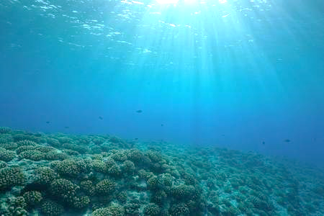

ONCE UPON A TIME…THE SEA

Project financed by the European Union - Erasmus + Programme
Reference number: 2018-1-RO01-KA229-049131
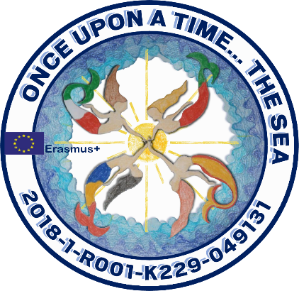

THE WORLD WITHIN DICTIONARY
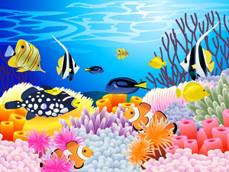
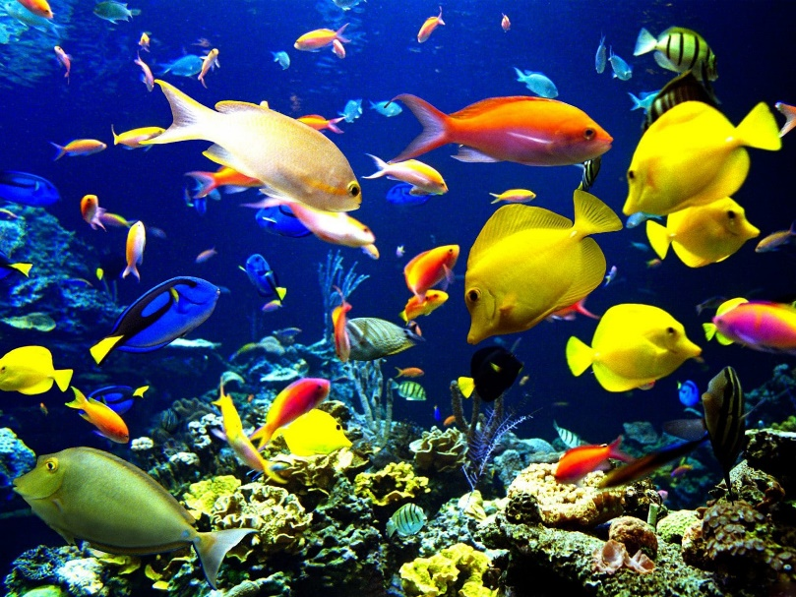

MINI-DICTIONARY ABOUT THE MARINE ECOSYSTEM
- SCOALA GIMNAZIALA LUCIAN GRIGORESCU - Medgidia – Romania
- ICS FRANCESCO RISO - Isola delle Femmine – Italy
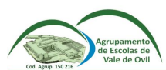
- ESCOLA GABRIEL CASTELLA I RAICH - Igualada – Spain
- AGRUPAMENTO DE ESCOLAS DE VALE DE OVIL Baião - Portugal
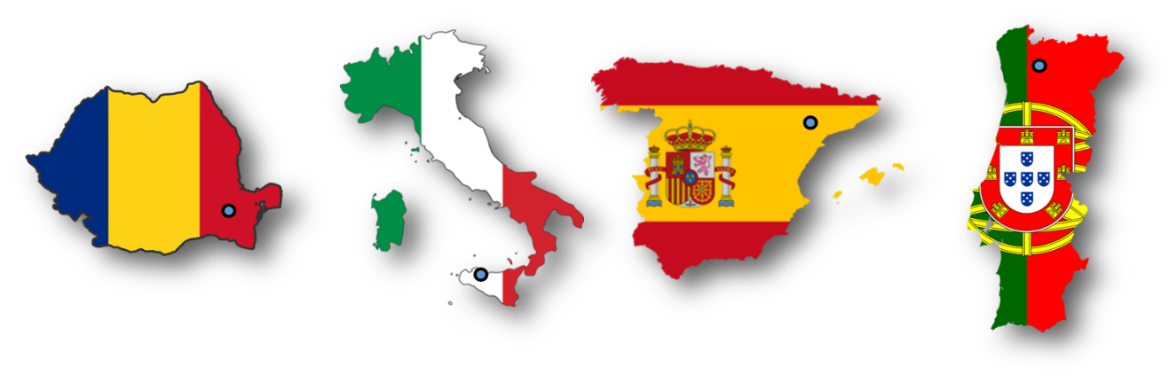

LETTER | ENGLISH | ITALIAN | PORTUGUESE | ROMANIAN | CATALAN / SPANISH
A | algae  https://vocaroo.com/i/s1CmwEF020qN | alga  https://vocaroo.com/i/s0wO5IBS3w28 | alga  https://vocaroo.com/i/s1vQ3cT03yit | alge  https://vocaroo.com/i/s0bbux6pm0v4 | alga/alga  https://vocaroo.com/i/s1bmuU2Zk3Lc
 | anchovy  https://vocaroo.com/i/s0WSvxPxjsfT | acciughe  https://vocaroo.com/i/s1wd9pRgptAE | anchova  https://vocaroo.com/i/s0OINXsBW7Kg | hamsie  https://vocaroo.com/i/s0pj8tnqexbp | anxova/anchoa  https://vocaroo.com/i/s025OHDxx2XK
 | 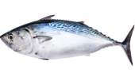  atlantic bonito  https://vocaroo.com/i/s0rVct6hCBwc | palamito  https://vocaroo.com/i/s1s6uzA4MS7J | bonito  https://vocaroo.com/i/s1vQzQLnJUNL | pălămidă  https://vocaroo.com/i/s09vfyqabatr | bonítol atlàntic/bonito del norte  https://vocaroo.com/i/s07gIaIOCyl9
B | 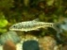  barbel  https://vocaroo.com/i/s1pYiQ4LN5uY | barbohttps  https://vocaroo.com/i/s1d6vNFxeCFF | barbo  https://vocaroo.com/i/s0n3QUFUVxoV | mreană  https://vocaroo.com/i/s0pbolbhcftm | barb/barbo  https://vocaroo.com/i/s0Z8Ei1fLnwy
 | 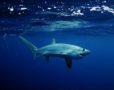  big-eye thresher  https://vocaroo.com/i/s01fIAd1ZC2Z | squalo volpe  https://vocaroo.com/i/s0YdepCbCgIg | tubarão raposa  https://vocaroo.com/i/s0Wv1IKsOoSU | rechinul vulpe  https://vocaroo.com/i/s1nvy0lbckxx | transtorn d’ulls grans/  trilladora de ojos grandes  https://vocaroo.com/i/s1qKsu1Zqjhb
 | 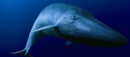  blue whale  https://vocaroo.com/i/s1nsgdO7v8hr | balena blue  https://vocaroo.com/i/s1P2HiNYvZKe | baleia azul  https://vocaroo.com/i/s0OQ8Xmj8izI | balena albastră  https://vocaroo.com/i/s1n0kmmplbgu | balena blava/ballena azul  https://vocaroo.com/i/s0Gq2t0RrsSO
 | 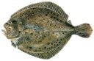  brill  https://vocaroo.com/i/s11KelW2wVD2 | rombo liscio  https://vocaroo.com/i/s1NvaRk8a8NQ | rodovalho  https://vocaroo.com/i/s1j2b11gOPvP | calcan  https://vocaroo.com/i/s1dlqfmx52gb | rèmol/torbellino  https://vocaroo.com/i/s0Jo2wp61Y7l
C | 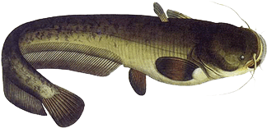  catfish  https://vocaroo.com/i/s0kDZf8r7sY9 | pesce gatto  https://vocaroo.com/i/s12pDTCX5PYN | peixe gato  https://vocaroo.com/i/s1WkKIgWbsrM | somn  https://vocaroo.com/i/s1a7krw6newv | peix gat/pez gato  https://vocaroo.com/i/s0xBAVK7QnXZ
 | 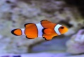  clown fish  https://vocaroo.com/i/s0gdGvshABUy | pesce pagliaccio  https://vocaroo.com/i/s087yTqb275h | peixe palhaço  https://vocaroo.com/i/s10df2ySROfd | peştele clovn  https://vocaroo.com/i/s1dwlcilanjp | peix pallasso/pez payaso  https://vocaroo.com/i/s0i84JUNbnBt
 | 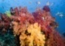  corals  https://vocaroo.com/i/s1VSeLQ5eLZ5 | coralli  https://vocaroo.com/i/s1dNdnMI949T | corais  https://vocaroo.com/i/s1s4tH48rOyU | corali  https://vocaroo.com/i/s1mlgszapt2w | corall/coral  https://vocaroo.com/i/s1EysAHV8n9R
 | 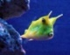  cowfish  https://vocaroo.com/i/s0bKUZDk0cZZ | lactoria cornuta  https://vocaroo.com/i/s1KCrQuZ04qU | peixe-vaca  https://vocaroo.com/i/s0Oum0MBk4Ik | peştele vacă  https://vocaroo.com/i/s0nngb1kyge1 | peix vaca/pez vaca  https://vocaroo.com/i/s1AuYNvJKMhC
 | 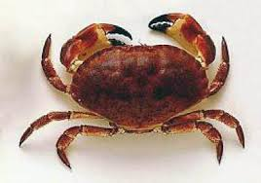  crabb  https://vocaroo.com/i/s1MTzkZ4BII5 | granchio  https://vocaroo.com/i/s0cdseTpHACw | caranguejo  https://vocaroo.com/i/s1kxmTJLo0ZT | crab  https://vocaroo.com/i/s1MPHMpBwSb7 | cranc/cangrejo  https://vocaroo.com/i/s0jGrKQg8UhO
D | 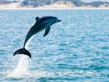  dolphin  https://vocaroo.com/i/s0mqtYf5pyFs | delfini  https://vocaroo.com/i/s0lOvQ1nMJPu | golfinho  https://vocaroo.com/i/s152XJAEHSXs | delfin  https://vocaroo.com/i/s1jfdy8ky8vj | dofí/delfín  https://vocaroo.com/i/s0K8B894bQdM
LETTER | ENGLISH | ITALIAN | PORTUGUESE | ROMANIAN | CATALAN / SPANISH
 | 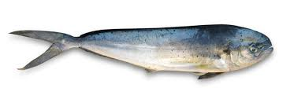  dolphinfish  https://vocaroo.com/i/s06VnHMsCaaM | lampuga  https://vocaroo.com/i/s0N6LyZq8np0 | dourado-do-mar  https://vocaroo.com/i/s0K9PF00vRFi | corifenă  https://vocaroo.com/i/s0ma5bwpwcvy | llampuga/lampuga  https://vocaroo.com/i/s1Cv1jlfoWaz
E | 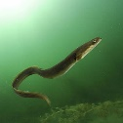  eel  https://vocaroo.com/i/s1JqbPSROxbM | anguilla  https://vocaroo.com/i/s1nkeXsMwOca | enguia  https://vocaroo.com/i/s0H5vlcsf9x3 | anghilă  https://vocaroo.com/i/s1xnz8esbhhh | anguila/anguila  https://vocaroo.com/i/s16WOSHg9fNk
 | eelgrass  https://vocaroo.com/i/s1Q9kEniDq8M | zostera marina  https://vocaroo.com/i/s02bSZ48gqOS | erva marinha  https://vocaroo.com/i/s1dneGIfFAbU | iarbă de mare  https://vocaroo.com/i/s1zffywti3tw | herva de mar/hierba de mar  https://vocaroo.com/i/s0lT5eLB7vY4
 | 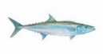  escolar  https://vocaroo.com/i/s1kNH8QNZ8Ir | tirsite  https://vocaroo.com/i/s1J9nIwHb0Ze | atum branco  https://vocaroo.com/i/s0CNALIozm0P | tonul alb  https://vocaroo.com/i/s1cszrxdkgi9 | peix mantega/caballa serpiente  https://vocaroo.com/i/s1mJYJBrCsVc
 | 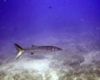  european barracuda  https://vocaroo.com/i/s1hQEQ7eJDeT | barracuda europeo  https://vocaroo.com/i/s1WXMEAh43WM | barracuda  https://vocaroo.com/i/s0DUy6oOSkj1 | baracuda  https://vocaroo.com/i/s0dnrmkn8lrk | barracuda/barracuda  https://vocaroo.com/i/s0dpkhmU9EZF
F | 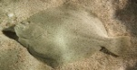  flatfish  https://vocaroo.com/i/s06veSpUZT9X | soglila  https://vocaroo.com/i/s05XpRCYFkXR | peixe chato  https://vocaroo.com/i/s0mH1XD1D0cz | peşte plat  https://vocaroo.com/i/s1j31nhziu0w | peix manta/pez manta  https://vocaroo.com/i/s1JQju56uc05
 | 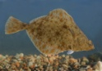  flounder  https://vocaroo.com/i/s1qezPdmDhkI | platessa  https://vocaroo.com/i/s1lNbst976I7 | linguado  https://vocaroo.com/i/s1O6CLVFR1IY | cambula  https://vocaroo.com/i/s1dhkijbsd3a | platija/platija  https://vocaroo.com/i/s1eXkpT0WHEU
 | 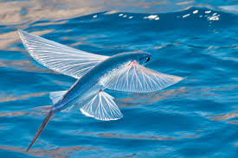  flying fish  https://vocaroo.com/i/s1467bBp3NVn | pesci volanti  https://vocaroo.com/i/s17OwpbO0sRb | peixe-voador  https://vocaroo.com/i/s09KSUno81XT | peşte zburător  https://vocaroo.com/i/s1fi5lleydfe | peix volador/pez volador  https://vocaroo.com/i/s0vhUd5wOUGg
G | 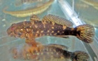  goby  https://vocaroo.com/i/s1nDukefgUd5 | pesce ghiozzo  https://vocaroo.com/i/s18a79vJHAkA | gobião  https://vocaroo.com/i/s027ms6hqZb0 | guvid de mare  https://vocaroo.com/i/s0FIZjWfTSMY | peix gobi/pez gobio  https://vocaroo.com/i/s0AaAjxmnCZX
 | grass goby  https://vocaroo.com/i/s0lrY19g9p6y | ghiozzo go  https://vocaroo.com/i/s11mlhSGo9bJ | gobião da grama  https://vocaroo.com/i/s0GW5uPBvP27 | guvid de iarbă  https://vocaroo.com/i/s0ZjOo5qZcyc | gobi d’herva/gobio de hierva  https://vocaroo.com/i/s1eqM8yXRSMb
 | 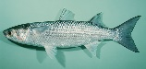  gray mullet  https://vocaroo.com/i/s0WO49Q9HEhb | cefalo  https://vocaroo.com/i/s1vK4ifcBtzp | tainha  https://vocaroo.com/i/s0NN11bSgNls | chefal  https://vocaroo.com/i/s06wm0vl8fpn | mullet/mullet  https://vocaroo.com/i/s0ideEGlTyGP
 | 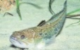  greater weever  https://vocaroo.com/i/s0tY0ig2cL9n | tracina  https://vocaroo.com/i/s1oWJqDtvGYq | peixe-aranha-maior  https://vocaroo.com/i/s17AHxiKzmzx | dragon de mare  https://vocaroo.com/i/s1IMIdSuRkqa | dragó de mar/dragón de mar  https://vocaroo.com/i/s03H8xocDnta
 | 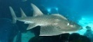  guitarfish  https://vocaroo.com/i/s1miJRXillwM | pesce chitarra  https://vocaroo.com/i/s0sIxjN1Tg8t | peixe-viola  https://vocaroo.com/i/s0zyugZl0JQm | peşte chitară  https://vocaroo.com/i/s0jho8TeJlq7 | peix guitarra/pez guitarra  https://vocaroo.com/i/s0qIfXV8zRgY
LETTER | ENGLISH | ITALIAN | PORTUGUESE | ROMANIAN | CATALAN / SPANISH
 | 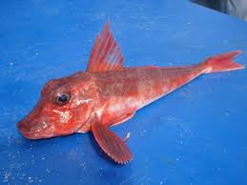  gurnard  https://vocaroo.com/i/s1Ju2iAVCQOA | gallinella  https://vocaroo.com/i/s0BegE8MRSHX | bacamarte  https://vocaroo.com/i/s0QxwmkMfHzP | rândunica de mare  https://vocaroo.com/i/s0ct3UF5iL0z | gallineta/escarcho  https://vocaroo.com/i/s0DLc8uRren0
H | 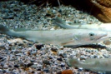  hake  https://vocaroo.com/i/s1twSsMuRb18 | merluzzo  https://vocaroo.com/i/s04Zk3CbD3Dm | pescada  https://vocaroo.com/i/s1jWkoBTQ0Gx | merluciu  https://vocaroo.com/i/s1JNLViVR04m | lluç/merluza  https://vocaroo.com/i/s1wobzNkU5FV
 | 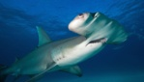  hammerhead shark  https://vocaroo.com/i/s0qRi8pKFkYk | suqlo martello  https://vocaroo.com/i/s1nHKmkhHsGy | tubarão-martelo  https://vocaroo.com/i/s1Q0S9cD3IrP | rechin ciocan  https://vocaroo.com/i/s1tIeYVPMnBB | peix martell/pez martillo  https://vocaroo.com/i/s0UMX01T5PDy
 | 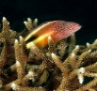  hawkfish  https://vocaroo.com/i/s0FS67izJTOw | cirrihtedae  https://vocaroo.com/i/s0MJR71hwDBh | peixe falcão  https://vocaroo.com/i/s111FAWZnWgn | peştele şoim  https://vocaroo.com/i/s1vX2GIUE6p9 | falcó/pez halcón  https://vocaroo.com/i/s09GsJ5zbm91
 | 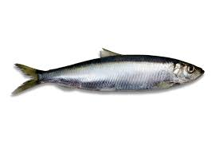  herring  https://vocaroo.com/i/s0FVm4dYfqNv | aringa  https://vocaroo.com/i/s0wpWvTLbcEN | arenque  https://vocaroo.com/i/s035bBpgNdJq | hering  https://vocaroo.com/i/s07gccs9Jlbg | arengada/arenque  https://vocaroo.com/i/s1zvlYGThqrl
J | 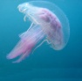  jellyfish  https://vocaroo.com/i/s0HD5z5FHhWq | medusa  https://vocaroo.com/i/s0n35OztKLT5 | medusa  https://vocaroo.com/i/s1PbFy4SOLI3 | meduză  https://vocaroo.com/i/s0CeqvUS9gH2 | medusa/medusa  https://vocaroo.com/i/s1UHZUFvTZz3
 | john dory  https://vocaroo.com/i/s0DvKMmlhYqT | coda di rospo  https://vocaroo.com/i/s15InbtGALE9 | peixe-galo  https://vocaroo.com/i/s1wHM0mmbZyt | dulgherul mare  https://vocaroo.com/i/s0KDm6cJAuoq | rap/rape  https://vocaroo.com/i/s01CXZ8RLrVd
K | 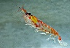  krill  https://vocaroo.com/i/s1HGNnbjbpjz | krill  https://vocaroo.com/i/s0lFN9Jpx8iD | krill  https://vocaroo.com/i/s00vPEei3QGD | krill  https://vocaroo.com/i/s1S5n5ikuvKN | krill/krill  https://vocaroo.com/i/s0LR64Kjl5Cb
L | 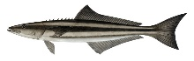  lemonfish  https://vocaroo.com/i/s1L8jpt2pBL7 | pesce limone  https://vocaroo.com/i/s1nRkvv6ExyU | cobia  https://vocaroo.com/i/s1bNCj11I3rZ | peştele lămâie  https://vocaroo.com/i/s0Bh03HAeuf0 | peix llimona/pez limón  https://vocaroo.com/i/s0C9e8nLp7P1
 | 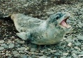  leopard seal  https://vocaroo.com/i/s0TjTUyAC95X | foca leopardo  https://vocaroo.com/i/s15InbtGALE9 | foca leopardo  https://vocaroo.com/i/s0M1FKu8q35U | leopard de mare  https://vocaroo.com/i/s0c0LpPjwwKa | foca guepard/foca leopardo  https://vocaroo.com/i/s1dSCNBYhs8l
 | 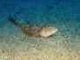  lizard fish  https://vocaroo.com/i/s18nG2tvJSJv | pesce lucertola  https://vocaroo.com/i/s0pVJpp25grD | peixe-lagarto  https://vocaroo.com/i/s1JBE59YTLAi | peştele şopârlă  https://vocaroo.com/i/s0yed0UoSjOu | llangardaix/lagartija  https://vocaroo.com/i/s1O5J3nPO981
 | 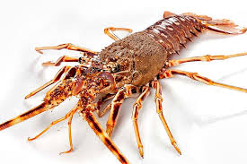  lobster  https://vocaroo.com/i/s1Qap8VCmfeA | aragosta  https://vocaroo.com/i/s02ZTEsZo192 | lagosta  https://vocaroo.com/i/s02Yr52ZOtYm | homar  https://vocaroo.com/i/s0aPPE5DpPhP | llagosta/langosta  https://vocaroo.com/i/s1ej99phIYlP
LETTER | ENGLISH | ITALIAN | PORTUGUESE | ROMANIAN | CATALAN / SPANISH
M | 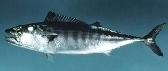  mackerel  https://vocaroo.com/i/s0gk18r3ckKm | sgombro  https://vocaroo.com/i/s1E1tdjz1nQg | cavala  https://vocaroo.com/i/s1cyTmtTlpJ6 | macrou  https://vocaroo.com/i/s1e6MCKX93Do | verat/caballa  https://vocaroo.com/i/s0uUULm95zi1
 | 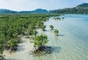  mangrove swamp  https://vocaroo.com/i/s0qqWJURmdhl | mangrove  https://vocaroo.com/i/s1hWGqhIM95g | mangue  https://vocaroo.com/i/s1TVLc7xAinY | mangrove  https://vocaroo.com/i/s0qKYU1SgiMh | manglar/mangle  https://vocaroo.com/i/s14VRpdZSHcw
 | 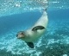  monk seal  https://vocaroo.com/i/s1JphwNtApmk | foca monaca  https://vocaroo.com/i/s0A5IxNQSmZj | foca-monge  https://vocaroo.com/i/s0lz9Odf5BoH | focă  https://vocaroo.com/i/s1Q6eSh5P5pN | foca/foca  https://vocaroo.com/i/s1moe5GXo546
 | 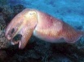  mollusc  https://vocaroo.com/i/s0lGuTEPomhi | molluschi  https://vocaroo.com/i/s0vzPigqHKMx | molusco  https://vocaroo.com/i/s0VWibAfXRzv | moluscă  https://vocaroo.com/i/s031xP3U9Cae | mol·lusc/molusco  https://vocaroo.com/i/s173BISzSx41
 | 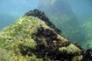  mussels  https://vocaroo.com/i/s0z9hUiKltJA | cozze  https://vocaroo.com/i/s0amTN1wxN4X | mexilhão  https://vocaroo.com/i/s1CEoL3GRZ6x | midii  https://vocaroo.com/i/s15LcTEOAwBn | musclos/mejillones  https://vocaroo.com/i/s1NTGTNJvBCn
N | 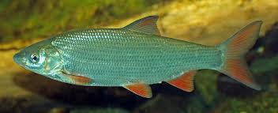  nase  https://vocaroo.com/i/s1J3fmZryRtP | carpa  https://vocaroo.com/i/s1cvq4FlHedx | carapau  https://vocaroo.com/i/s0v9O0yJhbOa | scobar  https://vocaroo.com/i/s0httU6lZsTs | carpa/carpa  https://vocaroo.com/i/s06a0fnPtNjV
O | 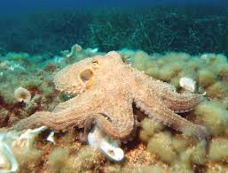  octopus  https://vocaroo.com/i/s0k9ndHWRVXp | polpo  https://vocaroo.com/i/s1TAP0GS52Ob | polvo  https://vocaroo.com/i/s1wpbDy5oS4P | caracatiță  https://vocaroo.com/i/s113dhwZtjoS | pop/pulpo  https://vocaroo.com/i/s0TgA0tBTnRA
 | 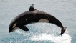  orca  https://vocaroo.com/i/s0XPii0Fwq7Q | orca  https://vocaroo.com/i/s0RwDhwjuOaY | orca  https://vocaroo.com/i/s0AbdRq3uVDA | orcă  https://vocaroo.com/i/s0pUABvQq5Pm | orca/orca  https://vocaroo.com/i/s0MC2FIXRNrP
P | perch  https://vocaroo.com/i/s15SkoYfqce3 | pesce persico  https://vocaroo.com/i/s1B6cpZM0UnJ | perca  https://vocaroo.com/i/s1J5ehafQKor | biban  https://vocaroo.com/i/s1fcvEcue3ct | perca/perca  https://vocaroo.com/i/s16E1vPOrVFv
 | 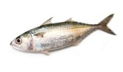  pilchard  https://vocaroo.com/i/s14W4zkY777R | sardella  https://vocaroo.com/i/s0nyjJZjijFE | sardinha  https://vocaroo.com/i/s06DvA0d5heY | sardea  https://vocaroo.com/i/s1ytS0UPiITp | sardina/sardina  https://vocaroo.com/i/s0u5cGu1pEWJ
 | 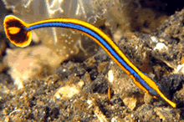  pipe fish  https://vocaroo.com/i/s0JfkMWoYowX | pesce pipa  https://vocaroo.com/i/s0DBkCN77Wap | peixe-cachimbo  https://vocaroo.com/i/s0UY4BxEKXL9 | ac de mare  https://vocaroo.com/i/s0B2VJJyBnbS | peix de pipa/pez pipa  https://vocaroo.com/i/s1BAlcddm0ke
LETTER | ENGLISH | ITALIAN | PORTUGUESE | ROMANIAN | CATALAN / SPANISH
 | 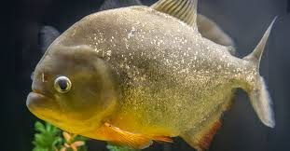  piranha  https://vocaroo.com/i/s0JCUqrJbF9m | piragna  https://vocaroo.com/i/s1eRJ24jbSY4 | piranha  https://vocaroo.com/i/s0CUkdcstPGB | pirania  https://vocaroo.com/i/s1DoKYLwKQQ9 | piranya/piraña  https://vocaroo.com/i/s09b24job9wi
R | 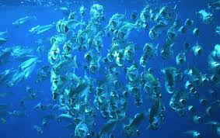  plankton  https://vocaroo.com/i/s0UXKHbBHOPV | plancton  https://vocaroo.com/i/s05McB6iqDSO | plâncton  https://vocaroo.com/i/s0wS8RxVOlFa | plancton  https://vocaroo.com/i/s0zttXCtth37 | plancton/plancton  https://vocaroo.com/i/s0UYk5tUag2C
 | 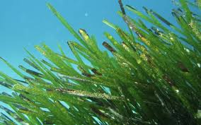  posidonia  https://vocaroo.com/i/s1x6YqJ8IVIa | posidonia  https://vocaroo.com/i/s0ZR6xLOvO6g | posidonia  https://vocaroo.com/i/s0XzKi9sIwHT | posidonia  https://vocaroo.com/i/s02KsgddzLqv | posidonia/posidonia  https://vocaroo.com/i/s1G5JNZGfWOR
 | 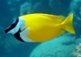  rabbitfish  https://vocaroo.com/i/s1sgOUhLcPur | pesce coniglio  https://vocaroo.com/i/s0enjNdSlHl9 | peixe-coelho  https://vocaroo.com/i/s1myDL5fITMZ | peşte iepuraş  https://vocaroo.com/i/s0i3npNRUieU | peix conill/pez conejo  https://vocaroo.com/i/s0kBrpbqHfFy
 | 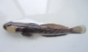  racer goby  https://vocaroo.com/i/s1ifWAjto47A | babka  https://vocaroo.com/i/s0tWTmwUn4d1 |  | mocănașul  https://vocaroo.com/i/s0w3ySSvWzyB | gobi corredor/gobio corredor  https://vocaroo.com/i/s09NWpyRaxu1
 | 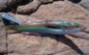  rainbow wrasse  https://vocaroo.com/i/s07RphJNJau4 | donzella  https://vocaroo.com/i/s10SrOpXAXy9 | peixe arco-íris  https://vocaroo.com/i/s1aZCuwJLa68 | peștele păun  https://vocaroo.com/i/s1PirjRLnpDk | peix paó/ pez pavo real  https://vocaroo.com/i/s1ANr6gsvJzN
 | 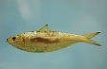  round sardinella  https://vocaroo.com/i/s1baaBekG7wj | sardella  https://vocaroo.com/i/s1gR2GcJKCz7 | sardinela redonda  https://vocaroo.com/i/s0X8HEmp9xeQ | sardeluţă  https://vocaroo.com/i/s1vgaEApm4pJ | alatxa/alacha  https://vocaroo.com/i/s18AmAvwRdAz
S | 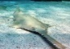  sawfish  https://vocaroo.com/i/s1A7bPAeOFHH | pesce sega  https://vocaroo.com/i/s0xTNQvLsPGl | peixe-serra  https://vocaroo.com/i/s10vgnBWMakU | peştele ferăstrău  https://vocaroo.com/i/s0MzktQ943CZ | peix serra/pez sierra  https://vocaroo.com/i/s1HbM6D4rMud
 | 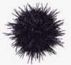  sea hedgehog  https://vocaroo.com/i/s1Bc0tlGruv5 | riccio di mare  https://vocaroo.com/i/s16PxWQhoTfH | ouriço do mar  https://vocaroo.com/i/s0pyPoRYDhio | arici de mare  https://vocaroo.com/i/s1lZjuycoi5S | eriçó de mar/erizo de mar  https://vocaroo.com/i/s1gALTQcoVbL
 | sea horse  https://vocaroo.com/i/s1EQqp5qQSqk | cavalluccio marino  https://vocaroo.com/i/s0l3PGBE4p2c | cavalo marinho  https://vocaroo.com/i/s1wYOCp5bdvy | căluț de mare  https://vocaroo.com/i/s0W5NKQrQhrC | cavall de mar/caballito de mar  https://vocaroo.com/i/s0YLxdaQZTeR
 | 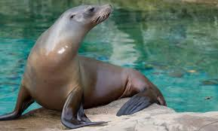  sea lion  https://vocaroo.com/i/s06OCFU1sRw5 | leone marino  https://vocaroo.com/i/s0juorWHiMz2 | leão marinho  https://vocaroo.com/i/s1EOCslnO7Na | leu de mare  https://vocaroo.com/i/s0CUGMmS1FRF | lleó marí/león marino  https://vocaroo.com/i/s0Nqwf7yXjMD
 | shark  https://vocaroo.com/i/s1JnLCc2zZ0y | squalo  https://vocaroo.com/i/s1N1IOv8HUqO | tubarão  https://vocaroo.com/i/s0kHd05j5KN3 | rechin  https://vocaroo.com/i/s1epK4emegxN | tauró/tiburón  https://vocaroo.com/i/s1LGUYMCyvOe
LETTER | ENGLISH | ITALIAN | PORTUGUESE | ROMANIAN | CATALAN / SPANISH
 | 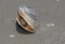  shell  https://vocaroo.com/i/s1x6imsVByJ2 | conchiglia  https://vocaroo.com/i/s1SQzpWxsLAe | concha  https://vocaroo.com/i/s1r2jLjwDLlq | scoică  https://vocaroo.com/i/s0iFeQ3RCZ4o | closca/cáscara  https://vocaroo.com/i/s0euus15vGf8
 | sole  https://vocaroo.com/i/s1HzaRv4PjQL | sogliola  https://vocaroo.com/i/s05XpRCYFkXR | linguado  https://vocaroo.com/i/s1wUKNwovOOq | limbă de mare  https://vocaroo.com/i/s1ElhNdwwo9H | llengua de mar/lengua de mar  https://vocaroo.com/i/s10Xh7BdFgMP
 | sprat  https://vocaroo.com/i/s0woTYM4xN3z | aringa  https://vocaroo.com/i/s19ikMglQtbc | espadilha petinga  https://vocaroo.com/i/s1HjufJ1U6mg | şprot  https://vocaroo.com/i/s0cD1vcB6Z3u | sarment/espadín  https://vocaroo.com/i/s1yq7SZ9xwCc
 | 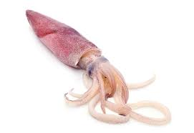  squid  https://vocaroo.com/i/s1WBE3pDkwdL | calamaro  https://vocaroo.com/i/s141S9Q435Ak | lula  https://vocaroo.com/i/s19ilv8DIcZN | calamar  https://vocaroo.com/i/s0R7H7EFbO7p | calamar/calamar  https://vocaroo.com/i/s05uegke5U3a
 | 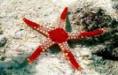  starfish  https://vocaroo.com/i/s12NYl6Z7awC | stella marina  https://vocaroo.com/i/s149GUxCQPng | estrela do mar  https://vocaroo.com/i/s1bOP3O6Mrjc | stea de mare  https://vocaroo.com/i/s1sJFjhxLIH6 | estrella de mar/estrella de mar  https://vocaroo.com/i/s0ppJKcvVjDd
 | 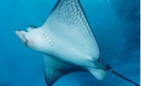  stingray  https://vocaroo.com/i/s1VS6pX0SPHI | razza  https://vocaroo.com/i/s1c4kyNt8NAK | raia  https://vocaroo.com/i/s0zpOTFuz3Z7 | pisica de mare  https://vocaroo.com/i/s0gOBg7lfTmF | raig/mantarraya  https://vocaroo.com/i/s140BOJvC1v9
 | 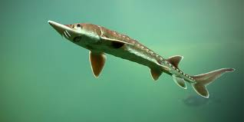  sturgeron  https://vocaroo.com/i/s1v4y2lXoxEX | storione  https://vocaroo.com/i/s1Ds4oFtyJIg | esturjão  https://vocaroo.com/i/s1EfLxEPCjED | nisetru  https://vocaroo.com/i/s0tPxVbvAZL4 | esturió/esturión  https://vocaroo.com/i/s1IeE8Ar2PDG
 | 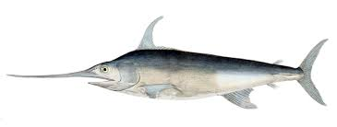  swordfish  https://vocaroo.com/i/s16NVFyXfhkd | pesce spada  https://vocaroo.com/i/s0GQIhXObdZj | espadarte  https://vocaroo.com/i/s1WAieJO8hYG | peştele sabie  https://vocaroo.com/i/s1vyVAZoNFc2 | peix espasa/pez espada  https://vocaroo.com/i/s0MwCAlArEx1
T | 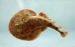  torpedo  https://vocaroo.com/i/s1m67WDQME7O | torpedine  https://vocaroo.com/i/s08EUgoRiArJ | raia-torpedo  https://vocaroo.com/i/s1TGL8AJLQJJ | peştele torpilă  https://vocaroo.com/i/s0GpvPmtbJI6 | peix torpede/pez torpedo  https://vocaroo.com/i/s0YXAIRpvfNt
 | 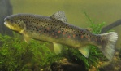  trout  https://vocaroo.com/i/s0Z8Yl7Q4vpA | trota  https://vocaroo.com/i/s1wHiLjaLAHE | atum  https://vocaroo.com/i/s1pLectrpl4J | păstrăv  https://vocaroo.com/i/s1BOrCcnwsxr | tonyina/atún  https://vocaroo.com/i/s0hIeZBBWNTX
 | 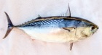  tuna  https://vocaroo.com/i/s0YjArYEWM8q | tonno  https://vocaroo.com/i/s1dBFjoHbNOB | truta  https://vocaroo.com/i/s1d4xnnorlcz | ton  https://vocaroo.com/i/s0EHQePYPYhv | truita/trucha  https://vocaroo.com/i/s0cN5RC59g2j
 | turbot  https://vocaroo.com/i/s1dq9EmZUN5N | rombo  https://vocaroo.com/i/s1YJPZJx9Dd8 | rodovalho  https://vocaroo.com/i/s0ZJLn0Jo80B | calcan  https://vocaroo.com/i/s0UZTpOjxlcr | rèmol/rodaballo  https://vocaroo.com/i/s1NKjkZAREPl
 | 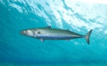  twaite shad  https://vocaroo.com/i/s1LIEN1JI3Or | cheppia  https://vocaroo.com/i/s1F9QfGTFEuK | cavala  https://vocaroo.com/i/s0e7ThgdNrnL | scrumbie  https://vocaroo.com/i/s0VyhUleXN02 | verat/caballa  https://vocaroo.com/i/s0TAruobRDan
LETTER | ENGLISH | ITALIAN | PORTUGUESE | ROMANIAN | CATALAN / SPANISH
U | 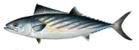  ukrainian stickleback  https://vocaroo.com/i/s1B2CpW2C7Tj | palamito  https://vocaroo.com/i/s1s6uzA4MS7J | sarda  https://vocaroo.com/i/s0Skp5p7u4xN | pălămida  https://vocaroo.com/i/s0IoaI16AarP | espinaça/espinaza  https://vocaroo.com/i/s0RJR1EFMhrO
V | vendace  https://vocaroo.com/i/s1QY8lEFoXzB | coregone  https://vocaroo.com/i/s1qzfEJIGo5n | truta prateada  https://vocaroo.com/i/s0GgwtrGNHkH | păstrăv argintiu  https://vocaroo.com/i/s1uVXs4uVwUc | truita platejada /trucha de plata  https://vocaroo.com/i/s1OeaaoRnP4q
 | 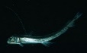  viperfish  https://vocaroo.com/i/s1dYNq46sE90 | pesce vipera  https://vocaroo.com/i/s1t8jT8rhXlL | peixe-víbora  https://vocaroo.com/i/s0dzew3mz4a4 | peştele viperă  https://vocaroo.com/i/s0Pb1DjCpBhu | peix escurçó/pez víbora  https://vocaroo.com/i/s1yPCgURpWW0
W | 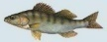  walleye  https://vocaroo.com/i/s0nvNtT8LGLV | lucioperca  https://vocaroo.com/ i/s13epWMNBUl5 | zander  https://vocaroo.com/i/s1iohhqhjut1 | şalău  https://vocaroo.com/i/s1oTtFnPIcFD | perca/perca  https://vocaroo.com/i/s1pvCQO4LzAy
 | 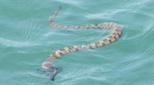  water snake  https://vocaroo.com/i/s0QkvrzNOeqb | biscia di mare  https://vocaroo.com/i/s1SGiI4Y8jv2 | cobra marinha  https://vocaroo.com/i/s1Iq9zpM5yiC | şarpele de apă  https://vocaroo.com/i/s0DEbLBLGbdn | serp de mar/serpiente de mar  https://vocaroo.com/i/s0UXbjNqPOxo
 | 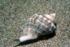  whelk  https://vocaroo.com/i/s1baXHrgAzBt | buccino  https://vocaroo.com/i/s01A96ENO1Do | búzio  https://vocaroo.com/i/s0W4tEYsTwr8 | melc  https://vocaroo.com/i/s0ceZWKGGN33 | cargol/caracol  https://vocaroo.com/i/s1pNAMWWspEg
Y | 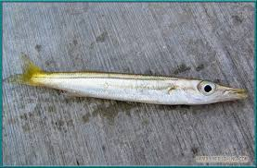  yellow barracuda  https://vocaroo.com/i/s1q2nPz1OSE5 | barracuda giallo  https://vocaroo.com/i/s07SfesXBntk | barracuda amarela  https://vocaroo.com/i/s0SrnyqGZcgv | baracuda galbenă  https://vocaroo.com/i/s1Gsa8cuf0XO | barracuda groga/barracuda amarilla  https://vocaroo.com/i/s12Ms1i0kDqZ
Z | 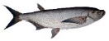  ziege  https://vocaroo.com/i/s0sefSEhht0I | chekon  https://vocaroo.com/i/s0ZNoHm96ER9 | carpa sabre  https://vocaroo.com/i/s1XhBFdqPpVU | săbioară  https://vocaroo.com/i/s0fyEiVslgu3 | carpa de sabre/ carpa sable  https://vocaroo.com/i/s10SmGxeB4DP

The European Commission support for the production of this publication does not constitute an endorsement of the contents which reflects the views only of the authors and the Commission cannot be held responsible
for any use which may be made of the information contained therein.
