Chemistry, environment, & water

Activity 1. Simulation of a simple water treatment plant.

Surely you know what a renewable resource is but… are you able to define it?

Do you think is water a renewable resource?

Which kind of pollutants may be in the water? Classify it according to its solubility and state of matter.

Can you think a technique to separate a liquid that does not mix with water?

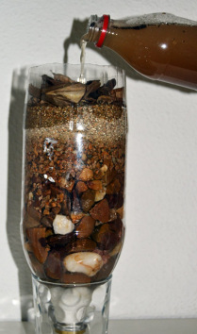
Build the filter.
Figure 1. Photograph of a homemade water filter.

1st step: Get the bottle and cut it in two halves.
2nd step: Get some cotton and fill the upper part of the bottle with a height of 2-3 cm.
3rd step: Turn around the bottle and place it over a beaker.
4th step: Get some stones and put them over the cotton. Then some sand and finally some smashed coal.
We have built a filter! Now it is the time to use it.
4th step: Carefully drop the water with sediments and impurities through the open part of the bottle.
5th step: Take your time watching how the water pass through the different layers.
- Does water look cleaner to you?

- Which kind of technique have we used? What kind of mixtures is this technique used for?

- Was it a physical transformation or a chemical reaction?

- This water cannot be drunk yet. Do you know the reason?

- To avoid infectious agents in the running water, some Cl₂ is added to the water. Do you think that this is a physical transformation or a chemical reaction?

