My plants By Adrián Prieto Alonso-Villalobos
(ALL THIS PLANTS WERE PLANTED IN MONFARRACINOS A VILLAGE FROM ZAMORA)
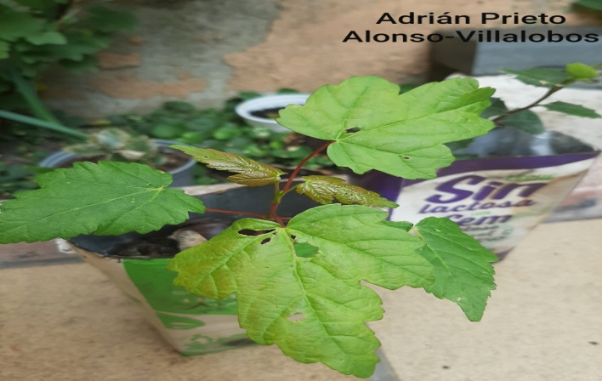
A year ago I planted a chestnut tree and an oak tree:

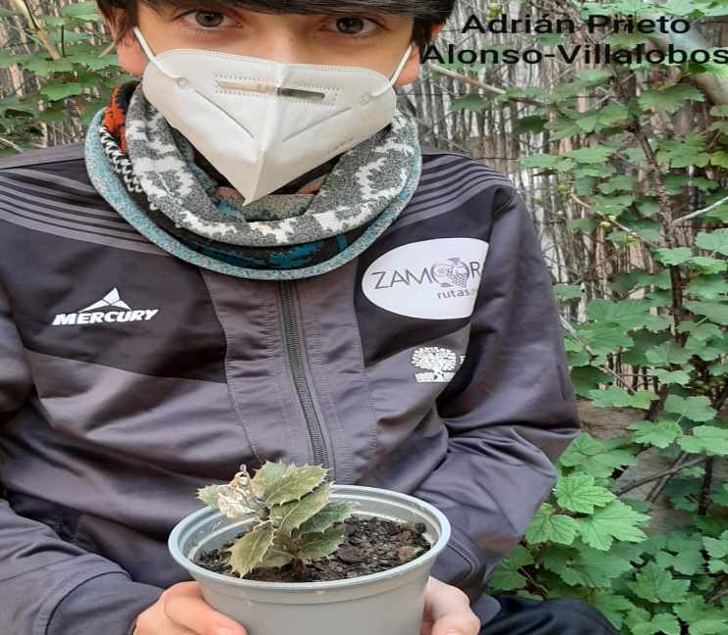
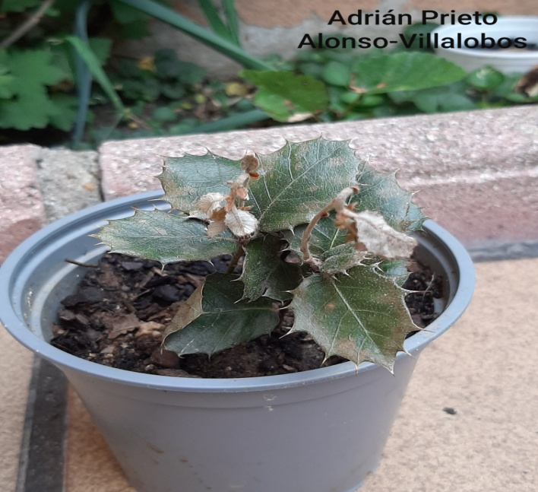
This is a chestnut tree that I planted in a milk break in my garden because there the chestnut couldn´t grow a lot and it couldn´t be eaten by insects or other animals.

Here it is my oak tree that is planted in a flowerpot and it can click you with that tiny spikes. It is also planted in my garden for the same reason like the chestnut tree.

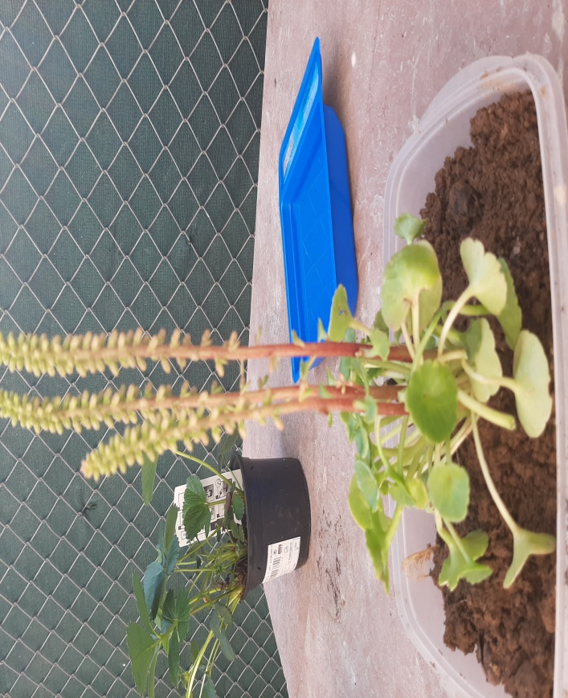

I found this strange plant planted near my oak tree and I planted it in my garden and... Two days later I found the plant dead in my ground´s garden because my dog ate and peed the plant (and that´s why I didn´t plant the other plants in my garden´s ground).

