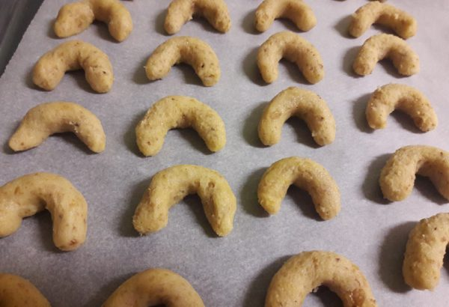
Czech „Vanilkove Rohlicky“ / „Vanilla Rolls“

In the Czech Republic we can´t imagine Christmas without cookies „Vanilla Rolls.
Here is a recipe for the most popular Czech Christmas cookie.
Ingredients:
1 cup all-purpose flour  ½ cup ground walnuts or almonds  1/3 cup powdered sugar  ½ cup and 2 tablespoons butter | 1 egg  1 teaspoon vanilla  1 cup powdered sugar to coat
Instruction:
Leave butter out at room temperature for two hours or until soft, then cut into small pieces.
Grind walnuts in food processor until very fine.
Mix butter sugar, egg and vanilla, then add ground nuts, and flour.
Prepare a smooth dough, cover and let rest for two hours in the fridge.
Roll the dough between the palms of your hands to make a long snake, the size of a thick pencil.
Cut the dough. Put them on a sheet pan lined with baking paper and bake in preheated oven at (180 C) for about 10 minutes.While they are still warm, toss in powder sugar. Let Vanilla Rolls in a cold room until Christmas.
Prep time: 30 minutes Cook time: 10 minutes Number: 50 cookies

