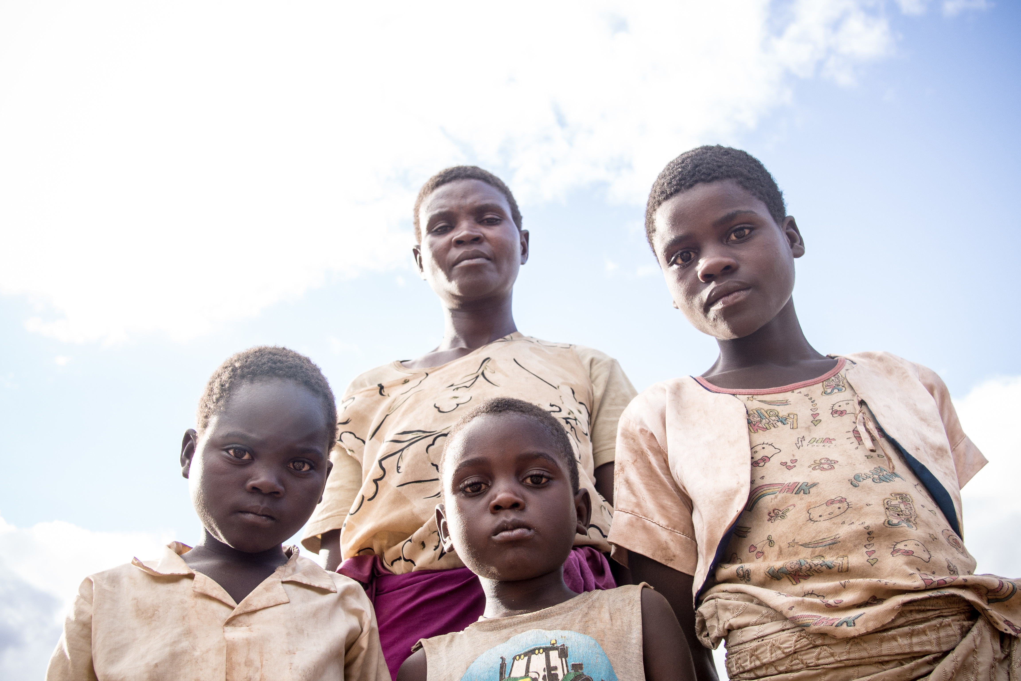
Hi I am Veronika and I am from Estonia.I have a great family where I am and am kept in great conditionsI have a mom, a dad, and a little brother.I have internet and a nice house and regular food.But I understand that not everyone has the same opportunities as in warm water or multiple meals and medicationsI chose this family because it's terrible for one mother to support three children in these conditions. They have no lighting or proper food or even a place to sleep.They have no opportunity to study or even go to the toilet and that makes me sad and you realize that there are a lot of people like that nowadays.If I lived in such conditions it would be incredibly hard to live I would do everything to live in human conditions .

