The Danish Constitution - the Foundation of Danish Democracy

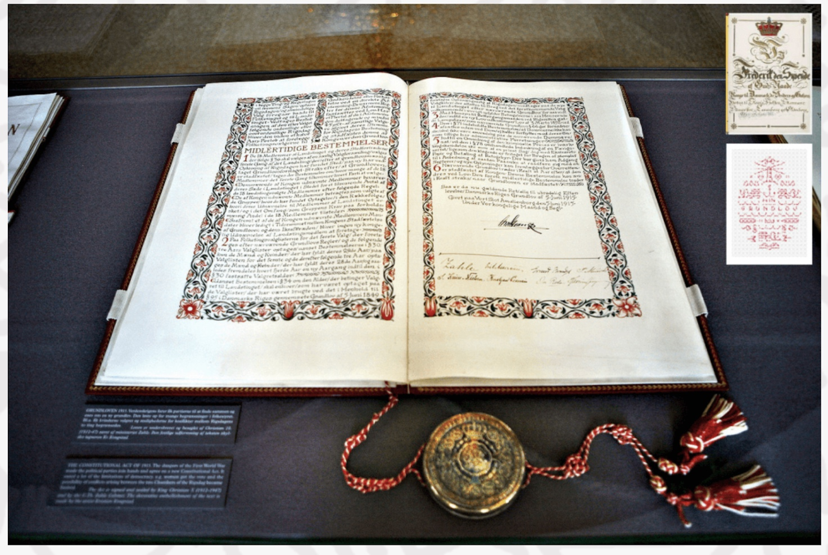
Grundloven on display in Folketinget -the Danish Parliament.

In Denmark, we celebrate the constitution on the 5. of July. On this date the first constitution was introduced. It was in 1849, it then laid the general rules of Danish democracy and the rule of law, as we know it today. The constitution determines who can legislate, how you should legislate, and what restrictions apply to the scope of the law.
Before the Constitution there was an absolute monarchy, the whole country was led by one ruler. The absolute monarchy existed for almost 200 years until Frederick VII came along.
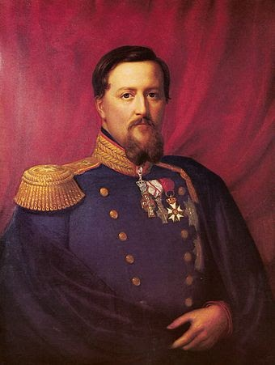
This was Frederick VII
The last King to lead
an absolute Monarch.

The constitution was written in 1849 when king Frederick VII ruled. At that time the french revolution had just ended, some decades earlier. The French revolution ended with the king getting beheaded by the people. At the same time, the liberal opposition had been growing in Denmark, causing a larger pressure on the king. This growing pressure made him write the first-ever constitution in Denmark. The current version of the constitution is from 1953. It is one of the oldest constitutions in the world The Constitutional Act has been changed a few times. The wording is general enough to still apply today. First, they showcased a draft of the constitution to the “Constitutional Assembly of the Realm”. The assembly consisted of 114 members directly elected in October 1848, and 38 members appointed by Frederick VII. The assembly was split into three different groupings: the National Liberals, the Friends of Peasants, and the Conservatives. A key topic for discussion was the political system, and the rules governing elections.

Some of the most important provisions of the constitution are the constitutional rights and the three authorities. The legislative, executive, and judicial provisions. The constitution also helps to limit the power of politicians so that the most important issues and problems of the democratic rule of law are not determined by a narrow majority. Although the first version of the constitution written in 1849 only allowed around 15% of the Danish population voting rights, it instead worked as a stepping stone towards a new government and would be further evaluated in the years after 1849.
over the course of many years, many things have changed with the constitution because the political point of view is very different today than it was back in 1849
Modernisering af grundloven - radikale venstre

The current constitution was adopted in 1953, which means that it is the longest-standing constitution we have had since the first constitution in 1849. Since 1953, the world has changed enormously, back then there was no such thing as the internet, computer, or mobile phones. Many would like an update of the constitution so that it becomes technology-neutral and can be more easily understood by the Danes and show that Denmark is a full-blown democracy which the current constitution does not clarify.

One of the prominent modern political parties wanting to reevaluate the constitution today is “Radikale Venstre” which means the “Radical Left” in English.They believe that the constitution is outdated and hard to understand and interpret in the modern-day. Over the course of many years, many things have changed with the constitution because the political point of view is very different today than it was back in 1849, which is why Radikale Venstre wants a new constitution Radikale Venstre states that they want a new constitution because the current one is more than 60 years old and times were very different in 1953 where the last constitution was made. In Denmark, we were still embossed by 2. World War and the EU wasn’t established yet, there were no phones and we have such technological prosperity today that we need to set some new rules according to Radikale Venstre.

Kilder:
https://www.radikale.dk/system/files/Dokumenter/Programmer_Retspolitik_Februar2014.pdf

