Crime and punishment in the 15th century and today.
------------------------------------------------------------------------

Denmark's way of treating criminals has changed a lot over time. In the old days, crime and punishment were very violent. Criminals were seen as people who had chosen to give up the protection and the rights which other citizens were given by the law and the authorities. Few people believed that criminals could learn to change their behaviour and become lawful citizens and little was done to help them. Instead punishment was often used as an example to others - a spectacle where public, violent and humiliating methods of punishment could teach other citizens not to give in to the temptations and commit acts of crime.
In the 15th century, criminal humans were living under especially harsh conditions. Did you deceive, you wouldn’t skip punishment. The 15th century was very different from today, and the way of punishing people has changed a lot since then. The most common reason for people to become criminals was poverty. People were hungry and desperate, they struggled to survive. Back then people looked down on the poor instead of helping them. So that’s an explanation why there were so many criminals back then. Compared to today, we have fewer poor people because of our well-functioning welfare society.

A new criminal law
In 1866 Denmark got a new criminal law, where they almost went away from physical punishment, except for children and young people because they meant that they benefited from being beaten. Instead of physical punishment, isolation was now used to “educate the prisons''. Today we know that isolation results in anxiety, psychoses, and depression, but they were not informed about that in 1866. Until 1920 several prisoners were locked inside for up to several years, living entirely alone in a prison cell. The criminals were divided into two groups: Those who were going to an improvement institution and those who were going to the penitentiary. Improvement institution was for first-time criminals or petty criminals. If you were sent to an improvement institution you could expect to get between 8 months - 6 years, while you could expect 2 -16 years if you were a prisoner in the penitentiary. One should be kept completely isolated when one is imprisoned. You were only allowed to go out when you were going to church, to school, to wash, or go for a walk. An additional punishment you could be put on “ on water and bread”, that meant that you did not get ordinary food during your imprisonment, but only water and bread. That resulted in that people become malnourished. The ultimate punishment was, of course, the death penalty. The death penalty was abolished in 1930.
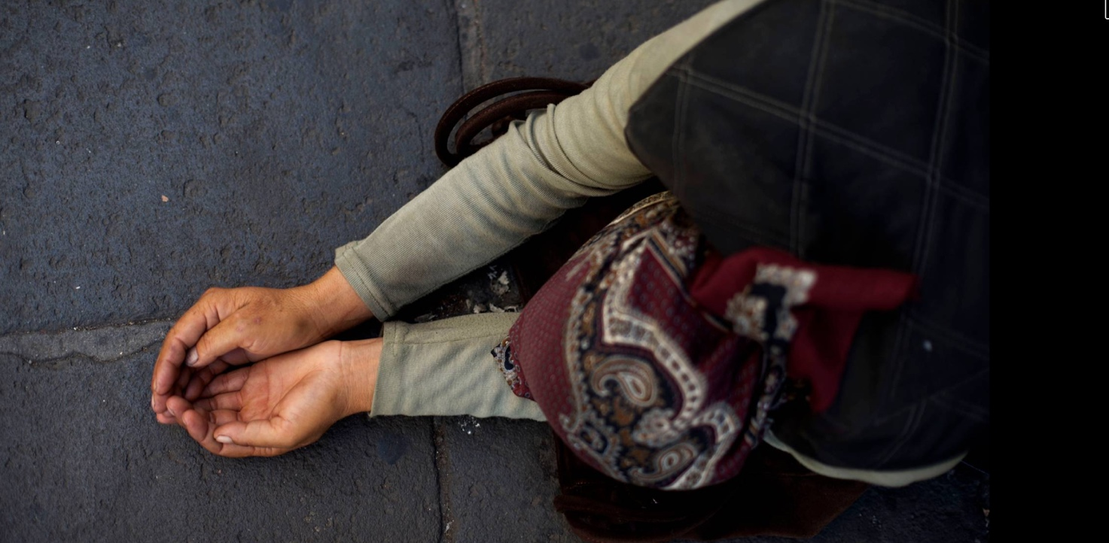
Begging without an official permit from the authorities was made a criminal offense in Denmark in the 1500s and begging in the streets remains a criminal offense in Denmark
today.

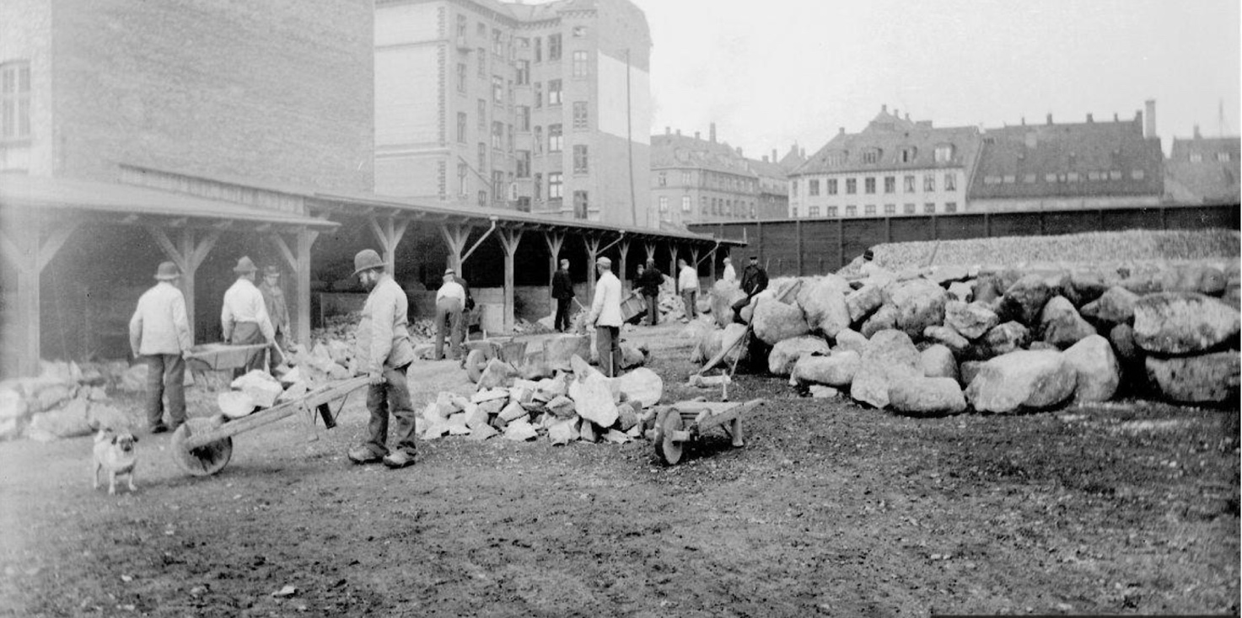 A penal work station in Copenhagen, 1898 If you were unemployed, you were a burden to the authorities and could be sentenced to penal servitude. You could also be stripped of your rights to marry and vote. These laws existed until the early 1960s - but were rarely used since the 1910s.

Criminals’ rights today
In today's Denmark, you have the right to vote, even though you are in prison. According to the Prison Service, the inmates have,, the right to vote by mail. It was done in different ways. In some places, it was done in the prison school, and in other prisons, it was done by the prison guard walking from one cell to another, and then the inmates could write their vote on a piece of paper.
The inmates today have a lot of freedom and are living with very good and humane treatment of prisoners. Even though they have violated the law, they have the right to do almost everything they want. They have high-class cells, they can work to earn money, they can go out of their cells to hang out with other inmates. It is almost like they weren't in prison. Because of the rights of criminals today, you can see a huge difference between back in the days, and today's Denmark as a prisoner

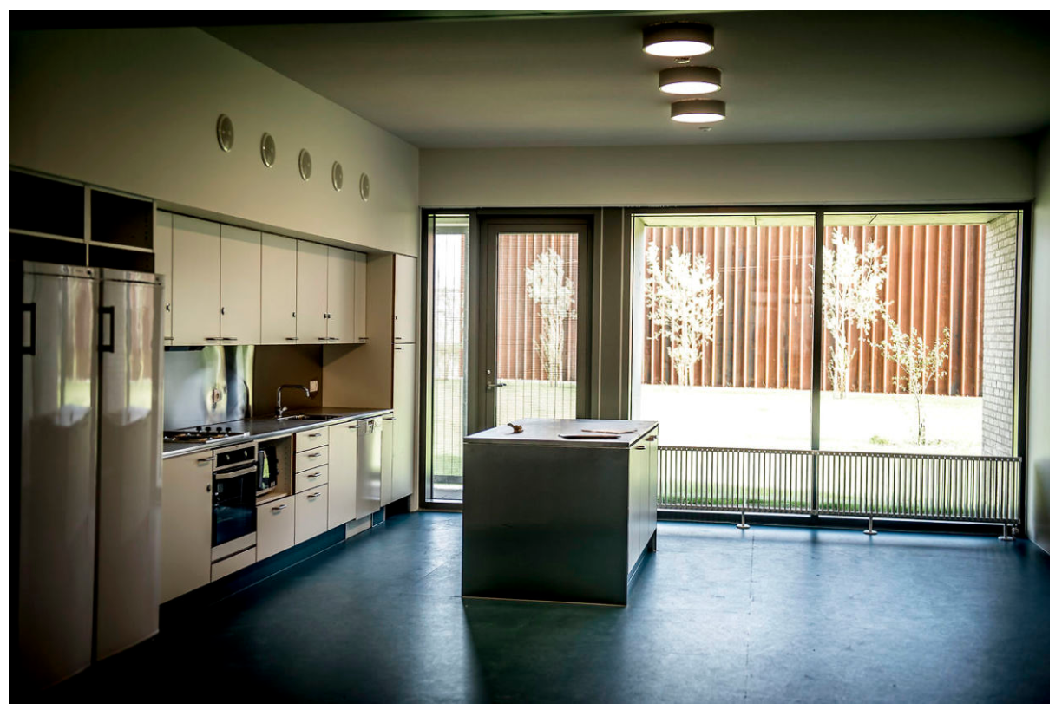
A Kitchen unit in the newly opened Storstrøms’s Prison. A kitchen unit is shared by the inmates of 5-7 inmates.
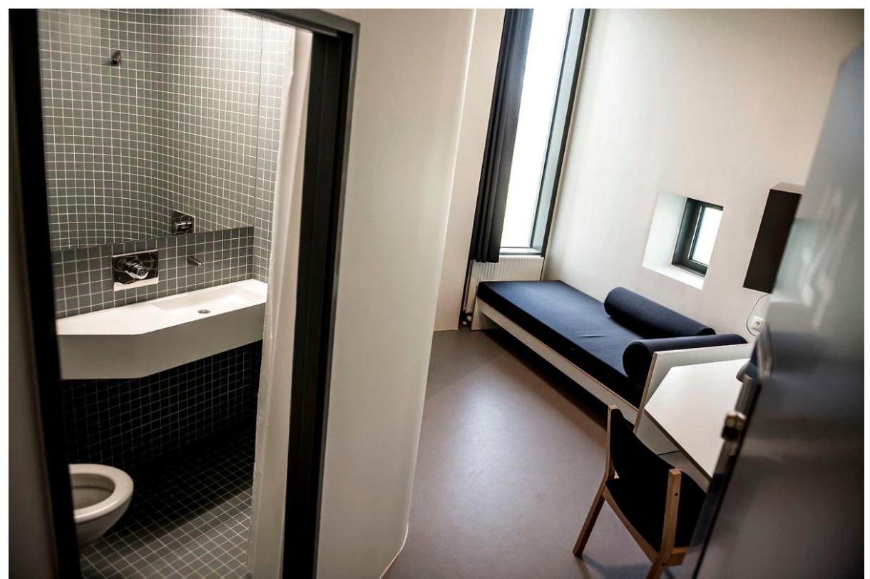
A cell in the newly opened Storstrøm’s Prison. Not all Danish prisons are as modern as this new prison.

The European Human Rights convention
Today The European Convention on Human Rights guarantees the rights of the citizens and also the rights of citizens who have been convicted of crimes.The European Convention on Human Rights consists of 59 articles, which are divided into three sections. The first section deals with the rights and freedoms to which all the people of the countries which have acceded to the Convention are entitled. This is followed by a series of articles on the European Court of Human Rights. There are some rules on how and how many judges are to be appointed to the court. Finally, the convention contains several provisions, it could be how a country can step out of the convention, in another way some rules of the convention. An article could be Prohibition of torture which is article number 3, it means that one shall be subjected to torture or to inhuman or degrading treatment or punishment. An another could be article 14 Prohibition of discrimination whicht enclude that this Convention shall be secured without any discrimination such as sex, race, colour, language, religion, political or other opinion, national or social origin, association with a national minority, property, birth or other status.

