The Danish Girl (2022)
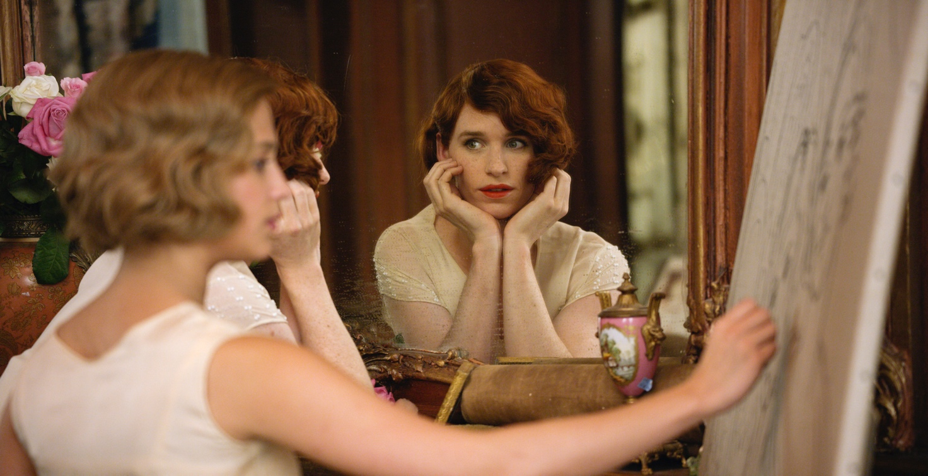

TITLE
DIRECTOR
RELEASE DATE
CAST
GENRE
RUNNING TIME
AWARDS

Questions about the movie
- What is the true nature of the marriage depicted in The Danish Girl? What does this story say about love and intimacy?

- Which difference do you imagine it makes for someone whether being transgender is an unconscious part of their personality or something they identify with? How could it influence their lives?

- Why doesn’t Lili tell Gerda about seeing Henrik again?

- The Danish Girl takes place around 1930. How have things changed for the trans community in the years since? In which ways does the world seem the same as depicted in the novel?

Activity: make a drawing of “The Danish girl”

Discuss, working in pairs:
- What does art and painting symbolize for Gerda and Lili?
- Why doesn’t Lili tell Gerda about seeing Henrik again?
- Why does Lili put so much faith in her final operation?
- What does it mean to her?
- Discuss how Lili views her former life? What has she said goodbye to? What will she always carry with her?
- Did you know that the movie is based on a true story

Source:
http://www.mikkelkiilerich.dk/english/the-danish-girl---worksheet.pdf

