Democratic changes
in Poland in 1989

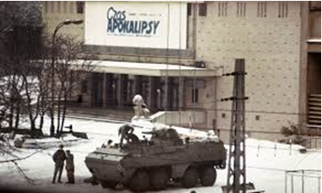

The activists of "Solidarity" were interned, many of activists were persecuted. The security services pacified the miners of the "Wujek" mine in Silesia. The acts of terror against Polish society only consolidated Poles around the idea of ​​regaining independence from the Soviet Union. After the end of martial law on July 21st 1983, "Solidarity" began to revive. The activists favouring the idea of ​​freedom were still persecuted by the communist authorities, which was particularly emphasised by the murder of the priest Jerzy Popiełuszko in October 1984. The economic situation in the country continued to decline as well as in other countries of the Eastern region. In 1988, another wave of strikes broke out in Poland. The communist authorities decided to start negotiating with representatives of "Solidarity." At the beginning of 1989, talks at the so-called Round Table started and were followed by democratic changes in the country, collapsing of the Soviet Union and the liberation of Eastern Europe. The powerful social movement activated almost 10 million Poles who opposed the dictate of the Soviet Union and supported the independence of Poland since the end of World War II. In partly free election the overwhelming victory of the “Solidarity” new authorities were chosen. Both chambers established constitutional committees to draft a new constitution with numerous changes:
- The name of the state was changed to the "Republic of Poland"
- leading role of the party and friendship with the Soviet Union were removed
- the principle of a democratic state ruled by law
- the principle of the so-called "social justice",
- political pluralism
- freedom of economic activity
- protection of property
- symbolic changes, which were reflected in the restoration of the crown in the emblem of Poland.

