SOLIDARITY
After the WWII Poland was govern by communists. There was little democracy that time in our country and it emerged people’s objection, which led to numerous protests.
The first major workers' protests took place in Poznan in June 1956, the year of Stalin’s death. An indirect result of the bloodily suppressed riots was the "Polish October 1956". The ruling team was changed. Most political prisoners were released from prison and rehabilitated, the Ministry of Public Security was abolished, the cult of Stalin in the USSR was condemned, and the press was allowed to develop freely for several months. Yet when time was passing, the rules became more and more backward. Already weak economy was further weakened by forced deliveries of materials (coal, and products - like ships) to the USSR, as well as spending huge amount of state money on armaments and maintaining growing apparatus of violence. Moreover, Poland was forced to fulfil the „allied commitments" to Cuba, North Vietnam and in Czechoslovakia. In March 1968 there were provoked student strikes, which the authorities used for a large-scale anti-Semitic campaign, as a result of which thousands of Jewish citizens were forced to leave Poland.
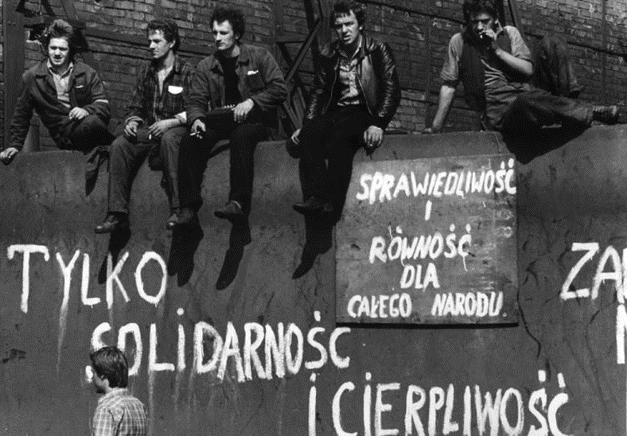
Workers' strikes in July and August 1980.
Afterwards, the workers' protests were in 1970 and 1976, caused mainly by economic issues. Yet the authorities again announced the rise in prices of basic food products. This led to a series of strikes. The scale of them was so big that the communist authorities decided to enter into talks with the strikers instead of pacifying them.

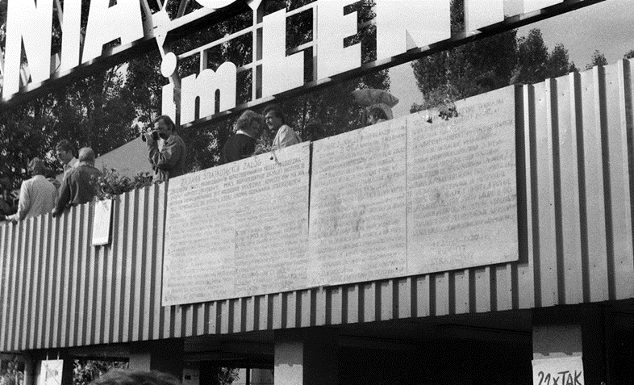

The strikers' demands were:
- the right to form their own representation – free trade union that could speak to the "workers' and peasants' government" on behalf of "the working people of towns and villages". It was directed against the ruling party PZPR, which was supposed to take care of the working class.
- respect for the right to freedom of speech according to the Constitution of the People's Republic of Poland and access to the party-controlled media.
- finishing repressions against people persecuted for their beliefs
- changes in the economy so that the country could recover from the crisis
- increased support for people bringing up children
- reducing the retirement age
- reform the health service
- free Saturdays.

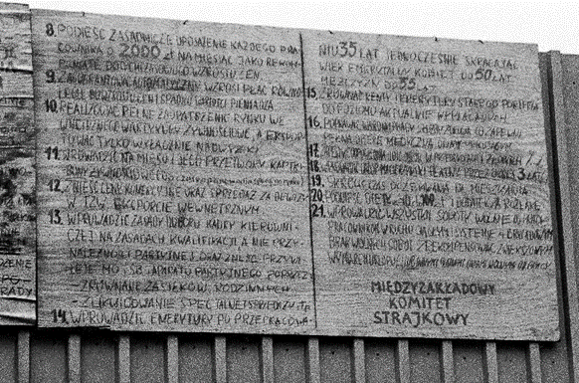
Unfortunately, according to the "Brezhnev doctrine", no country that was in Warsaw Pact could turn back from the way to communism. The governments set up by the USSR could be supported by so called “brotherly help” of neighbouring communist countries. However, the difficult economic and political situation forced the communist authorities to sign an agreement with workers on 31 August 1980, which created the first independent organisation in the countries enslaved by the Soviet Union. The “Solidarity” trade union was established, gethering 10 million Poles. Its activities were brutally ended on 13 December 1981 when devoted to the Soviet Union, General Jaruzelski imposed the state of war in Poland.

