Principles of the political system of reborn Poland based on
the March Constitution of 1921
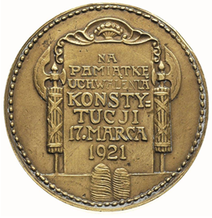
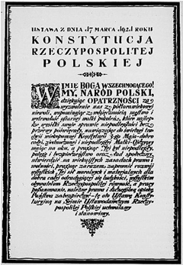

After the long time of not existing on the map, in 1918 Poland was reborn. At first it was extremely difficult. In the divided into three parts country it was necessary to introduce new law and new rights. So called March Constitution, established 17 March 1921 was the foundation on which the Second Republic of Poland was built. It shaped democracy and created the independent country after 123 years of slavery, which gave people a kind of spirit of freedom.
The document consisted of seven chapters and was based mainly on the principle that the state government was led by the people. It established that Poland was a democratic parliamentary republic with a free choice of political parties. The people elected their representatives to the Parliament in universal, equal, secret, free and proportional elections. The Constitution guaranteed the tripartite division of power:
- legislative power - a bicameral parliament (with Sejm and Senate)
- executive power - a government (the President with the Council of Ministers)
- an independent courts (tribunals) - composed of judges elected to this position for life.
It also introduced the principle of state control, which was exercised by the Supreme Audit Office.
Women’s rights
After Poland regained independence in 1918, different legal systems regulated women's rights in different ways. Thanks to the decree on the electoral law issued by Jozef Pilsudski on 28 November 1918, women were granted the right to vote and to be candidates. Equal rights for men and women in this matter were confirmed in 1921 by the March Constitution. Its Art. 96 stated that "All citizens are equal in the light of the law". The granting of suffrage to women was an innovative and quite unusual measure for those times. The March Constitution of 1921 didn’t allow restrictions on the basis of sex and fully cancelled the limits on married women to deal with legal and procedural capacities.

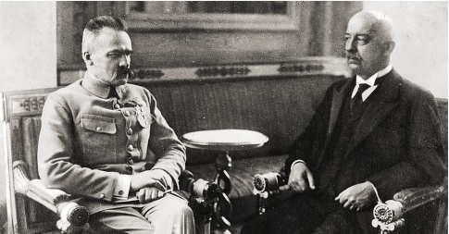

The Act not only regulated a number of constitutional issues, but also granted many rights and freedoms to citizens. It guaranteed e. g. freedom of the press and assembly and personal inviolability.

