Constitution of May 3

The next huge stage of democracy development in Poland was the Constitution of May 3, passed in 1791 regulating the legal system of the Polish-Lithuanian Commonwealth. It introduced the law of universal independence (for the nobility and the middle class) and the tripartite division of powers:
- legislative (bicameral parliament),
- executive (king)
- judiciary
It changed the state system into a constitutional monarchy, and significantly limited noble democracy introducing a partial equalization of personal rights of lower class people and nobility. It also placed the peasants under the protection of the state, and formally abolished the liberum veto. It was the first constitution in Europe and the second in the world.
Unfortunately, the Constitution of May 3 was only in force for a year. It was abolished by the Russian army as a result of the lost Polish-Russian war. The empress Catherine 2nd wanted to invade Poland and the adoption of the constitution acted against the influence of the Russian Empire in Poland.
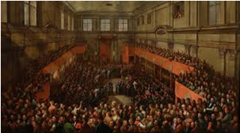
The deliberations of the Great Sejm which passed
the Constitution on May 3, 1791

