RIGHTS OF MENTALLY DISABLED

It has been a long journey to get democracy in Denmark, but a step on the way was to secure everyone’s equal rights. One of the difficult questions during the process of democratising was the treatment of the citizens with mental health problems. Throughout the history of the mentally disabled in Denmark, there has been a development in the treatment methods. But it has not always been easy for people with mental disabilities. They have been victims of a number of procedures, patronizing actions, and assaults. Their rights have not been much worth in the past. This is their story.

At the beginning of the 1800s, the Sct. Hans Hospital was moved to Roskilde, near the capital Copenhagen. At this time, the only way to cure mentally disabled people was to use coercion. The whole point was to give the sick people their senses back, and at that time, no one knew that therapeutic treatment was a better way of doing it.

Psychical coercion could be a lot of different things, but it mainly consisted of forced chairs, unpleasant baths, and starve and thirst cures. All of this, because you were seen as a sin against the Holy Spirit and it was also because of immoral conduct.
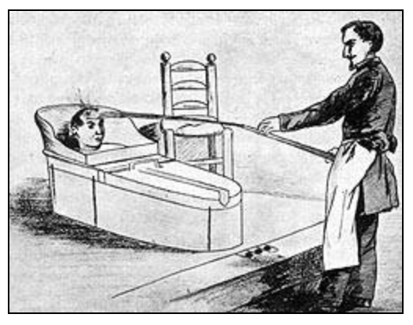
An illustration of a treatment from the eighteenth century, The patient is tied up inside the box and sprayed with cold water http://psykiatrihistorie.dk/psykiatrihistorie/plancher/pl6-indhold.htm
Later in the 1800s, the thoughts of mentally disabled people changed a bit. The doctors went from the hard psychical cures to a much more pedagogical way of curing the patients because they found out because the old perception of being a sin against the Holy Spirit was repressed.
Instead of the psychical cures, the doctors would now do therapy. They found out that if you were mentally disabled, it was because you were born with a disease in the brain. All of that meant that in the middle of the 1800s, the view on mentally disabled people became more humanistic.

Mentally ill people were seen as a threat to society. Among others, they were scared that the disabled would get too many kids. Therefore Denmark was one of the leading countries when it came to surgical procedures on the weakest in society, and we had an extensive law about sterilization. They focused on eugenics, therefore they would stop the people with bad genes from getting children, but the ones with good genes could continue to get children. Therefore there was forced sterilization on the mentally disabled from 1934-67. The disabled were getting the choice whether they wanted to live life in an insane asylum, or freedom but without having the opportunity to get kids.
Denmark was also one of the first countries in Europe that committed people who were “moral defect”. If you were a woman you were sent to a women’s home on a Danish island called “Sprogø”. It was not like a prison but they were committed indefinitely. The girls on the island were seen as frivolous and promiscuous.
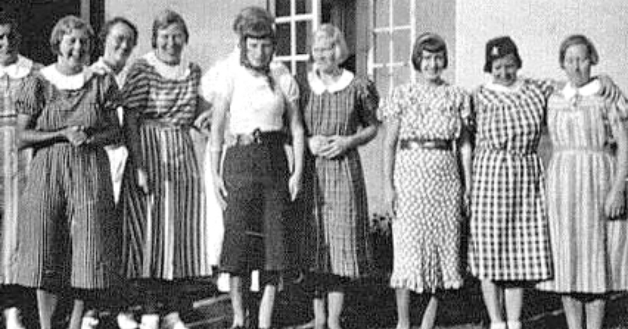
Photo: A group of girls who were committed to the Women’s home at Sprogø

The ones who were committed were girls who were not following the gender norms back then. In total 500 girls were sent to the island. If you were a man you were sent to another danish island, this one is called “Livø”. Here it was men who were either not intelligent, petty criminals, or sexually active, that got committed to a boys institution.
The two islands are an example of how society tried to avoid mentally ill people or just people who did not fit into the standard gender norm, getting children. It was a form of a human purge.

The insane asylum in Middelfart opened in 1888. It is located in the center of the city and it was originally built for 400 patients. In the 1890’s it was extended to 700 patients and in the 1950s the hospital's capacity was 1250 patients. Afterward, more and more patients got out of the insane asylum, and in 1999 the hospital closed its doors.
Today, the former patient building is turned into an exhibition. Stories about treatment and therapy are told here, as well as the story of daily life at the hospital for patients and staff.
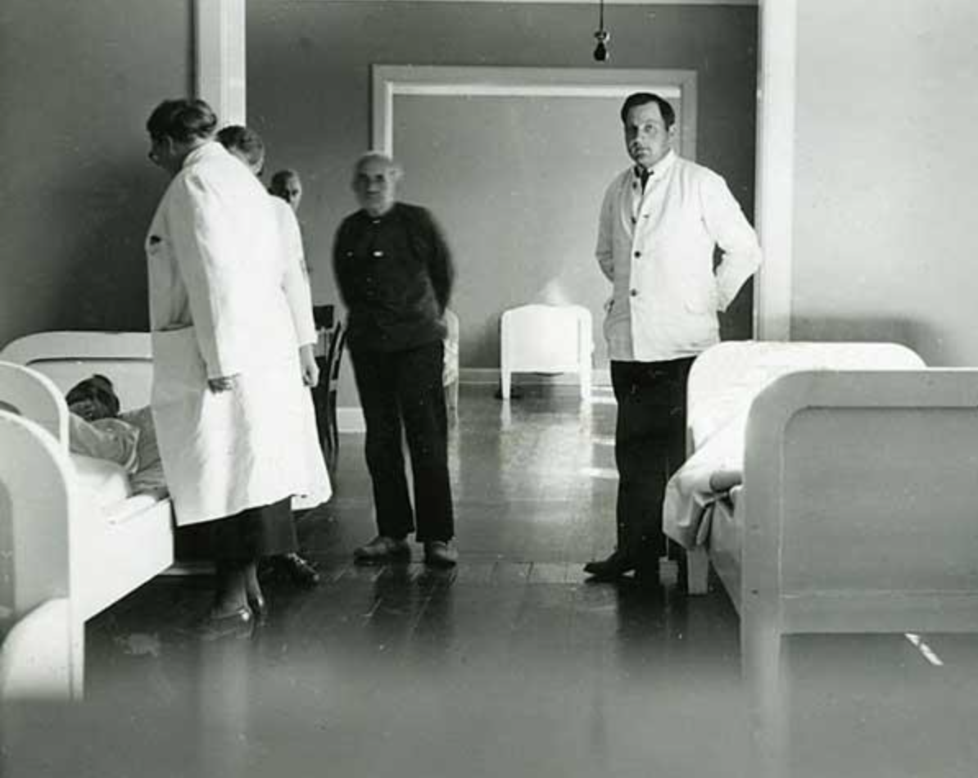
Photo: Rounds at Middelfart Insane Asylum in the 1940s. From Middelfart Museum

During the time the asylum was open, a number of different procedures were performed there. From electric shock treatment to different surgical procedures, for instance, “The white cut” or “Det hvide snit”, as it is called in Denmark.
“The white cut” is a neurological procedure, where doctors cut into mentally ill people's brains because psychiatrists meant that the procedure would help cure their disease.
Between 1939 and 1983, at least 4471 Danes had “The white cut” made.
“The white cut” was performed while the patient was under a local anesthetic. A piece of the skull was exposed, so the surgeon could drill two holes into the brain. In the beginning, they injected the brain with an alcohol infusion, but they, later on, started to cut a centimeter-long gash into the brain. The purpose of that procedure was to cut the nerve pathways in the frontal lobes. The procedure was therefore called a lobotomy.
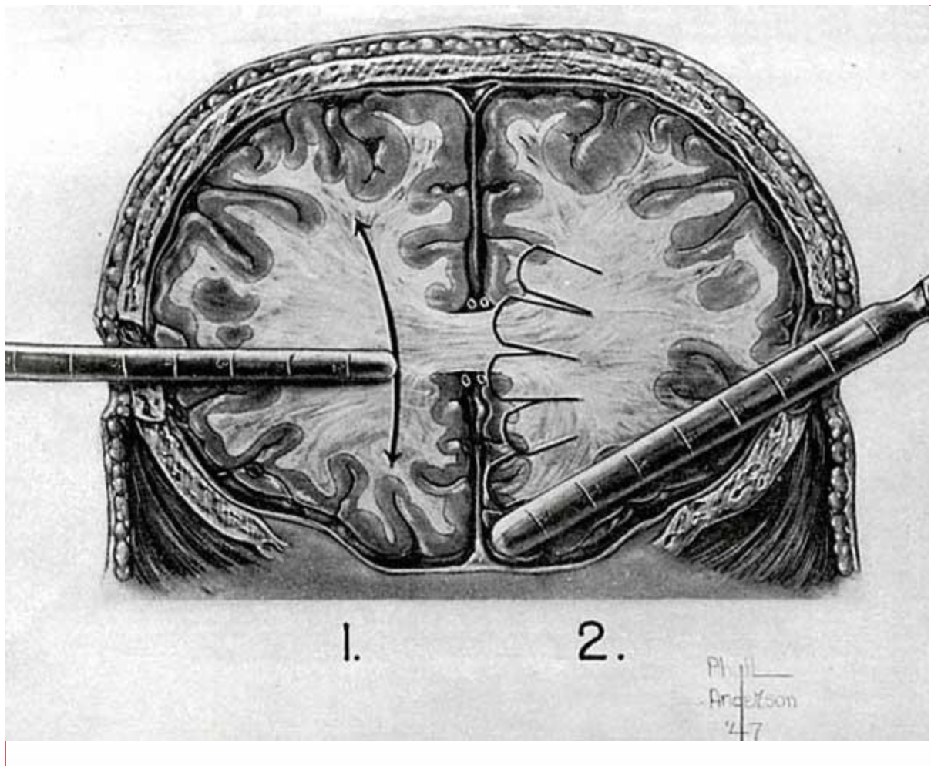
Photo: Instruction drawing for lobotomy. From W. Freeman & J. Watts: Psychosurgery, USA 1950

They wanted to cut the nerve pathways because back then they believed that thoughts and ideas were stored in the pathways. They thought they could cut the crazy and the destructive behavior out of the patients. Not only were the psychiatrists happy with the new treatment method. The Danish authorities also allocated money for performing the procedure. No one ever questioned the procedures made. “The white cut” was mostly used on people with schizophrenia disorders, but women would be more likely than men, get the procedure done. Maybe it had something to do with how they looked differently at women than at men, back in the day. It was also used on children with developmental disabilities.
“The white cut” had severe postoperative complications, so we can ask ourselves: Why did we continue?

In the 1800’s Denmark, the handicapped were called retards, crazies, and insane. The opinion on mentally ill people back in 1800, was not the opinion that we have today, so they didn’t have a lot of rights and didn’t get to have their own opinion on how bad they were treated. They were just shipped off to the asylums, without their own say-so. This went on from the 1800s up to the end of the 1800s, where Darwin's theories made the process a bit better. They began making groups of which they were “learnable and teachable”, those that were “workable” and the last group was for those who got called “beasts” or the most ''insane”. They were the ones who had chromosome abnormality and had a lot of spasms and whatnot. This vision of the mentally ill carried on all the way up to the 1940s where the insane asylums were brutally criticized, and new rights for the mentally ill were made in 1959. In 1959 the words for mentally ill were changed into nicer words, and they were taken better care of, and new rights were made for them. In 1980 the last of the mentally challenged children were sent to school.

Frank Stephens (in the middle) talks about how his life is worth living even though he has Downs syndrome, and he talks about mental illnesses should be respected.

The fight for better rights for the mentally ill is still on, but in 2006 FN carried a motion that was to make the rights of the mentally ill better. Denmark accepted that as well. But today with Covid-19, many of the relatives think that the handicapped’s situation has put them in an even worse position. The bad position they are being put in is because of the risk of the virus’s transmission. So, when the virus is gone, more time will be spent on how to make the lives of the mentally handicapped even better than it already is.

