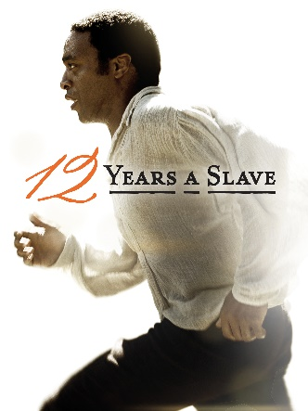
12 Years a Slave
Before You Watch

- Find out information about the film to complete the table

TITLE
DIRECTOR
RELEASE DATE
CAST
GENRE
RUNNING TIME
AWARDS

- In order to understand the film better, do some research to answer the following questions.

  - What was the name of the war between North and South?
_____________________________________________________________________________

  - How long did it last?
_____________________________________________________________________________

  - Why did it start?
_____________________________________________________________________________

  - What were the consequences of the war?
_____________________________________________________________________________

  - Who was the first Republican president of the USA?
_____________________________________________________________________________

  - Were all African Americans slaves before slavery was abolished?
_______________________________________________________________________

While You Watch

- Order the events as they appear in the film.
- Because of a plague in the cotton plantations, the slaves are temporarily
taken to Judge Turner’s farm. ________
- He is kidnapped and taken to a slave state in the South. ________
- He is taken to work in Mr Edwin Epp’s cotton plantation. ________
- His wife says there is nothing to forgive. ________
- Mr Ford buys Platt so he can work in a sawmill. ________
- Platt gives all his money so that Armsby can post a letter in Marksville. ________
- Platt is invited to play the violin in parties and is allowed to keep the money
they give him. ________
- Platt punches Tibeats and Mr Ford fears for his life. ________
- Platt tells his story and asks Bass to write a letter to his friends in the North
to prove that he is a free man. ________
- Solomon’s wife travels with their two children to work for three weeks. ________
- The boss is impressed with his work and offers him a violin as a reward. ________
- Two men offer Solomon money to go to Washington and play the violin in
a circus for two weeks. ________
After You Watch

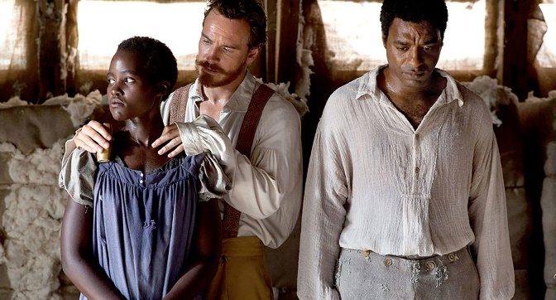
- Working in pairs/groups, discuss:
- How you think Solomon´s family lived during the time he was kidnapped;
- What you think they might have done to try to find him.

- Identify the differences between the North and the South in the film.
________________________________________________________________________________________________________________________________________________________________________________________________________________________________________________________________________________________________________________________________________________________________

