Before You Watch
Difret 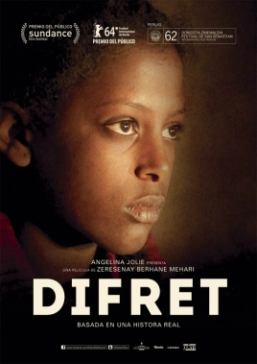
- Find out information about the film to complete the table

TITLE
DIRECTOR
RELEASE DATE
CAST
GENRE
RUNNING TIME
AWARDS

- In order to understand the film better, do some research to answer the following questions.

  - What is the importance of local traditions vs rules of law in African countries?
____________________________________________________________________________

  - Should traditions be more important than state law in any issues?
____________________________________________________________________________

  - Can murder in defense be adjustable?
____________________________________________________________________________

  - Why is it so easy to do evil and name it traditions and habits?
____________________________________________________________________________

  - What is the situation of women in Africa?
____________________________________________________________________________

  - How can women in Africa protect themselves?
_______________________________________________________________________

While You Watch

- Order the events as they appear in the film.
- In self defense she shoots her kidnapper killing him.
- Freed on bail Hirut is placed in the orphanage to study and hide from her opponents.
- A women's rights activist, Meaza Ashenali, becomes Hirut's lawyer and takes her to hospital.
- A very promising 14 year old student, Hirut Asseva, is kidnapped on her way home from school and raped by a man who wanted to marry her.
- As result of this difficult case Meaza sues the Minister of Justice and in response he closes Andined-Ethiopian Woman Lawyers Association.
- Fortunately, the Minister of Justice gets fired, the organization is restored and can protect Hirut again.
- Because of ambiguity of girl’s age, Meaza comes to Hirut's parents looking for appropriate documents proving it and notices that Hirut's sister doesn't attends school.
- The girl is found guilty by local people and banished from the village.
- Finally, Meaza defends young woman, they win the trial and Hirut is free.
- The public prosecutor takes over Hirut and it seems that her fate is doomed.by a man who wanted to marry her.

- _____ 2. _____ 3. _____ 4. _____ 5. _____ 6. _____ 7. _____ 8. _____ 9. _____ 10. _____

After You Watch

- Working in pairs/groups, discuss:
- Why was it so difficult to help Hirut?
- Is it possible to help women in Africa being in our homes?

- Find out three examples of breaking the law in Africa and explain them.
____________________________________________________________________________________________________________________________________________________________________________

