Religious Tolerance
in Poland

The history of religious tolerance in Poland is long, it was initiated by the king Casimirus the Great in 14th century, when he approved the customs of freedom and privileges for the Armenians and declared respect of rituals and customs to the followers of the Orthodox Church. Thanks to the King Casimirus Poland became the first multi-religious state in Europe, when the royal court was Catholic. It was a breakthrough. It led to the Warsaw Confederation in 1573. It guaranteed unconditional and eternal peace to all who differ in faith. The document is considered to be the beginning of legally accepted religious tolerance. What is worth mentioning In 2003, the text of the Warsaw Confederation was entered on the UNESCO Memory of the World list.
Europe in the 16th century was the scene of religious wars and persecution of various faiths. Against this background, the Republic of Poland was an oasis of peace and tolerance.
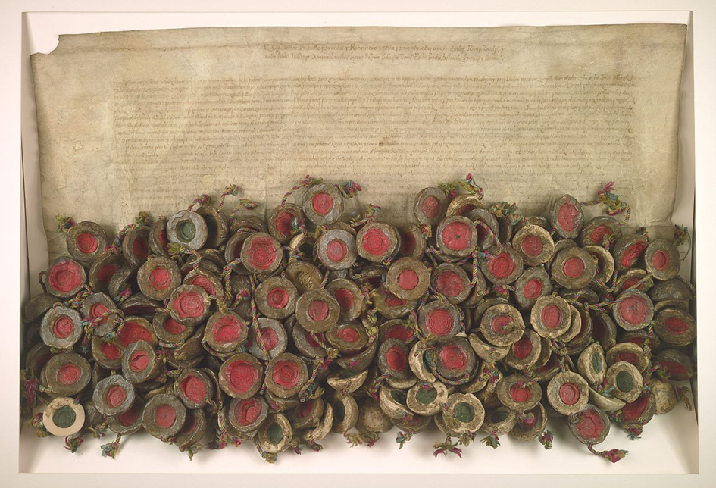

The Act of the Warsaw Confederation.

