**C3 Short-term exchange of groups of pupils Portugal 28th March to 1st April 2022**

**Be Active for DemEUcracy**

|  |  |  |  |  |
| --- | --- | --- | --- | --- |
| **Monday, 28th March** | **Tuesday, 29th March** | **Wednesday, 30th March** | **Thursday, 31st March** | **Friday, 1st April** |
| -Presentation of the school and the Portuguese school system  -Celebration of the International Day for the Rights to the Truth Concerning Gross Human Rights Violations and for the Dignity of Victims  -Session with OEI Organization of Iberian-American States and delivery of the IV Iberian-American Award in Human Rights Education  -Presentation of Liberty, the Mascot -#LoveNotWalls-Chain  -Workshop *I Love to Help*  **Welcome Lunch**  -Quizizz Contest -Language workshop  -Guided visit to ESSA | -Visit and volunteering at *Centro Paroquial de Santo André*  -Visit to the primary school  **Lunch at the school canteen**  -Discussion about the experience  -What can we do to make the difference?  -Brainstorming- teenage role models, active in the defense of Human Rights.  -Poland in the protection of war refugees  -What does it mean to be deaf? | -Films for DemEUcracy Debates in mixed groups. -Role-play debates (films).  **Lunch at the school canteen**  -Virtual meeting with Italian partner  -3D printing of Liberty | -Song to Unite Nations Presentation and explanation of each country’s song  -Working on the collaborative project’s anthem  **Lunch at the school canteen**  -Collaborative work on the project’s Newspaper | Cultural visit to Lisbon  **Free lunch**  -Evaluation of the meeting  Certificate Ceremony  -**Farewell dinner** |

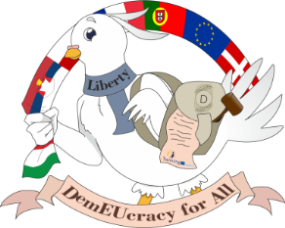With the support of the programme of the European Union.