GENIALLY
website: https://www.genial.ly
WHAT IS IT? – A tool for creating an interactive content / collaborative work possible
You create your profile and can keep your creations.
INSPIRATION SECTION – you can see examples.
SHARE your CREATIONS, DOWNLOAD or embed.
part of its features FOR FREE upgrade to PREMIUM
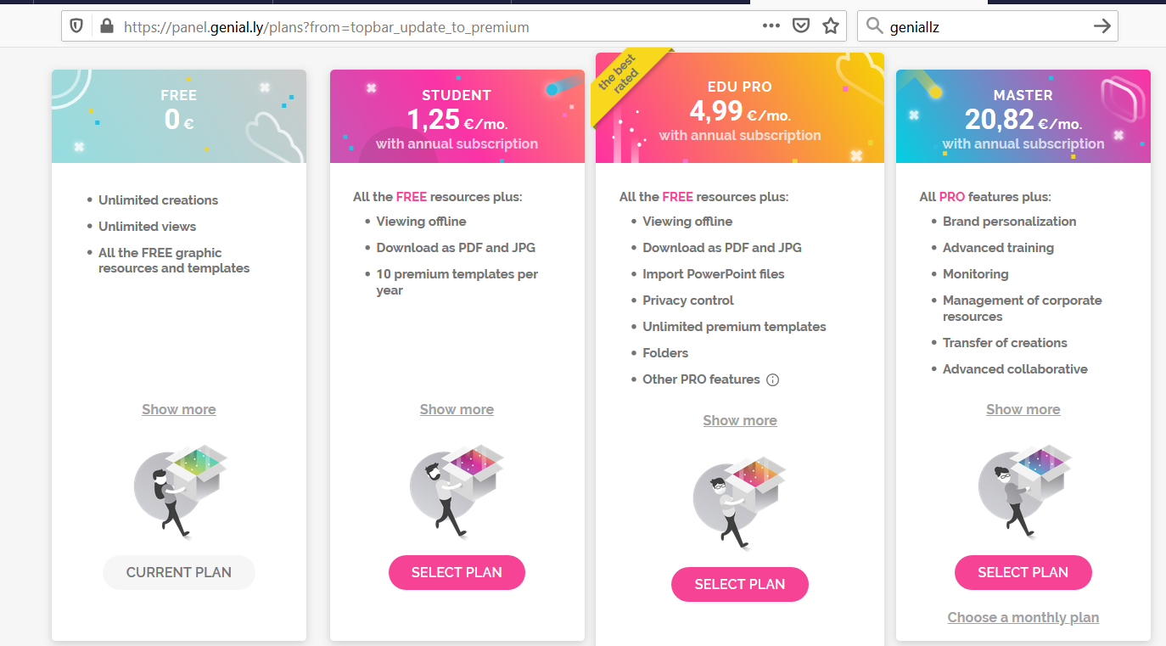

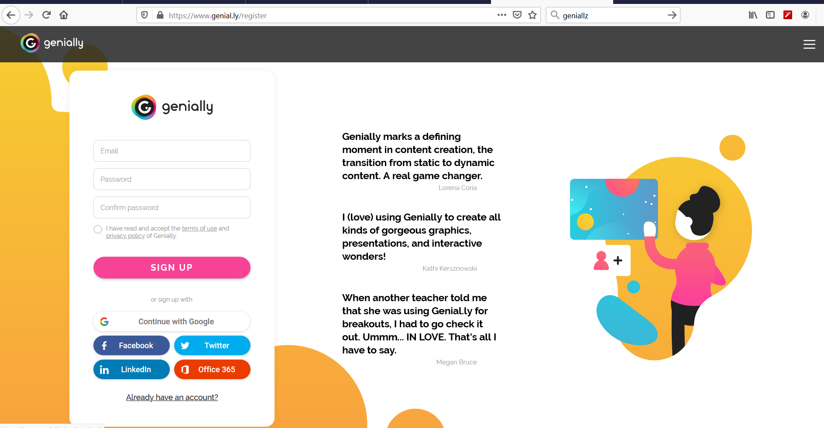
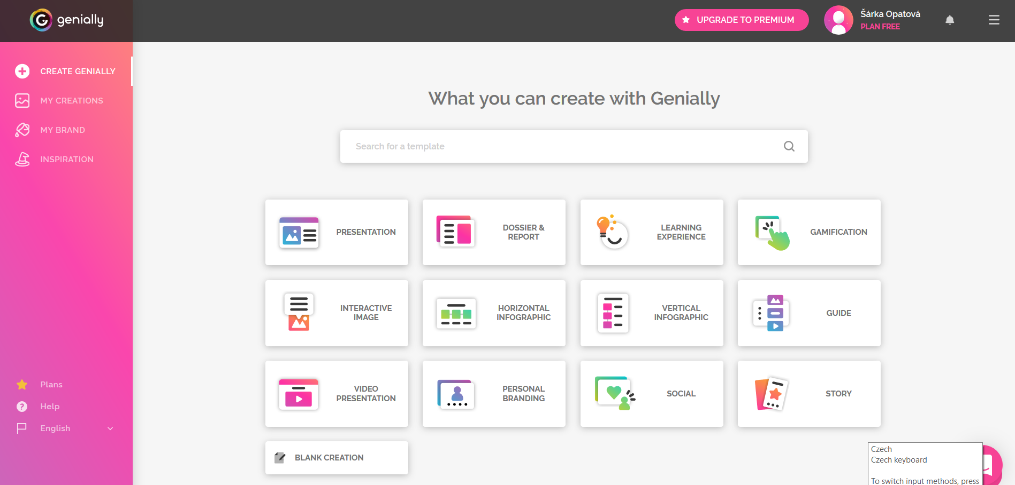

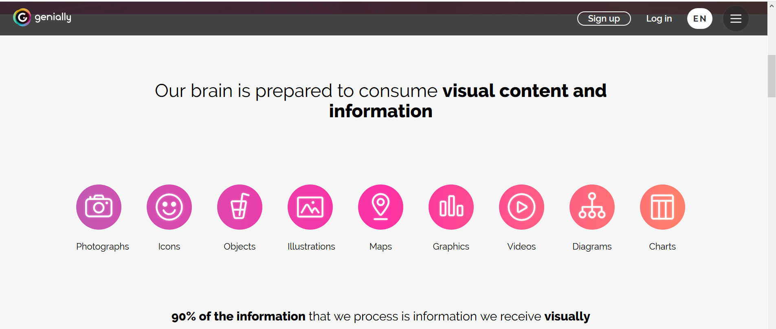

You can label a picture and create a Pictionary.
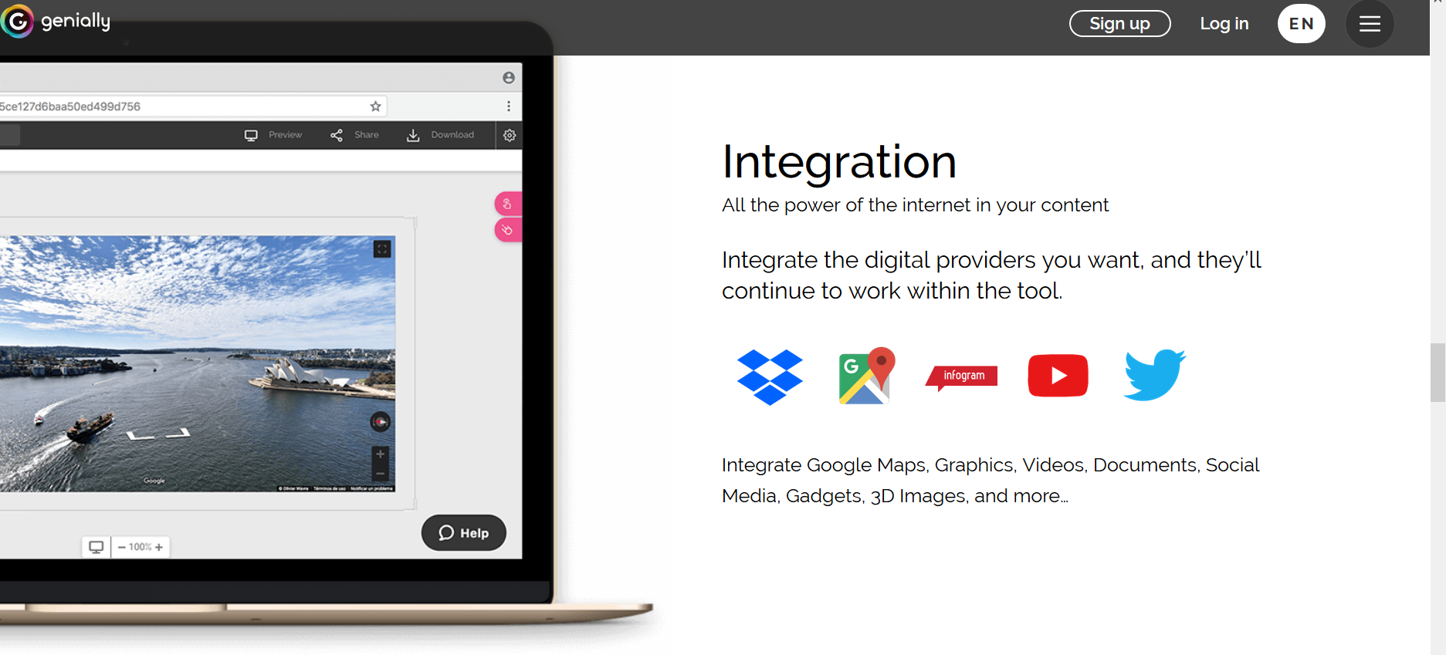

VIDEO TUTORIAL FOR STUDENTS by KYLE NIEMIS:
https://www.youtube.com/watch?v=no-4o7sC1QI

1) CREATE GENIALLY 2) VIDEO PRESENTATION (for example) 3) CHOOSE A TEMPLATE (with a * is paid !)

4) e.g. TRAVEL TEMPLATE
CHOOSE THE FIRST PAGE and start editing.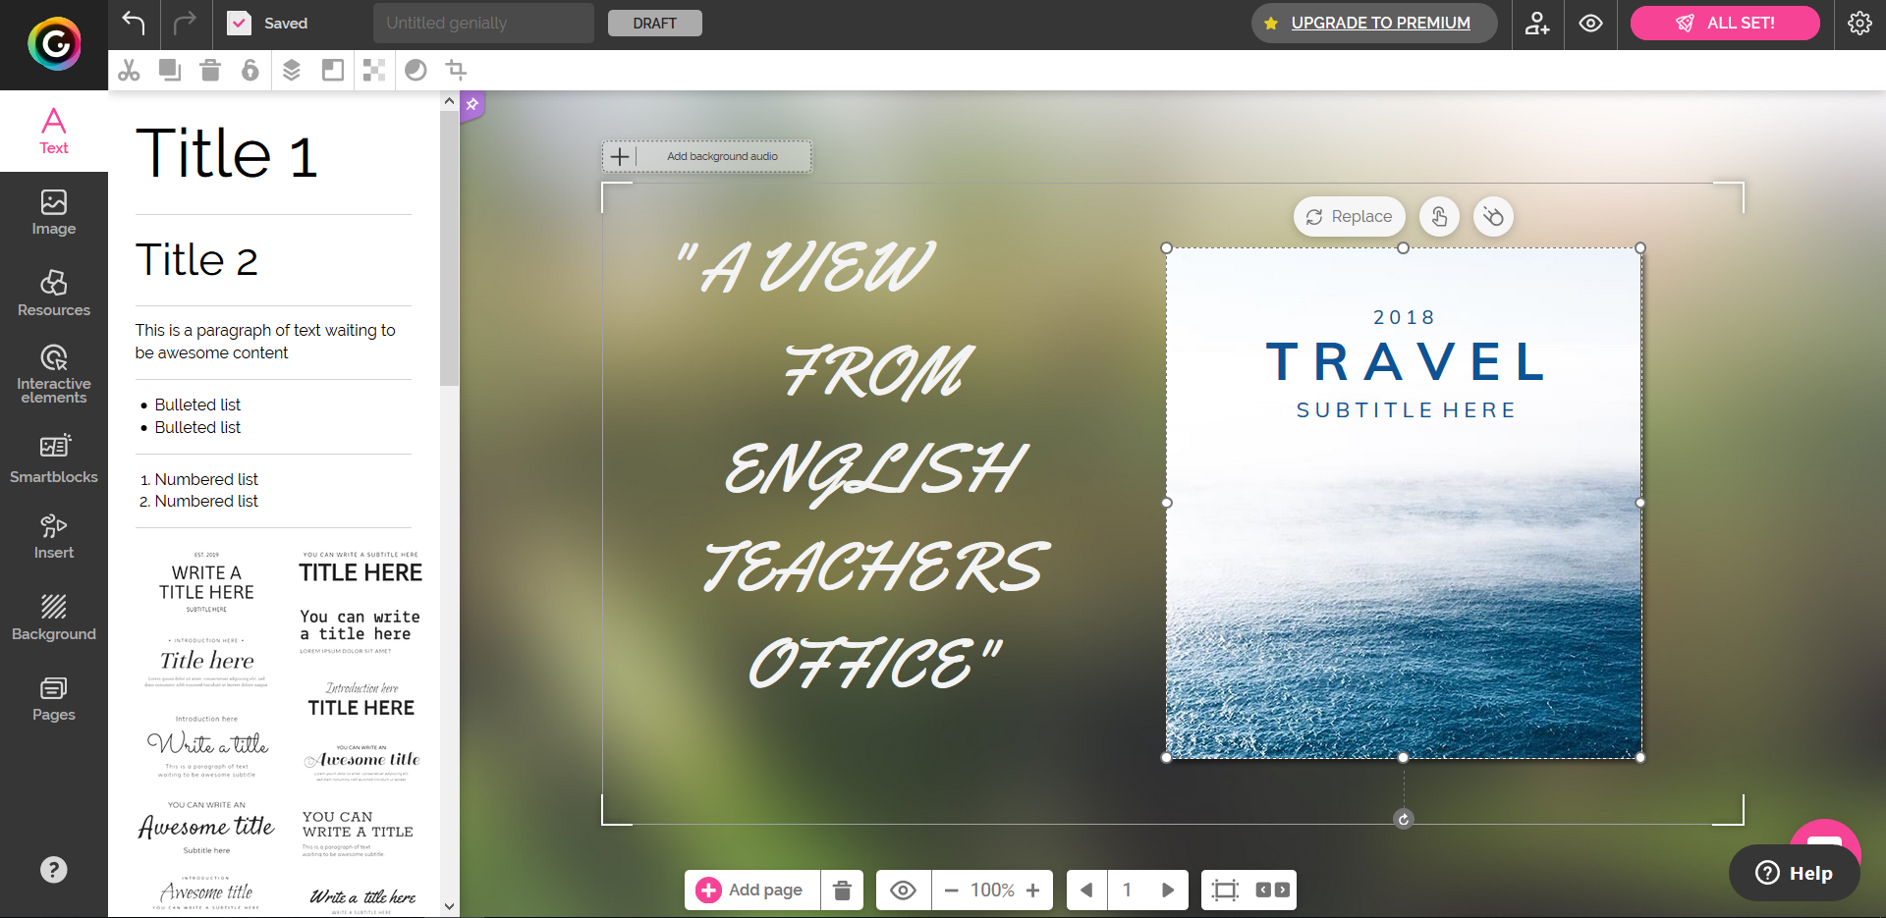
My created example: https://view.genial.ly/5df207149ddc450f5e792450/video-presentation-untitled-genially

