SoukainaBenamar

Hello

My name is Soukaina Benamar. I am 17 years old and I’m excited to introduce myself. I’m a spontaneous and cheerful girl (as you can see in the picture). I’m a really positive person, because that’s the only thing that helps me in difficult times. I enjoy the little things in life. The sound of birds in the summer, reading a good book on my own or travelling around the world to discover other cultures makes me happy. So I ’m excited to be a part of this project.

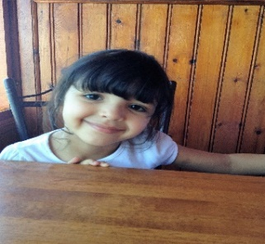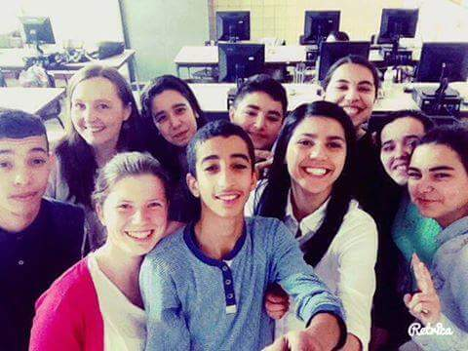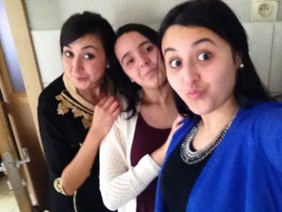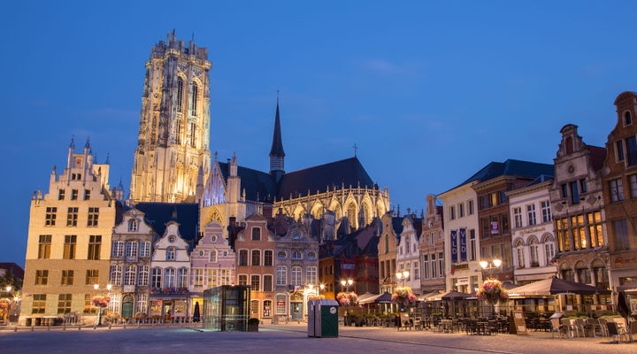

Friends and family are important for me. I live in a nuclear family with my beautiful parents, two older brother and two younger sisters. My father is a bus driver. My parents are born in Morocco. So the Moroccan culture is not unknown for me. Every holiday we visit the country. My friends mean a lot to me. I have a very diverse group of friends. I see them in school and on holidays. We often go to the shopping center to make fun, to laugh and to enjoy life.

I live in Belgium in a city that is called Mechelen. It is a lovely city with lovely people. I also go to school there. So every morning I take my bicycle. My school is called Ursulinen and I study Office Assistance. I like to study languages. It helps me to communicate with people in other countries and that is important for me.

I’m exciting to see you all!

I

Kind regards!