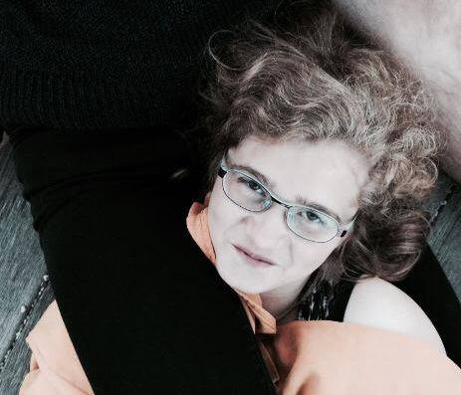
Hello everybody! :)

My name is Iveta Brajerová and I am 17 years old. I live in a small town Dobříš in Czech Republic. I study at grammar school called Gymnázium Karla Čapka.
I am not a social person. I need some time when I meet some new people. But my friends know that I can be very loud and crazy. I would say that I am introvert with some extrovert moments. :)
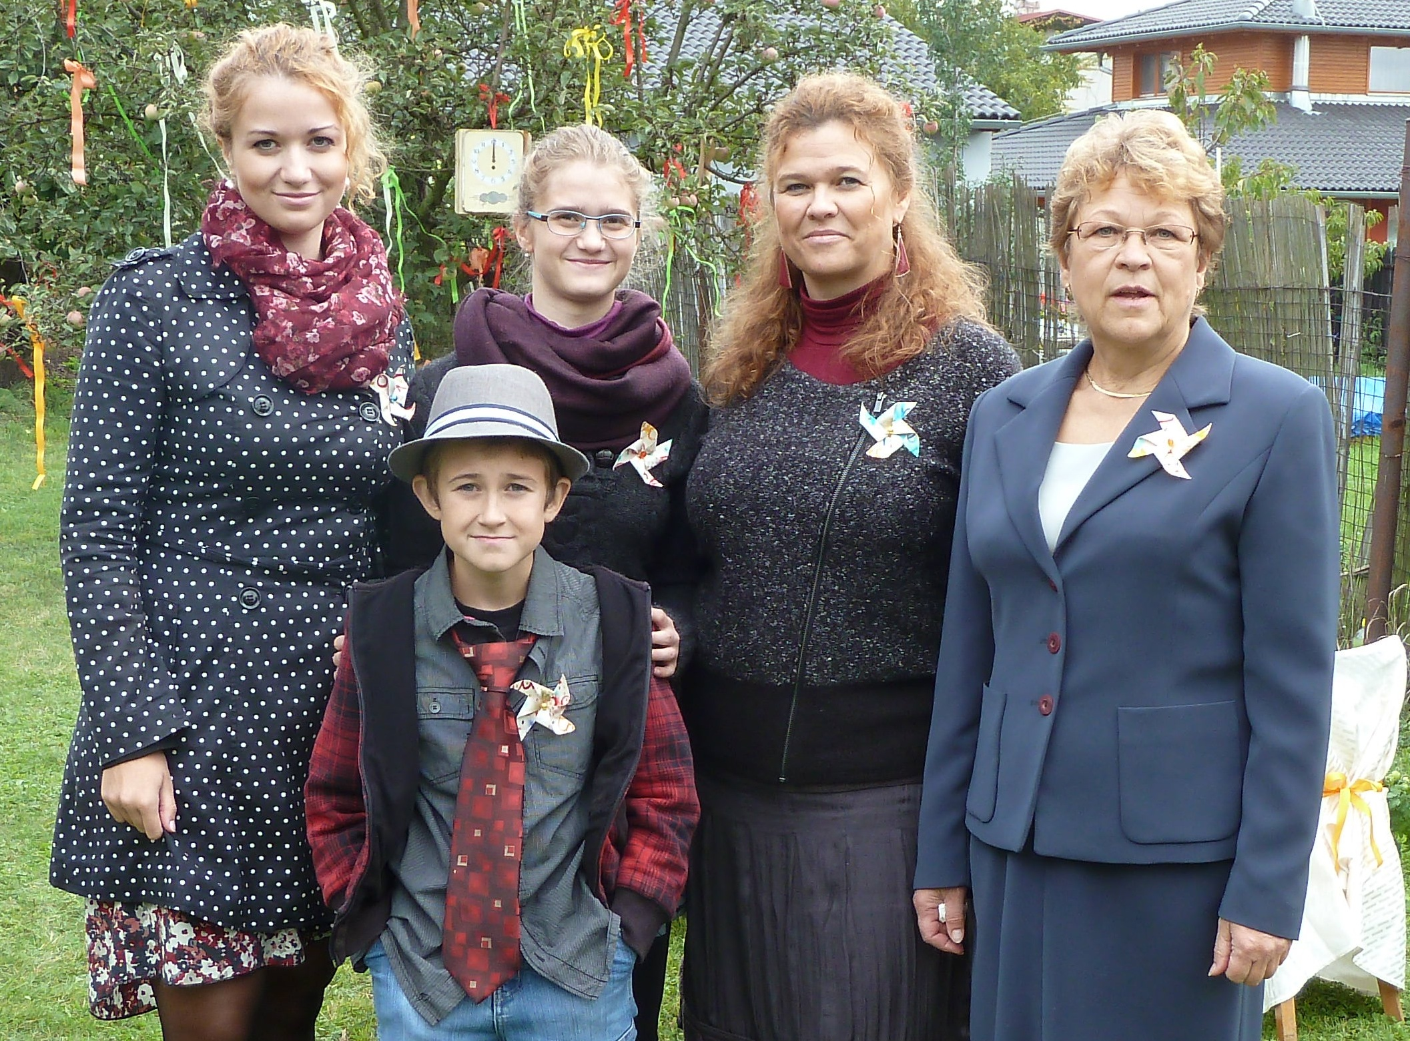
Me :)
My family...
I have one brother and one sister. My sister is 21 a her name is Kamila and my brother Jakub is 13 years old. My mum works as a nurse in a hospital. My dad is a bank clerk.
We live in a flat. It isn´t small but I haven´t got my own room so my siblings often get on my nerves. :D
I have three guinea pigs and at the moment only one fish.
Me and my family :)
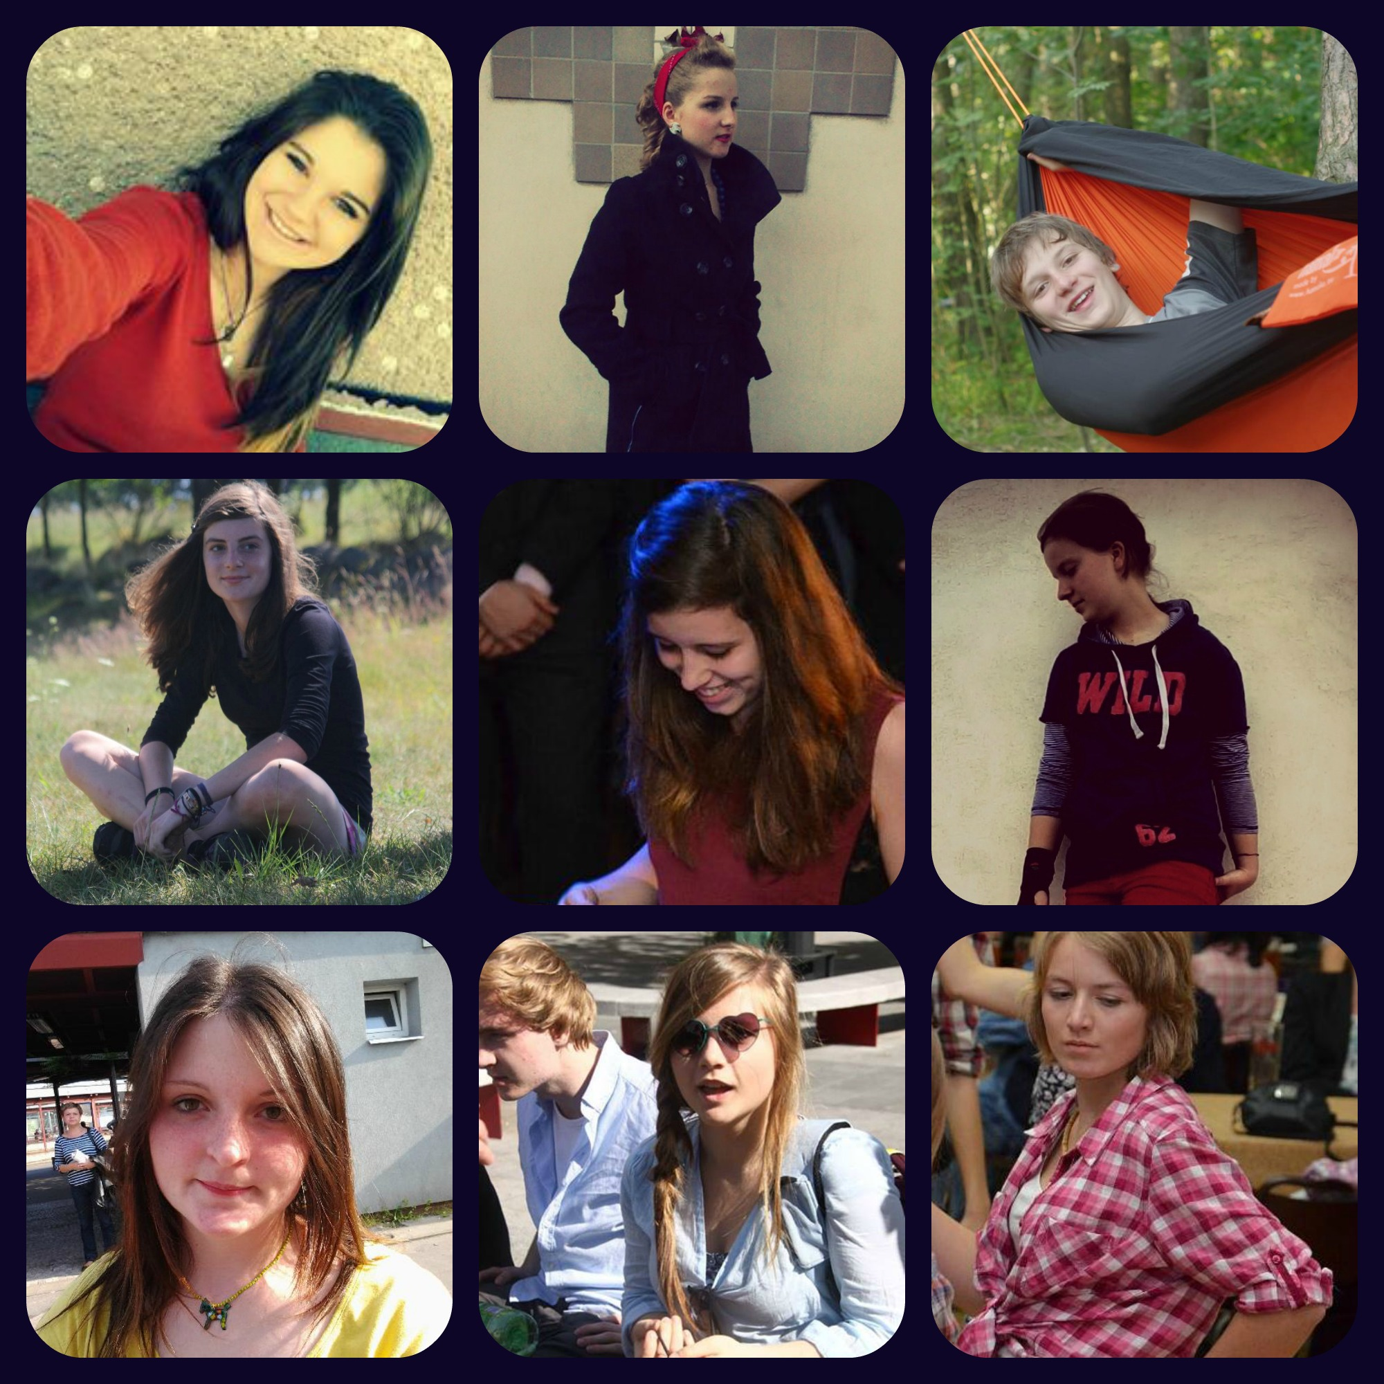
My hobbies...
I really like going out with my friends. It is the thing I love the most. Besides that, I like drawing, playing the piano and MUSIC! Music is very important for me. I haven´t got a favourite band but I listen for example Nirvana, Beatles, Red Hot Chili Peppers, Radiohead, Oasis...
I have been a scout for 10 years and I met good friends there. My good friends are in the school, too. It´s the reason why I go to school.
That´s all about me. If you want to know me better, write me on facebook- Iveta Brajerová.

My best friends! :)

