Hello!!
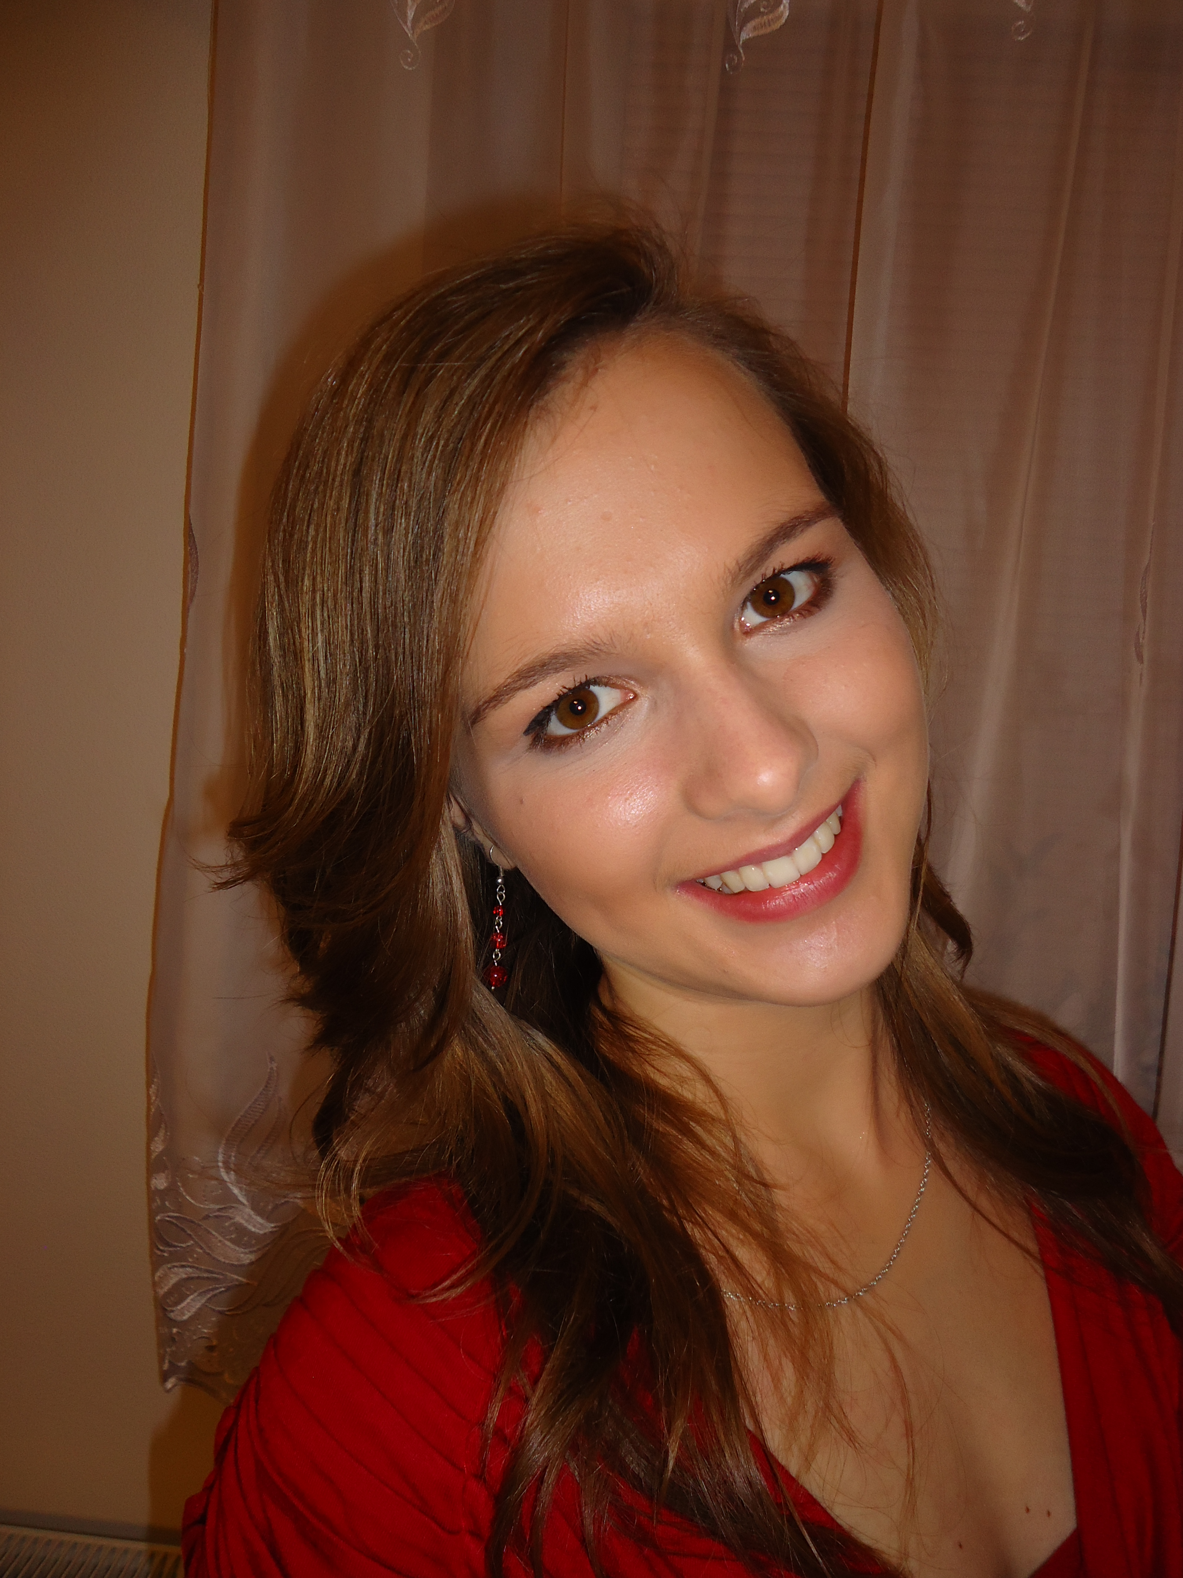This is me :)

My name is Kamila . I´m 17 years old. I live in Dobříš in a family house with my family. I have older brother. His name is Vojta and he studied also at our gymnazium. Now he studies at a university.
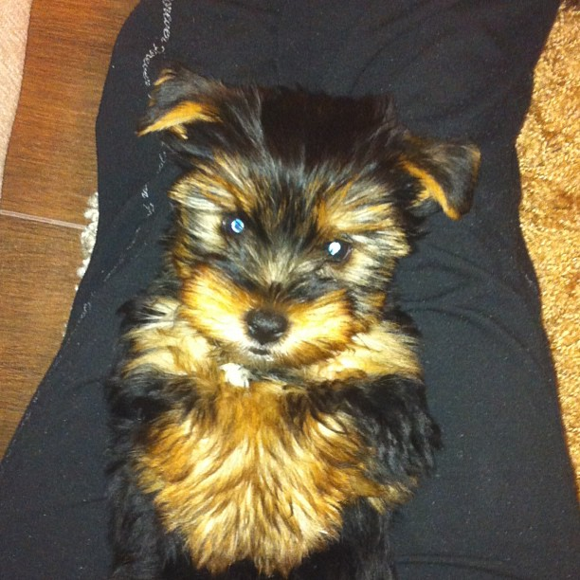Our love!!! - Max
We have a small dog. His name is Max. He is young and he enjoys running in our garden.

I´ve been studying Gymnazium Karla Čapka in Dobříš for two years. My favourite subjects are Literature, History and languages. I would like to work as a TV presenter in the future.
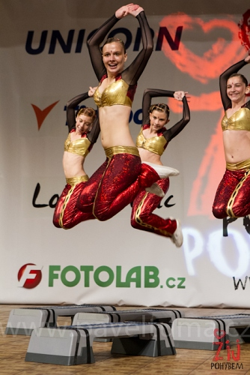Aerobics!!! :)
My great hobby is aerobics. I first started doing aerobics at the age of seven. I practise aerobics in
a eight-member group. I love the atmosphere at competitions with my friends.

Next my hobby is fashion. I love shopping as
every girl. :)
I also like travelling. I visited Slovakia, England, Austria, Turkey, Egypt, Tunisia, Croatia, Germany and Poland.
I love spending time with my friends. I like going to the cinema and I like watching movies.
I also like meeting new people and I enjoy communicating with them.

It´s all about me. :)

Follow me and contact me on my facebook (https://www.facebook.com/kamila.paulova)
and my instagram(camilla236)

