FAMILY LIFE

In the Italian scene, Italian people live hectic lives, but the family is still an important unit. Of course, its structure has highly changed in the XX century and the present because of many reasons. Nowadays we can refer to the Italian family as a nuclear family, no much to do with the large families before and soon after the first and second world wars. The change from the larger families with parents, grandparents and maybe uncles and aunties to a nuclear family has required longer time than what has happened in the rest of Europe. On average the family is made up of three people (parents and one child), but there has been an increase of one-parent family.
Most young Italians live with their parents until they are over 28, 30 mainly because there is a difficulty in affording housing expenses, and nowadays with the crisis, the situation can’t really improve as the rate of unemployment among young people is rather high.
Our group has organised for this article according to the results of some interviews (with parents and grandparents) and reading some newspaper articles based on ISTAT (the National Institute of Statistics) results.
Members and relationship: In the past families were more numerous and larger and parents were more authoritative, especially the father. The mother was usually a housewife and took care of the children. Nowadays a lot of women work especially in the north of Italy even if the rate of employment for Italian women is rather low if compared to the rest of Europe. In 2013 it was 47%.
Around 50% of the women working, leave their job after their first child.
As for young people, they tend to be at home longer with their parents. About 70% of Italian young people (20 to 30 years old) live with their parents. It seems to be an obliged choice because of their study and the difficulty of finding a job therefore to afford a living. 43% of young people live their original family because they get married.
Today the relationship seems to have improved, especially for teenagers who are asked to express their opinions.
The main values for all generations were and still are: truth, honesty, respect, education, independence.
Income: At grandparents’ time the income was surely smaller and the father was the breadwinner. The income was mainly used for primary necessities, very little was left for holidays and amusements. Nowadays it is quite normal that both parents work and they can offer a better living standard to their children.
Habits: Family habits haven’t changed so much; the woman was and is the person in charge of the housework even if nowadays the husband and children are more likely to help and they share duties. In general it's not used to have a maid.
In the past the family members used to have lunch and dinner together at home, nowadays instead the main meal for all the family is dinner. At lunch time grannies are more likely to look after the children’s lunch.
As for the bringing up of the children, in the past they were brought up by mother and grand-mother, nowadays they are looked after by babysitters and both parents contribute. Most of the young children start their school life at nursery school if grandparents are not available. In the past there were differences in bringing up boys and girls. Girls played with dolls and in their games they were trained to be good housewife. Today the differences are less evident.
As in the past Italians often gather as a family to celebrate special occasions or just to come and enjoy a meal and to stay together on Sunday. Many families stay at home watching television, listening to the radio, reading books etc. Other families go to visit grandparents who live in different cities.
Accomodation: The Italian family usually owns the house or flat where they live. In 2013 about the 81% of Italian families owned their house which they bought usually asking for a loan. The property of a house is still considered a good way to invest their money.

Marriage: In 2012 there were 207,138 marriages and compared to the previous years the number was a little bit higher. The average age is 34 for men and 31 for women; 122,297 weddings had a celebration in church. These religious marriages seem to last longer.
Divorce: Everybody says that the family should be the fundamental part of the society, but on the contrary, it is always more and more difficult to keep a long marriage.
Anyway, in 2012 for the first time separations (88,288) were decreasing a little bit as divorces (51,319). On average the couple ask for separation after 16 years, divorces come after 19 years. The more recent marriages tend to be of a shorter time.

http://27esimaora.corriere.it/articolo/le-donne-italiane-lavorano-11-ore-piu-degli-uomini/
http://www.axerta.it/news/124/statistiche_separazioni_divorzi_italia.htm http://www.repubblica.it/cronaca/2010/01/18/news/figli_d_europa-1988968/

Typical old houses
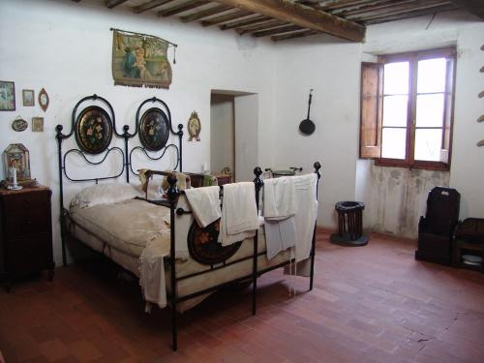
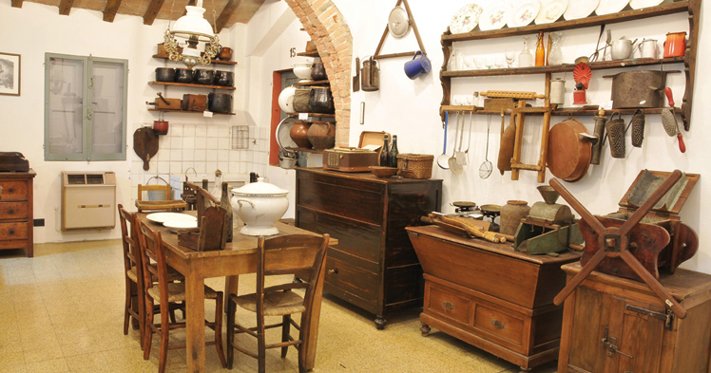
Tools and kitchen equipment in a house of farmers

The bedroom of a house in the countryside
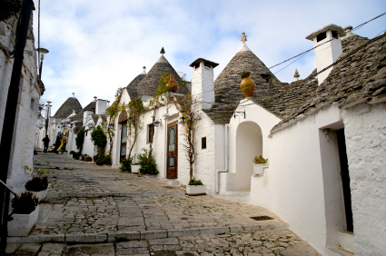 Trulli in Puglia (Old style house in the countryside)

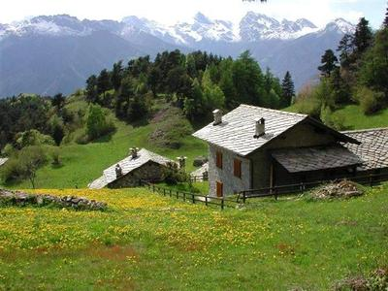
Baita in the Alps

Houses of today

Andrea, Giulia, Lucia Vittoria, Filippo, Martina, Giada, Greta, Bianca, Leonardo, and Aleksandra.

