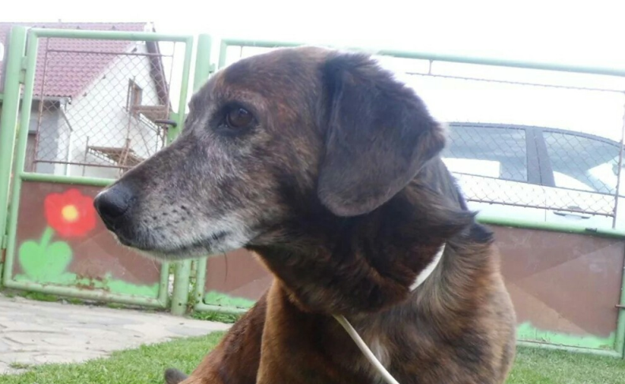
My name is Martin I'm seventeen years old. I live in the village Buková u Příbramě, it's near Dobříš something about six kilometers. We have a spacious house with a large garden. My family live in attic and under us lives my grandmother. I have an older brother Tomáš, he is twenty-two and the dog Míša.

I have been studying at Gymnázium Karla Čapka in Dobříš. My hobbies are: reading, listening to music, playing computer games and spending time with friends. Sometimes I´m playing MTG. My favourite music bands are: Tristania, Powerwolf, Death Angel and a lot of more. I have no favourite books because it's impossible to choose it. I'm a friendly, crazy and hyperactive guy with sense of humor. My favourite movies are: LOTR, Hobbit and all episodes of Resident evil.

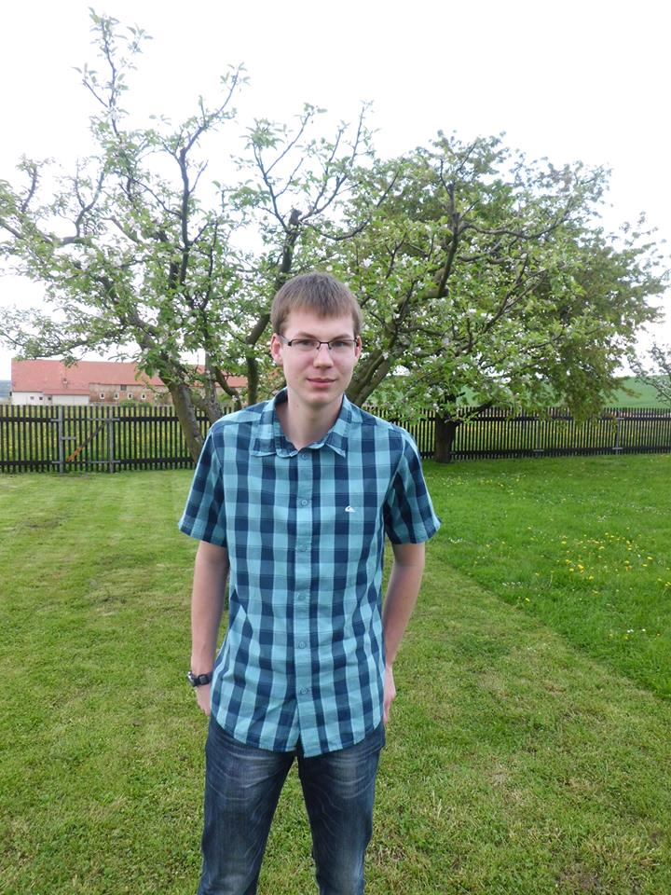
I do not like unfriendly people and people who think they´re the best. Then I realy do not like some subjects at school for example History and Chemistry. I do not like this two subjects because I have problem to remember all eras and chemical formulas. Subjects which I like are Math (We have a nice teacher), Physics (I am interested in it) and that is all ☺.

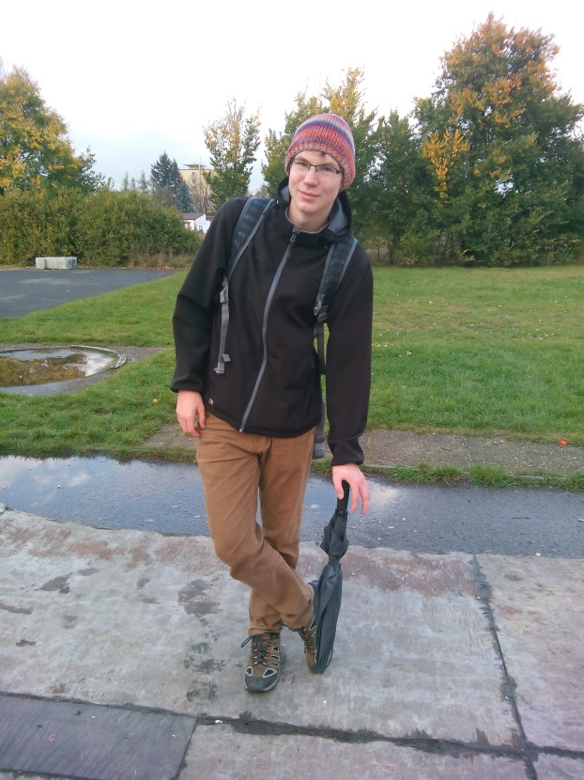Me

My dog

