Classroom of the future

1 Watch a video and answer the question
https://www.youtube.com/watch?v=O_x4OLsfReQ
Q: How do you like a flexible classroom format?
A:

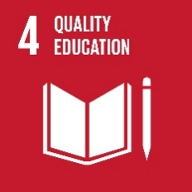

Global goal 4 – QUALITY EDUCATION
2 Read about the Quality education and its targets, answer the question
https://www.globalgoals.org/4-quality-education

10 targets
Q: In which countries might they be a problem? What about the Czech Republic?
A:

3 Do the activity
- draw a large outline of a person. Think about what qualities and characteristics an educated person might have. Write these within the outline of the person.
- draw a big circle around the drawing of the person to represent the world. Students should now discuss what the qualities and characteristics of a world full of educated people would be
Use: autodraw.com (start drawing on a new sheet)

