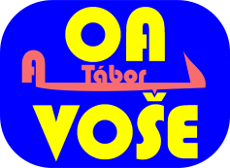
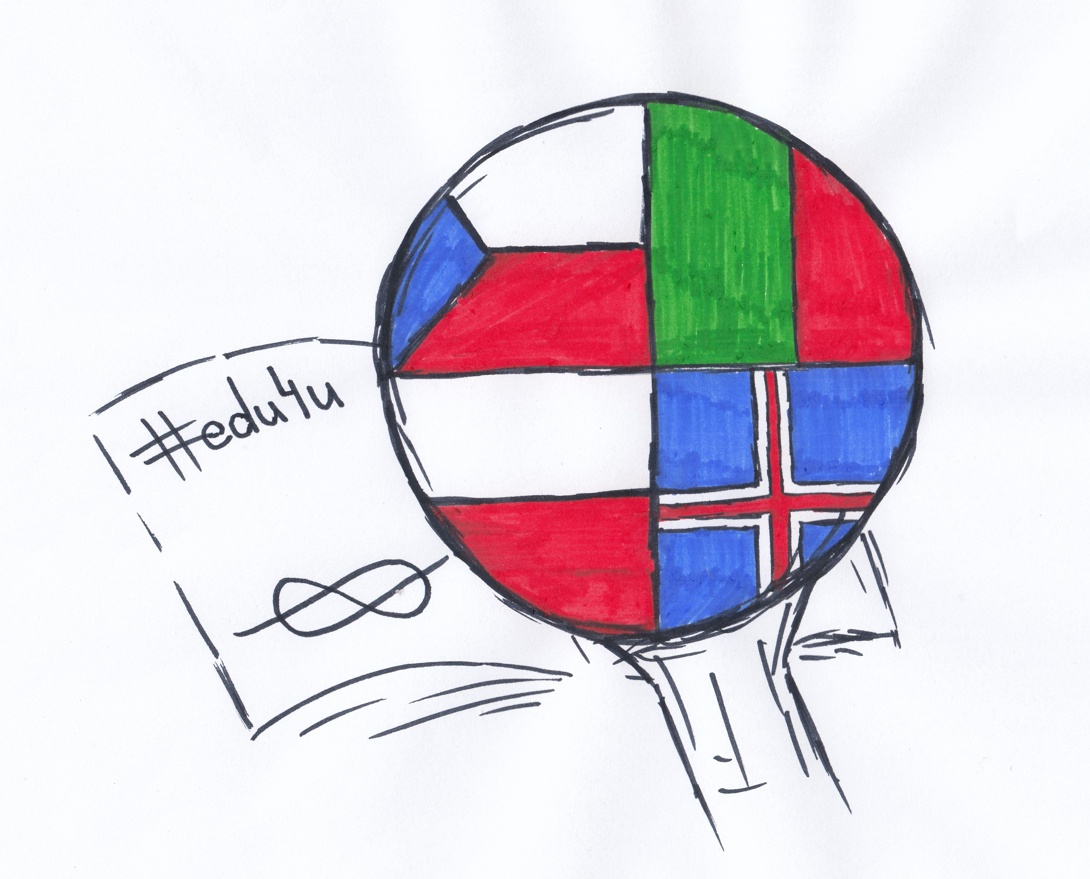
Tábor Training Event, February 16th -22nd,2020

Date | Morning | Afternoon | Evening
Sunday  February 16th |  | Arrival of partner schools,  welcoming and accommodation | Arrival of partner schools, welcoming and accommodation
Monday  February 17th  SCHOOL | Breakfast (hotel)  8:00 Meeting at school  8:15 Official opening  8:30 – 10:00 Icebreaking activities  10:00 – 12:00 Debating (Ideal School) | 12:00 Lunch (school canteen)  13:00 – 14:30 Creating a poster, presenting outcomes of Ideal School  Teachers´ Meeting | 17:30 Dinner (school canteen)
Tuesday  February 18th  SLAVONICE | Breakfast (hotel)  7:15 Departure for Slavonice (by coach, meeting point: outside train station)  9:00 WW II fortifications, museum, forest trail | 13:00 Creative pottery workshop with lunch | 18:00 Dinner (school canteen)
Wednesday  February 19th  SCHOOL | 8:00 Doing business - mixed teams, school  (creating a company – profile, products, SWOT analysis, preparing presentations and speeches), 3D designs | 12:00 Lunch (school canteen)  13:00 Presentation of the companies  13:30 – 15:00 Tábor Rally in mixed teams  Teachers´ meeting | 17:30 Dinner (school canteen)  Teachers – special programme
Thursday  February 20th  PRAGUE | Breakfast (hotel)  7:01 Departure for Prague (train; 6:45 meeting)  9:00 The Museum of Senses  10:30 – 14:30 Guided tour in mixed teams with treasure hunt tasks | Lunch packet  After the guided tour - free time in Prague, leaving for Tábor at 17:31 (Tábor 18:56)
Friday  February 21st  SCHOOL | Breakfast (hotel)  9:00 Making – workshops with Ozobots and Micro:bits (mixed teams) | 12:00 Lunch (school canteen)  13.00 – 13:45 Certification, end of the event  Free activities in town | 17:00 Dinner (school canteen)
Saturday  February 22nd | Breakfast (hotel)  Departure of partner schools

