- ECOala

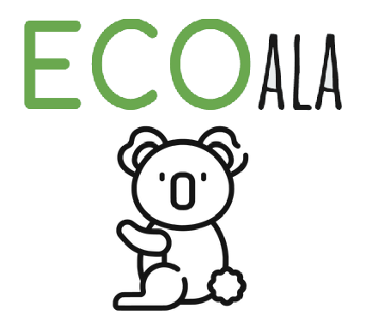
4.
Hug Nature, go eco go ecoala
5. You have to download the application “Augment”, and scan the QRcode, and that´s it .

6. Maria Amado, Clara Lopes, Francisco Rabaça, Thorbjorg Jonasdottir, Kamil Weglorz

