- Pet-Jamas

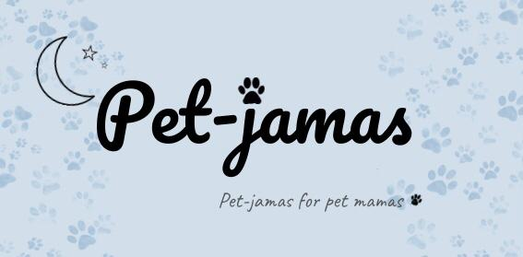
4.
Pet-Jamas for pet mamas
5. You have to download the application “Augment”, and scan the QRcode, and that´s it .

6. Pedro Lourenço, Margarida Morais, Sophie Taylor, Roman Antoni, Luca Rez

