1. Ocean Pearl
2. 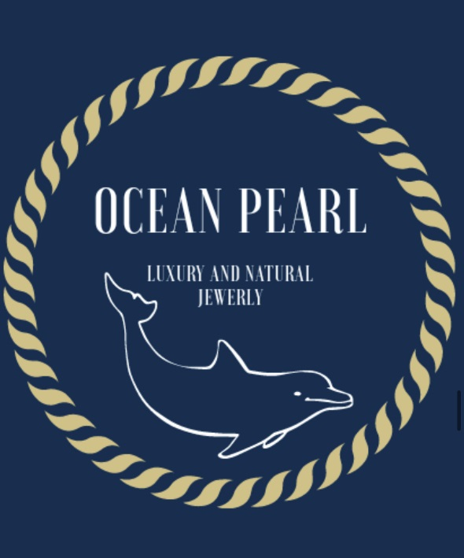
3.
4. Saving the planet in style
5. After downloading the Augment app, scan the QR code below, point your camera at a random surface with good lighting and watch your construction come to life.
6. Gudlaug, Isabel, Matheus, Paula, Lourenço

