Worksheet
Doing a bit with a Micro:bit
1) Download the Micro:bit application from the store
2) Open CREATE CODE, then new project
3) Write something instead of hello (start = 1x; forever = repeatedly):
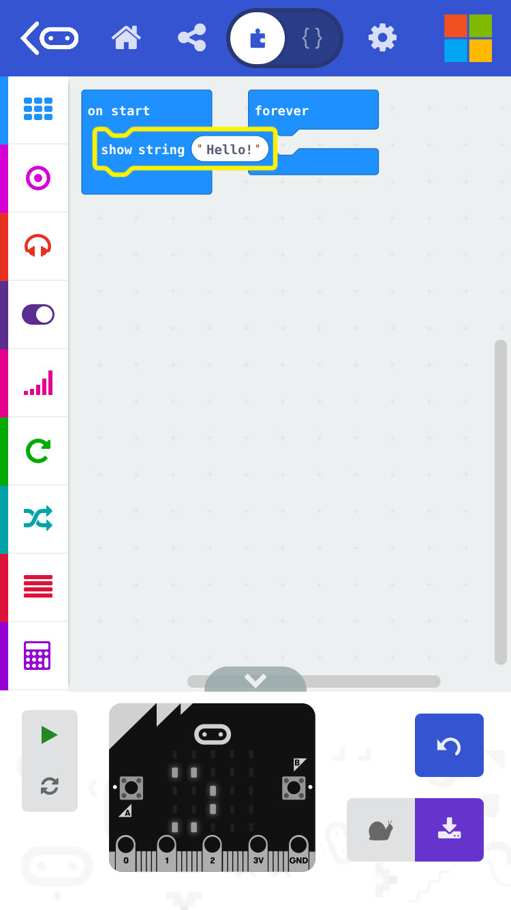 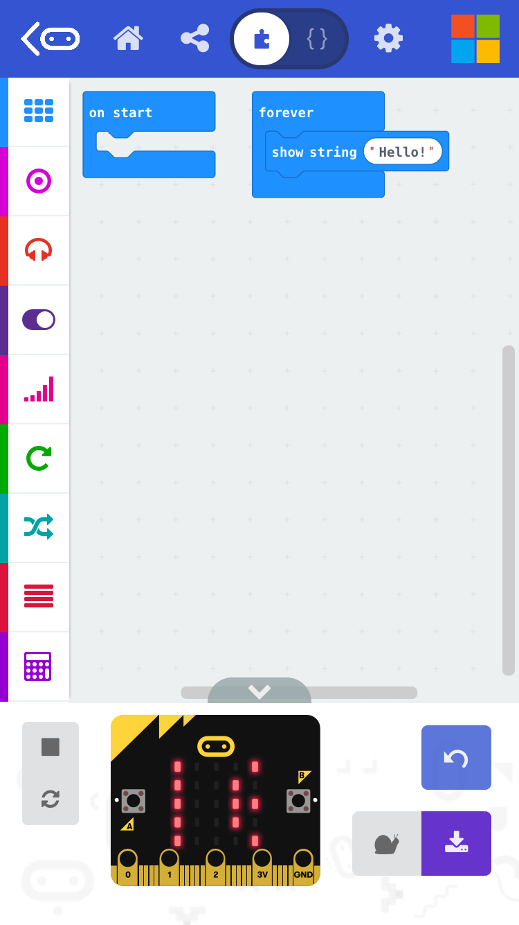
Add a pause
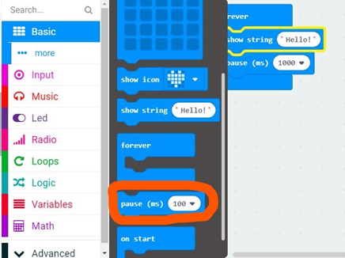
Connect with MIcro:bit – FLASH (download)

4) Create an image or a smiley:
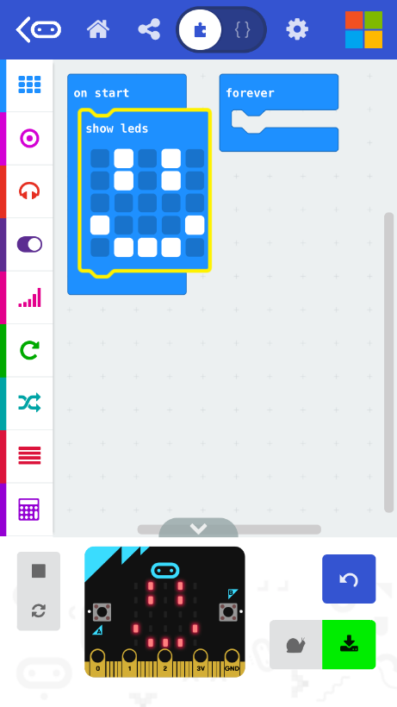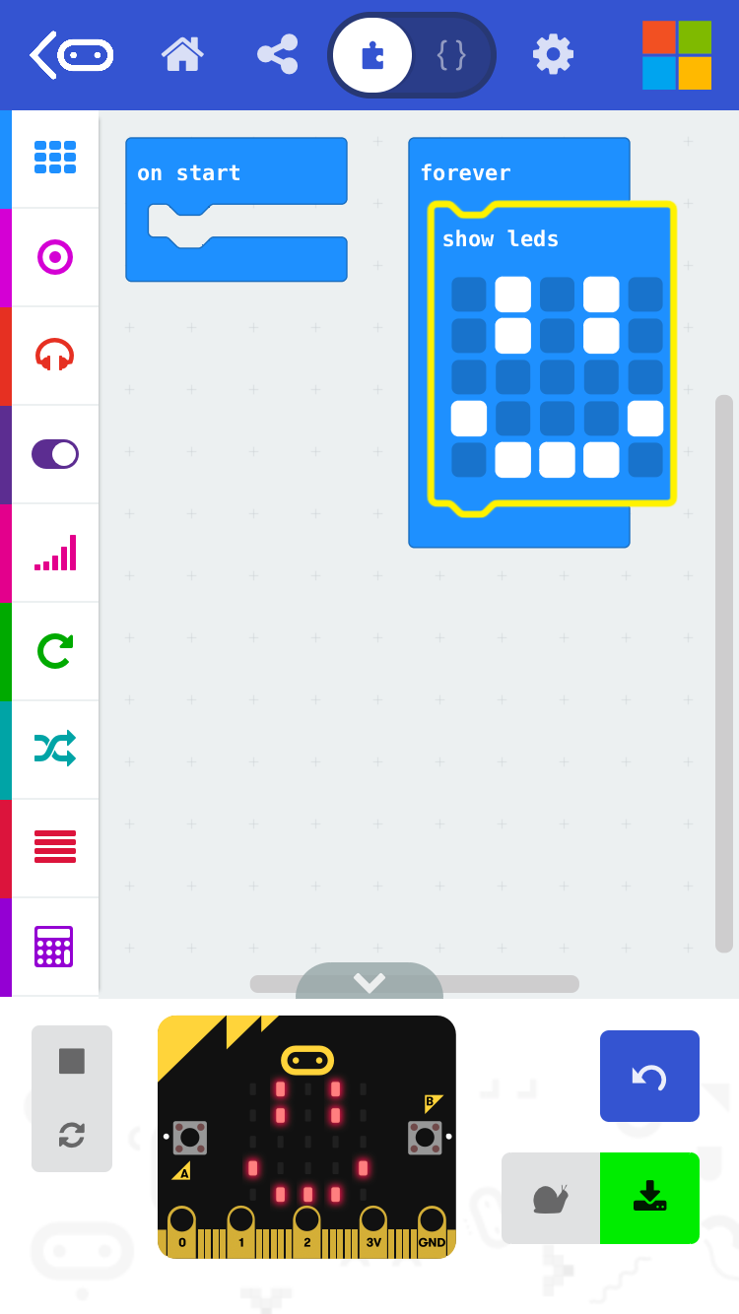

Add a pause
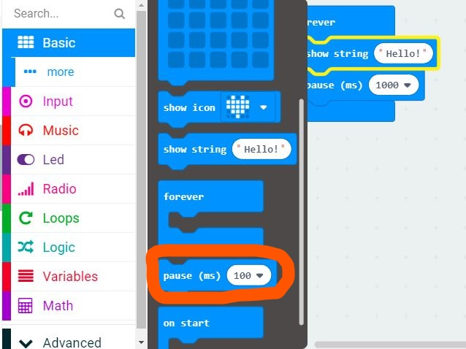

Connect with Micro:bit – FLASH (download)

5) Make a compass
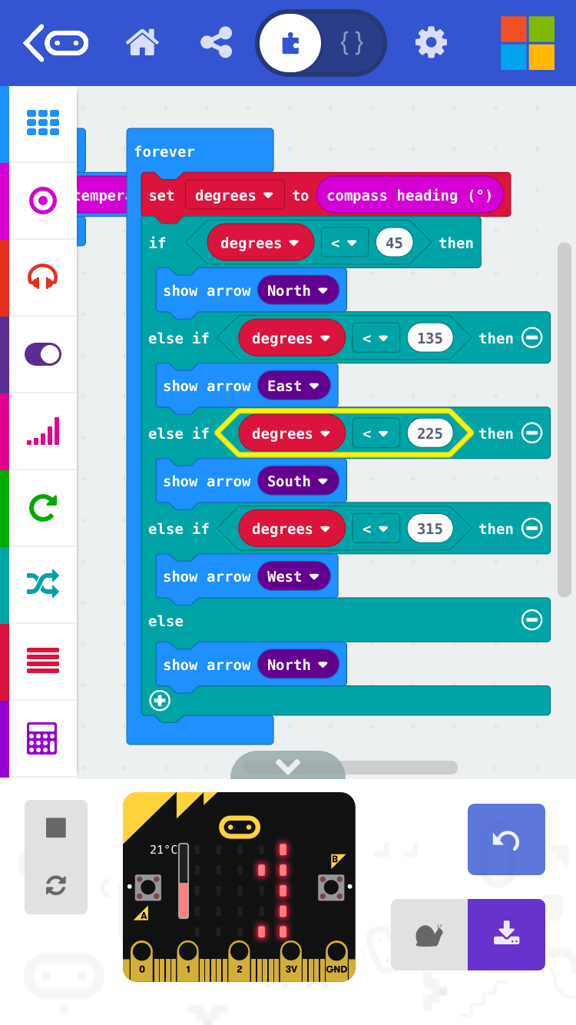

Connect with MIcro:bit – FLASH (download)

6) Make a dice
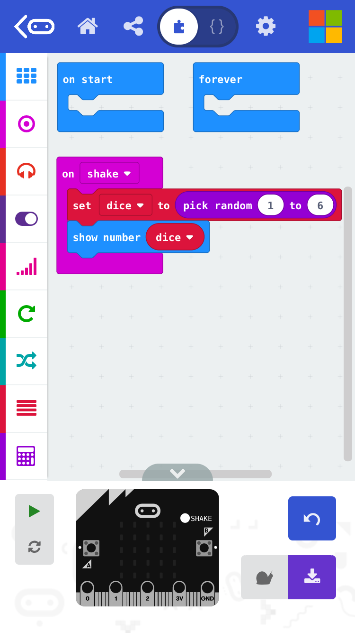
Connect with Micro:bit – FLASH (download)

FINAL TASK on Micro:bit

- Enter the name of your business + some other symbols for visualisation
- Make a short video of about 20 sec
- Send it to an email: jandlova@oatabor.cz

