Company’s name: Care4Edu
Company’s Logo:
QR code to the stand:
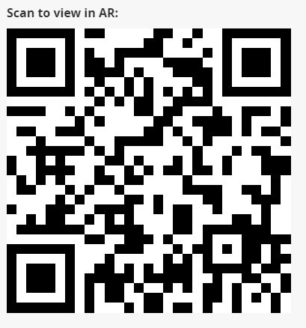

Slogan:
Education is the most powerful weapon to change the world - Nelson Mandela

Explanation of the app:
The name of the app is Augment. Once you have downloaded it, press the QR scan button and scan the QR code you want to see in AR. Then point your phone camera to the floor and place the virtual stand model.
Made by:
Filipe Barreiros
Sonia Klusek
Margarida Sá Machado
Sigurlaug Sigmundsdóttir

