Diverseyes
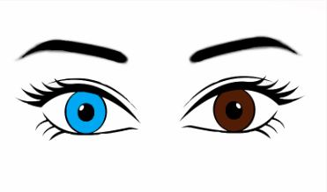
We thought that eyes show our differences in a beautiful way. Working on this project we of course notice that we look different but we also think different. We come from all around the world, with that comes cultural differences. We are used to doing thing one way and the others are used to doing things another type of way. This can sometimes create a misunderstanding but in the end we are all humans with the same rights even though we behave differently. We thought that eyes show our differences in a beautiful way. Working on this project we of course notice that we look different but we also think different. We come from all around the world, with that comes cultural differences. We are used to doing thing one way and the others are used to doing things another type of way. This can sometimes create a misunderstanding but in the end we are all humans with the same rights even though we behave differently.
Slogan: embracing one another uniqueness

Thank you for your attention

