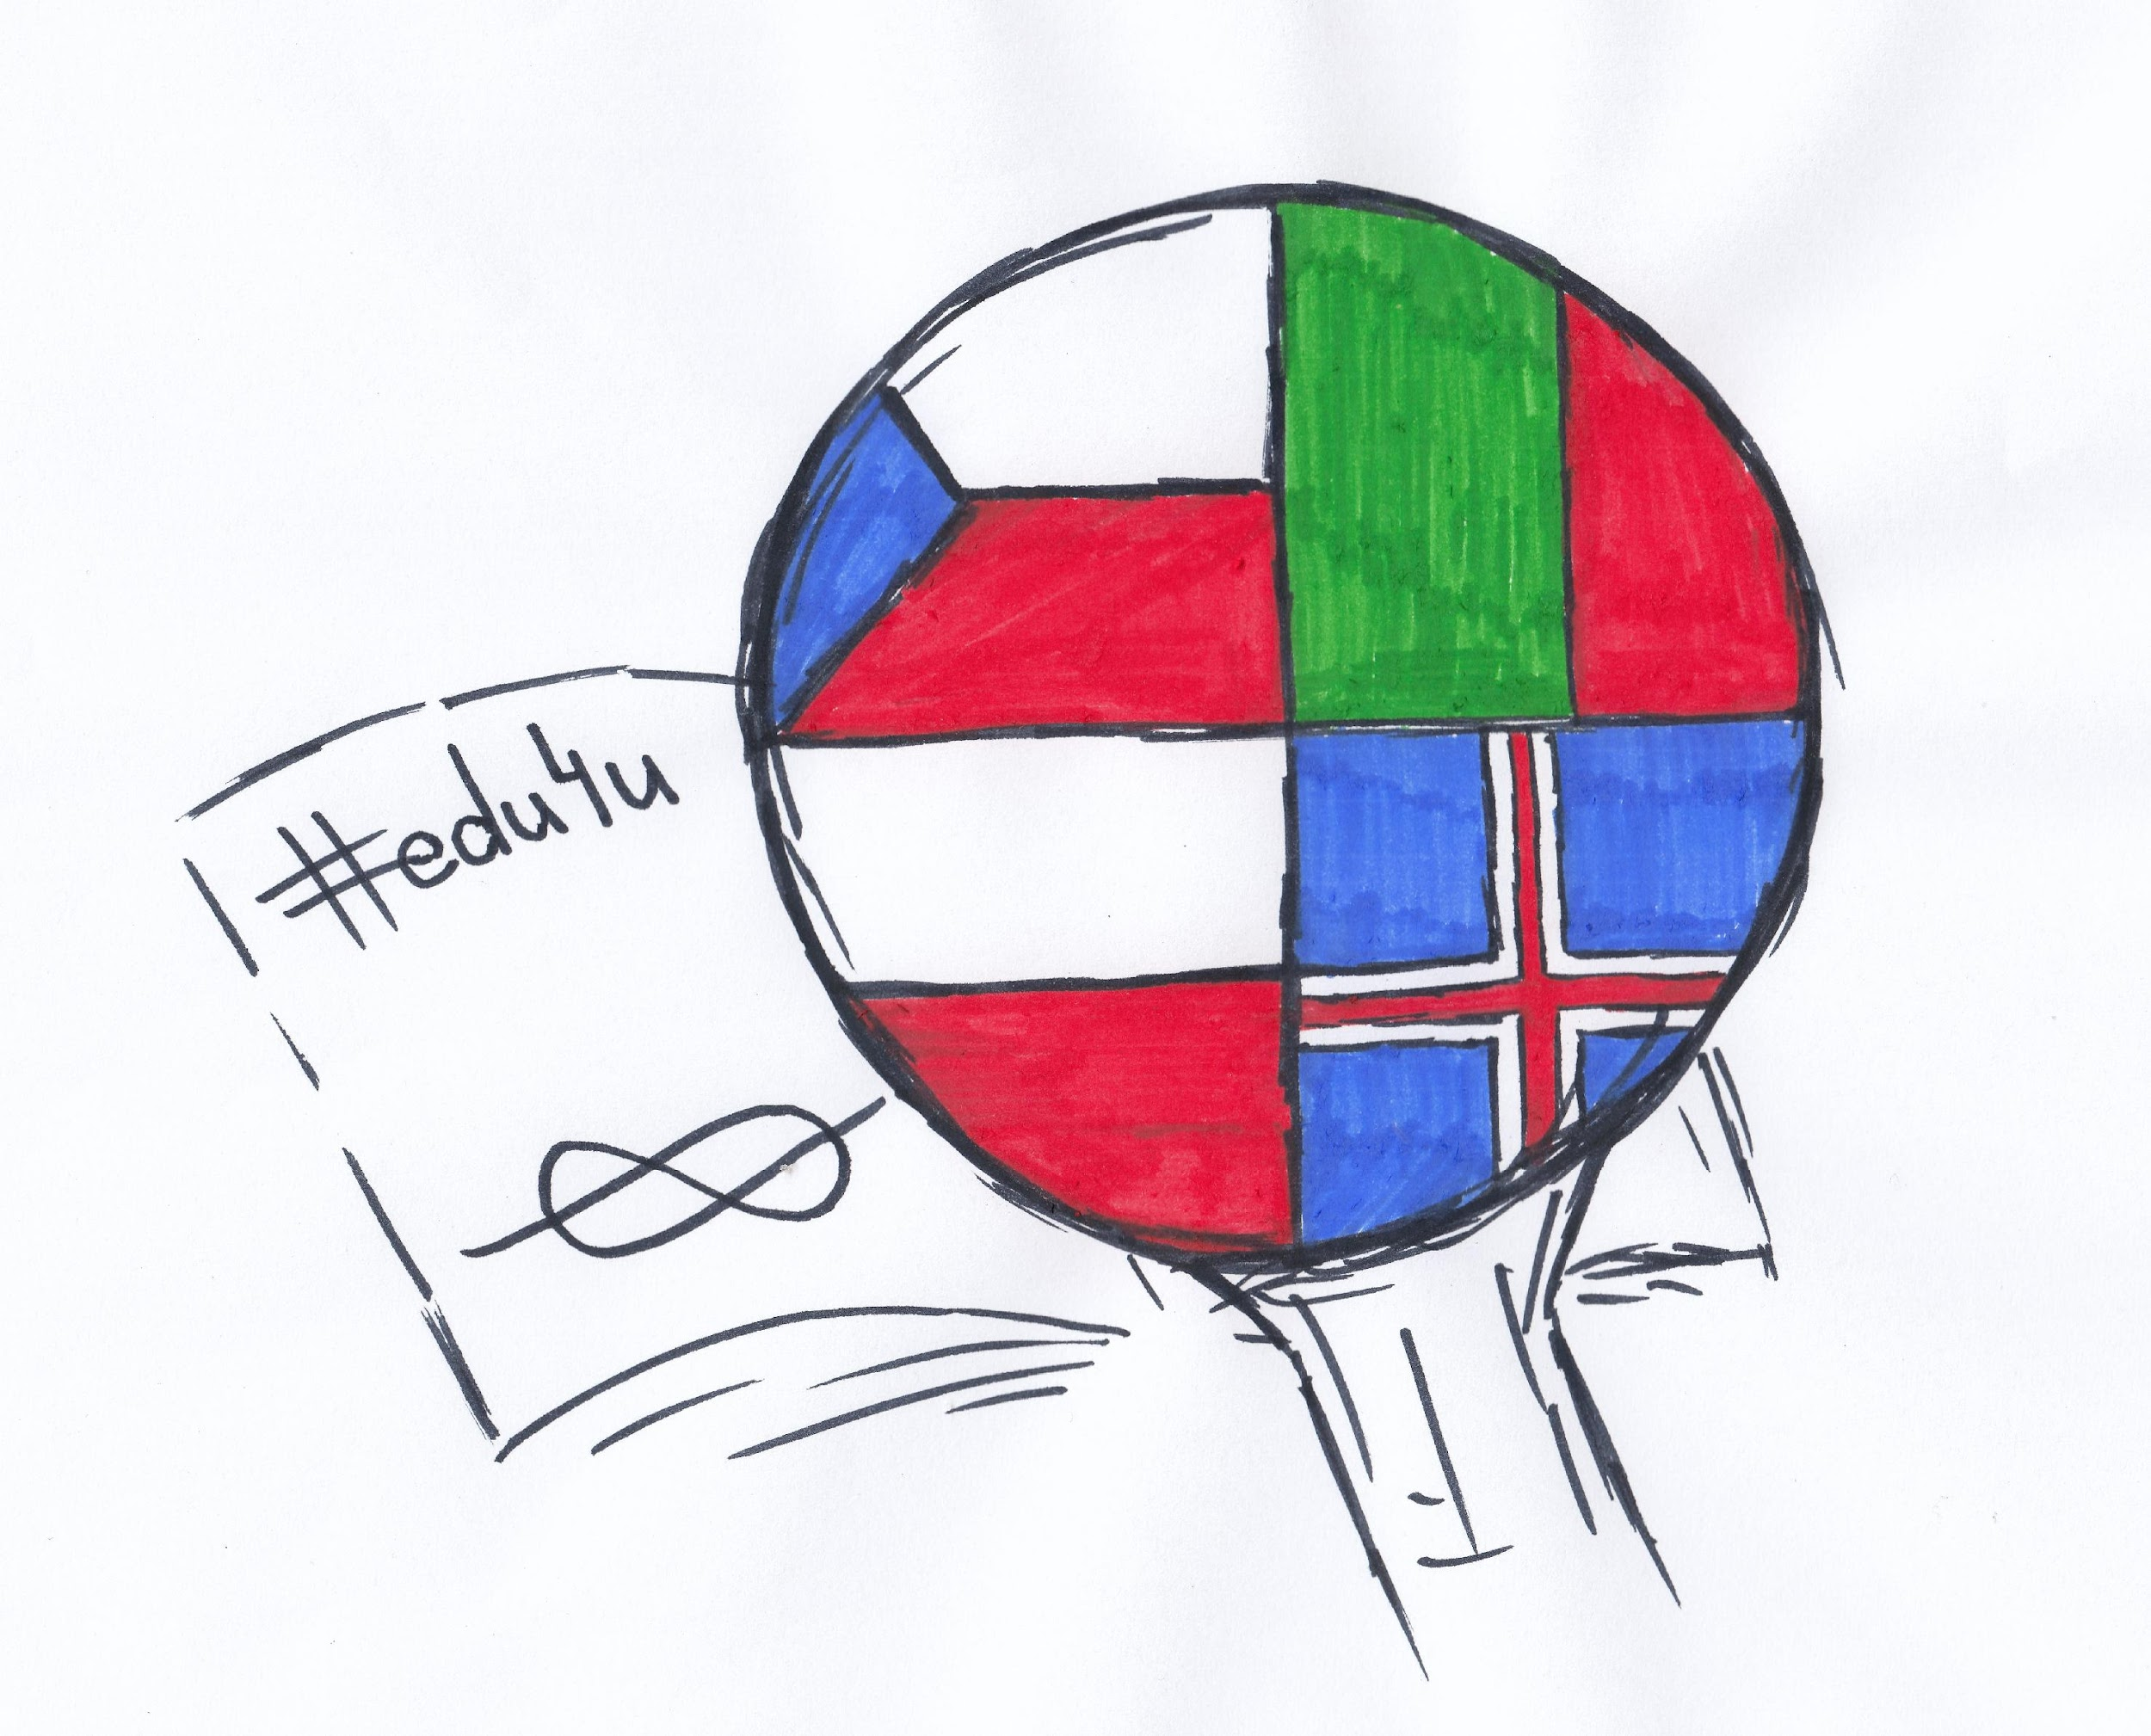
Edu4U - Rybnik Training Event, 6th-12th March 2022
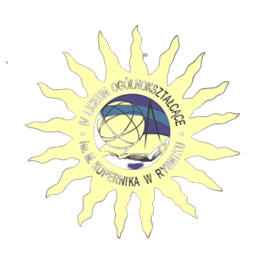

DATE | TIME/ ACTIVITIES
Sunday, 6th March | Arrival of groups:  11.30 - Iceland - Pyrzowice  12.45 - Portugal - Kraków  15.26 - Czechia - Rybnik
Monday, 7th March | 8.30 - going to school by bus (the bus picks the guests up at the hotel)  9.00 - meeting at school and welcome by Małgorzata Wróbel, Principal  9.30 - 11.00 - icebreaking activities  11.00 - 11.15 - coffee break  11.15 - 12.00 - debating  12.15 - 13.00 - lunch at the Birreria restaurant  13.00 - 13.30 - going to the centre  13.30 - 15.00 - Rybnik Quest
Tuesday, 8th March | 8.15 - a trip to Auschwitz (the bus picks the guests up at the hotel)  10.00 - 13.30 - visiting the concentration camp  14.30 - 15.30 - visiting The Silesian Museum in Katowice  15.30 - 16.30 - a walk around Katowice  17.30 - back at the hotel  19.00 - teachers’ dinner
Wednesday, 9th March | 8.30 - going to school by bus (the bus picks the guests up at the hotel)  9.00 - 12.00 - Training firms - marketing  12.15 - 13.00 - lunch at the Birreria restaurant  13.15 - 14.30 - Training firms - presentations  14.30 - the bus picks the guests up at school
Thursday, 10th March | 7.30 - a trip to Cracow (the bus picks the guests up at the hotel)  10.00 - 14.00 - a guided tour  14.00 - 15.30 - free time in Cracow  16.00 - 18.30 - return to Rybnik
Friday, 11th March | 8.30 - going to school by bus (the bus picks the guests up at the hotel)  9.00 - 12.00 - Makerspace: creating board games  12.15 - 13.00 - lunch at the Birreria restaurant  13.15 - 14.15 - School concert & certificates  14.15 - 15.00 - farewell party  15.00 - the bus picks the guests up at school
Saturday, 12th March | 9.00 - registration at the Run Office  10.00 - 11.00 - Kopernik Run  12.00 - award ceremony (estimated time; 15 mins after the last participant reaches the finishing line)  12.26 - departure of the Czech team (railway station)  13.30 - departure of the Icelandic team
Sunday, 13th March | departure of the Portuguese team

