Teachers’ assessment results
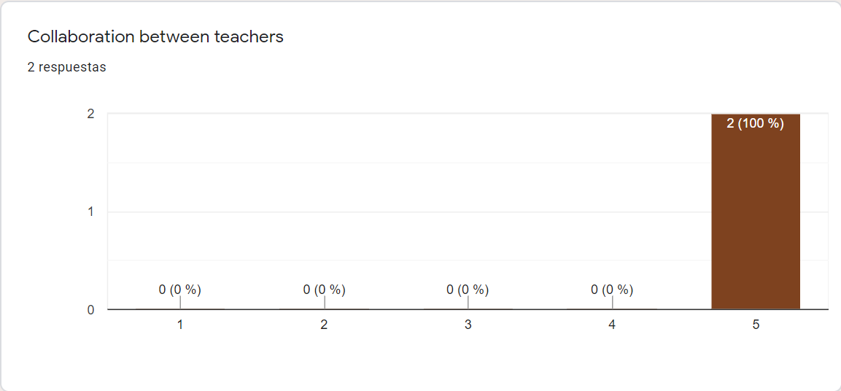
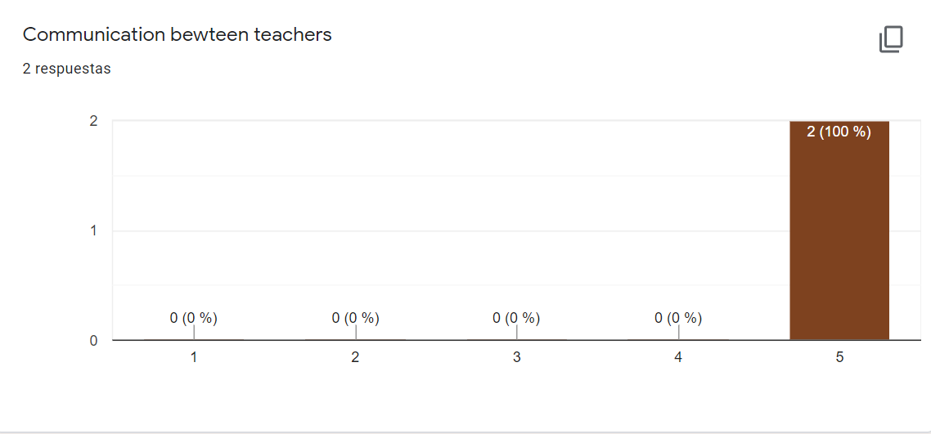
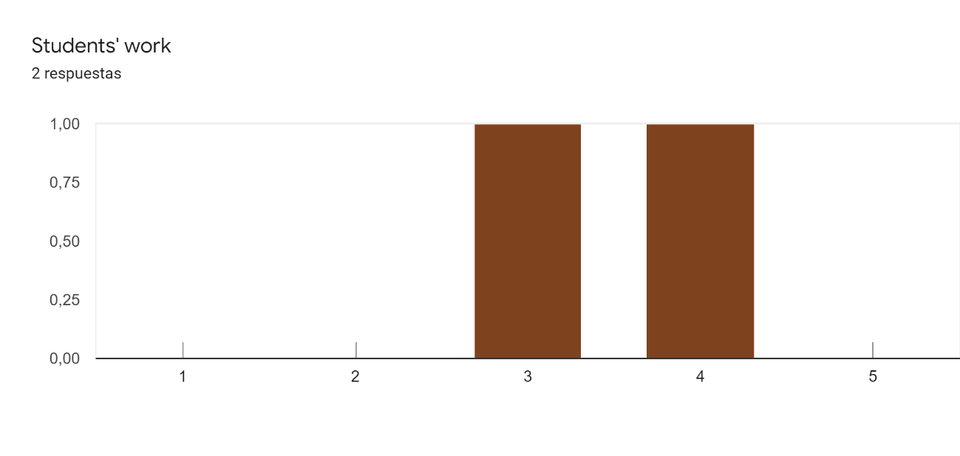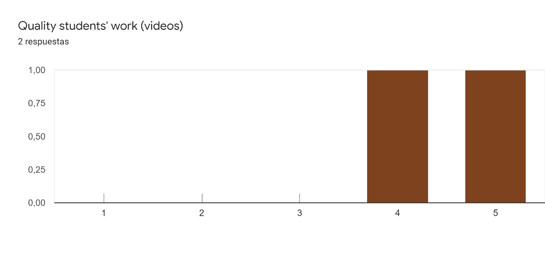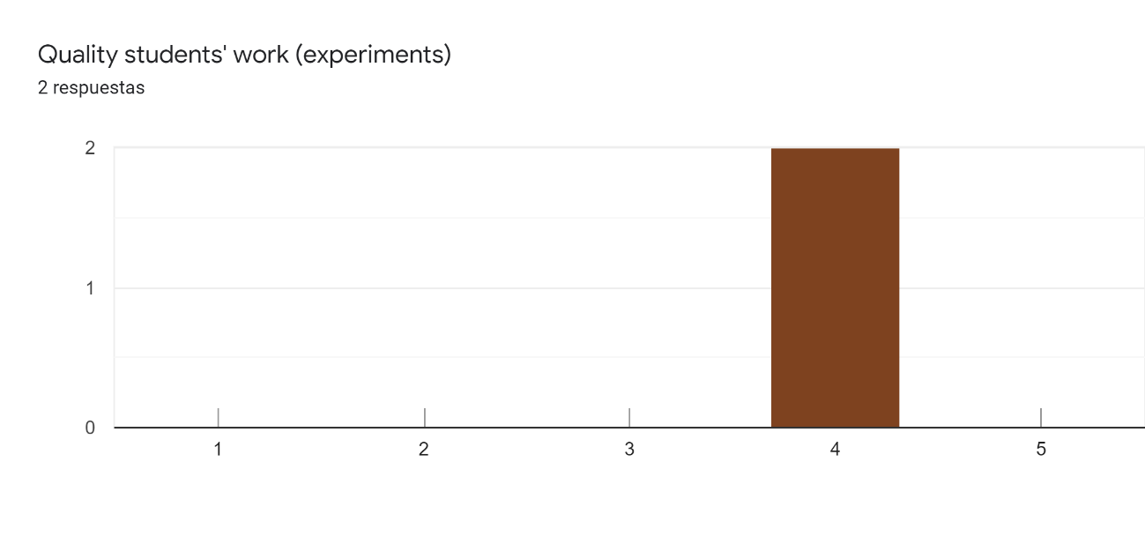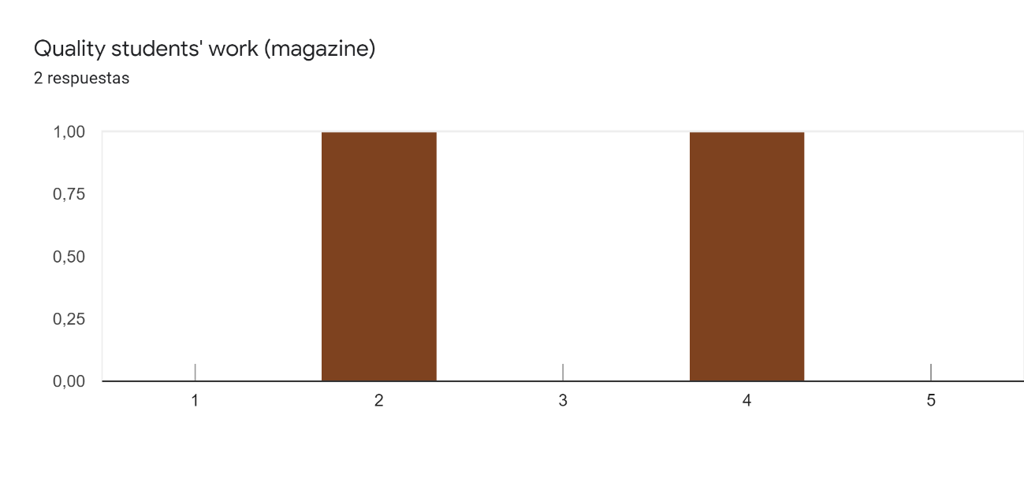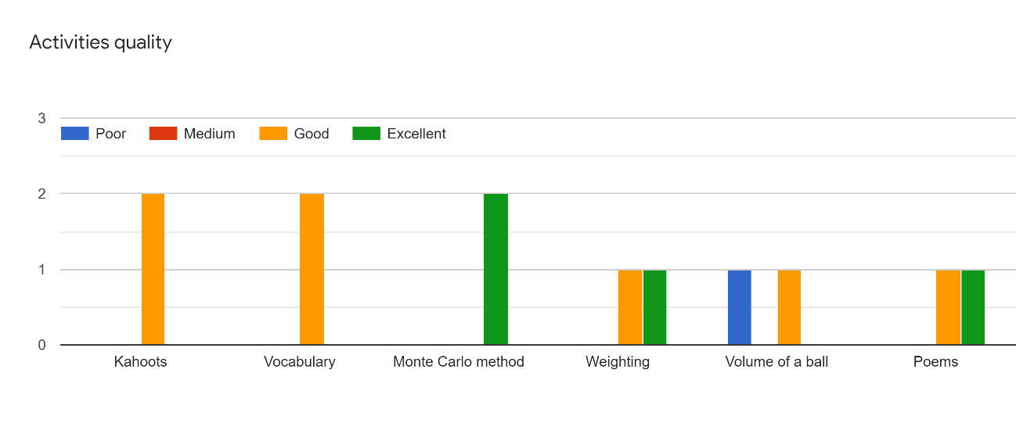
Observations:
I really like this project, I have done different activities I've never tried like recording videos or audios. I also have learnt new tools like kahoot and discovered a very interesting tool, magmaz for making magazines. Thanks a lot,I believe that I'm a better teacher now!! It was a pity that my students didn't be as enthusiastic as I'd like
This project provides me with new pedagogical methods to make collaborations come real in math among the students. I think now that this can be improved better whereas I am already very satisfied with the results reached this year.

