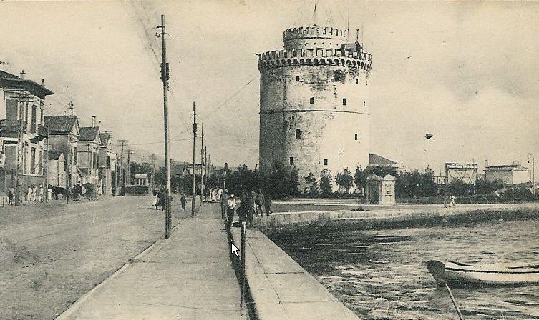
Travel Guide
Global Citizenship steps in Europe
user
[Πληκτρολογήστε το όνομα της εταιρείας]
[Επιλογή ημερομηνίας]
Thessaloniki
1st Primary School of Asvestohori
1st Primary School of Asvestohori

Thessaloniki (or Salonica, as it is also known), is the second-largest city in Greece and the capital of the region of Central Macedonia. It is a city with a multicultural character due to the many nationalities of people who have lived here as the centuries passed.
Thessaloniki is served by Macedonia International Airport (IATA: SKG) for international and domestic flights. The airport lies 15 km southeast of the city center
Thessaloniki is one of the oldest cities in Europe. There are a great number of historic and archaeological sites dispersed in the city, but its heritage is found in the sophisticated and slightly puzzling character of its inhabitants.
Because of its strategic position and importance, Greeks often refer to it as the “co-capital” of Greece. Indeed, it is a most important commerce and culture center.
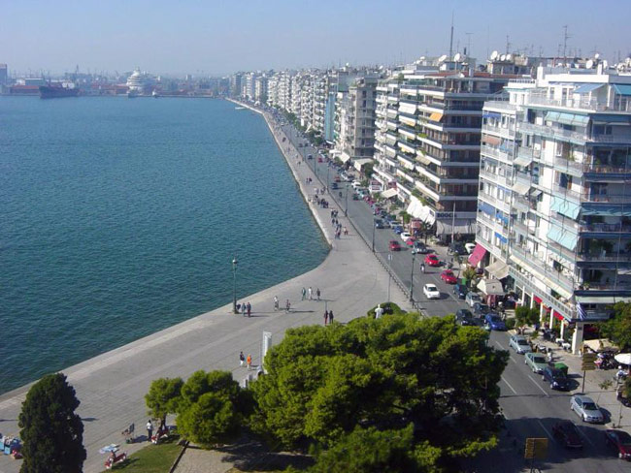
One of the things that give Thessaloniki its distinct character is its long and wide waterfront. Stretching from the harbour to the White Tower (the "Palia Paralia" = Old Beach), all the way to the east part of the city and beyond, it is the delight of locals, as well as visitors, who can be seen strolling at any time of day (or night), in any weather conditions. The coastal road is filled with cafes, some of great style and fame, that provide just the right atmosphere to pause your walk, enjoy perhaps a beautiful sunset (the sun sets over the sea, affording many such opportunities) while sipping your frappe or greek coffee.

A taste of history

Thessaloniki (or Salonica, as it is also known) is 23 centuries old. It was first established in 316 B.C. by Kassandros and named after his wife, Thessaloniki, half sister of Alexander the Great. It means Victory in Thessaly. It is here that the Apostle Paul first brought the message of Christianity (50 A.D.) and that Demetrius, a Roman officer died in martyrdom (303 A.D.), thus becoming the holy patron of the city.

In 168 B.C. the Romans made Thessaloniki the capital of the Roman province of Macedonia and the southern Balkans. The construction of the famous "Via Egnatia" (that connects the "East" to the "West", which is being revived as an active route today), together with the city's port, contributes to Thessaloniki's expansion and affluence.

Thessaloniki was the second most important city of the Byzantine Empire, next to Constantinople, and is full of beautiful examples of Byzantine art and architecture. In the 15th Century Thessaloniki became a haven for Jews exiled from Spain, who became an important part of the culture, until they were sent to the concentration camps during the Nazi occupation, thus ending a period of four hundred years of Jewish influence both socially and economically. This period roughly corresponds with the occupation of Greece by the Ottoman Turks.

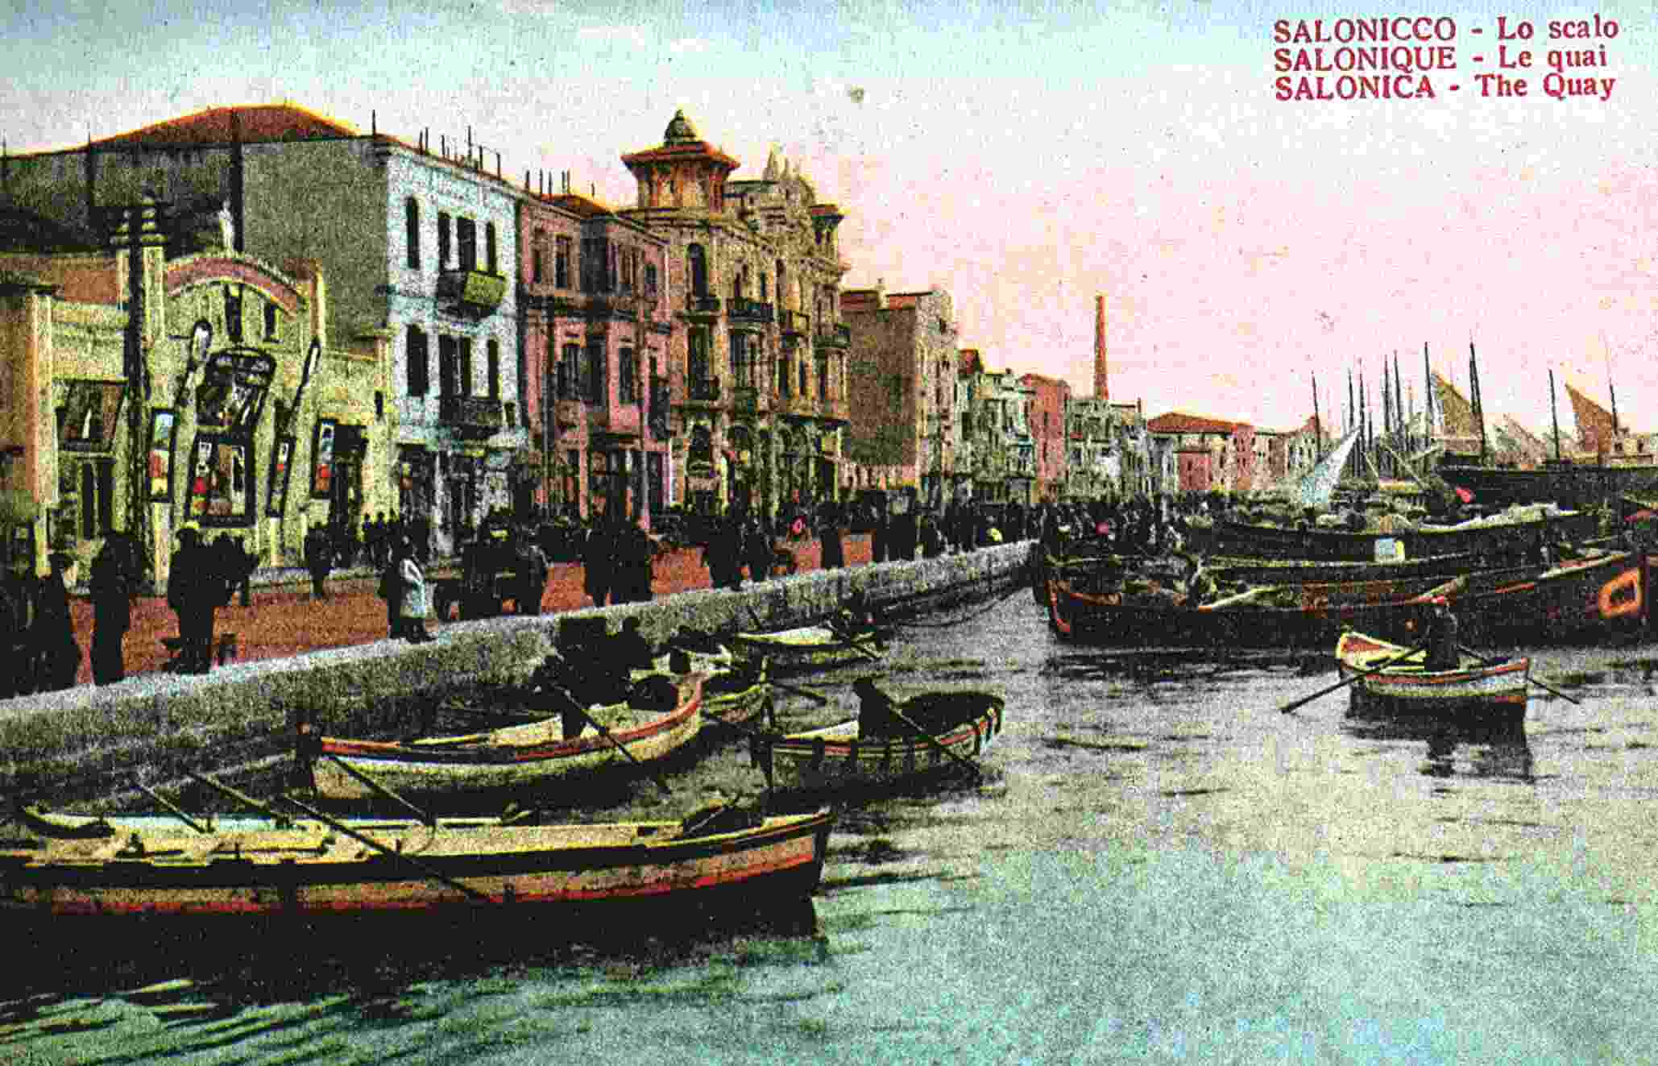
It became a part of the modern state of Greece in 1913, but burned in 1917 creating a homeless population of 70,000. The city was rebuilt in the 1920s and today Thessaloniki is a lively modern city bustling with life and movement.

What to See in Thessaloniki

A tour in Thessaloniki will reveal you hidden aspects of it and it is bound that you will be charmed.

MUSEUMS

- Archaeological Museum of Thessaloniki: 6 M. Andronikou str
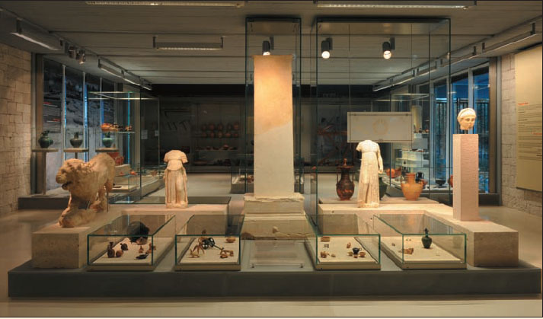
After an extended renovation the Archaeological Museum of Thessaloniki has opened again its doors to the public. The exhibition includes findings from the Neolithic period, the Iron Age (1100-700 BC), the Archaic period from 7th century BC to 3rd century AD, the Classical period and findings from the Roman period.

A special wing houses the impressive unique findings from the area of Vergina including the contents of the tomb of king Phillip of Macedon, found intact by Professor Andronikos in 1977. Archaeological Museum of Thessaloniki is considered to be as one of the finest museums of this kind around the world so do not miss visiting it.

Opening Hours: (1 April - 31 October) Monday: 13.00-19.30 & Tuesday-Sunday: 8.00- 19.

Tickets: Full Admission 6€, Combined ticket (it includes admission fee to the Myseum of Byzantine Culture): Full Admission 8€,

- Museum of Byzantine Culture: 2 Stratou Avenue

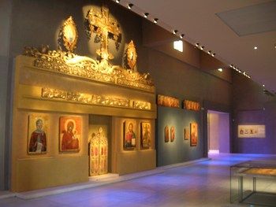
The permanent exhibition of the Museum of Byzantine Culture presents various aspects of Byzantine art and culture, as well as of the following era, after the fall of the Byzantine Empire to the Ottoman Turks in 1453. The exhibits are displayed not merely as works of art, but as witnesses to the culture that created them and the society that used them, within an informational framework of information on their original context and function. The Museum also hosts temporary exhibitions which are exhibitions form museums all over the world relative to Byzantine culture and art. The past exhibitions included Treasures of Mount Athos exhibitions, icons exhibitions, everyday life exhibitions and other interesting exhibitions.

Opening Hours: Monday: 10:30-17:00 & Tuesday to Sunday: 08:30-15:00
Tickets: Full Admission 4Combined ticket (it includes admission fee to the Archaeological Museum): Full Admission 8€

ARCHAEOLOGICAL SITES

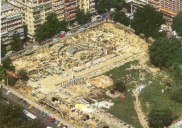
- The Palace of Galerius (300 A.D.) at Navarino Square. The ruined Palace of Galerius, the early-4th century Roman emperor, sprawls east-west across the square. Pieces of floor mosaic, columns and a few walls survive.

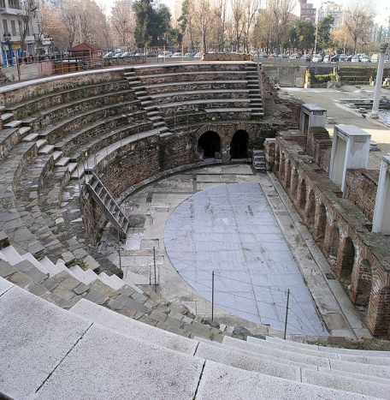
Roman Market and Theater

Ruins standing at the Court of Law Square (Dikastiria). It is located in the centre of the city, between Philippou and Olympou st. This spot was the centre of activities of Thessaloniki for about 8 centuries.

MONUMENTS AND CHURCHES

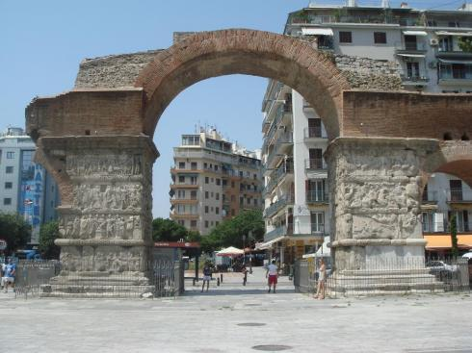
- The Arch of Galerius (Kamara) belongs to the Galerian group of buildings, in the south eastern part of the historical center of Thessaloniki and was built in 305 AD to celebrate the definitive triumph of the Emperor over the Persians. From the original triumphal arch only three pillars and a part of the brick masonry above are preserved to the present day. The two main pillars are covered with sculpted marble slabs. The whole structure consisted of 4 main pillars and 2 smaller ones on each side, the former supporting a central dome. Through the latter, a connection to the Galerius Palace (to the south) and to the Rotunda (to the north) was possible. Today, only a part of the monument still stands and there is no information on the period or the circumstances under which the rest of the arch was destroyed.

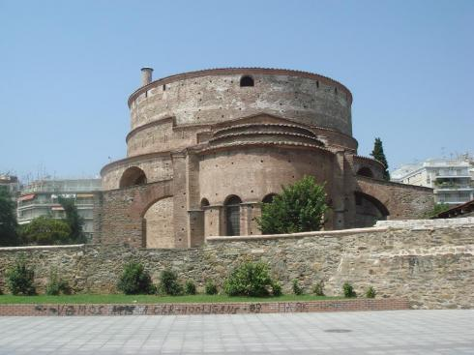
- The Rotonda, a domed building of early 4th century A.D., served as a Pantheon or as a Mausoleum for Emperor Galerius. In Byzantine times, under the reign of Theodosius the Great it was converted into a Christian church, and during the Ottoman Empire it was converted into a mosque and the minaret still stands. Now it is the church of Saint George. Do not miss to admire the unique mosaics of the 4th century AD.
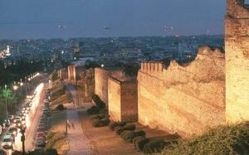
- The City Walls were erected during the time of Theodosius the Great to guard the city. The two walls were divided into east and west walls. The walls formed a four-sided shape with two right angles to the sea sides and two parallel (coastal wall and wall of the Acropolis hill). They had approximately 4.60m of width, an average height of 10-12m and a perimeter of approximately 8km long. They were built with stones and mortar, along with repeated rows of wide horizontal bands of brick that increase the strength and polish their surfaces. In 1869 large sections of the walls were demolished.

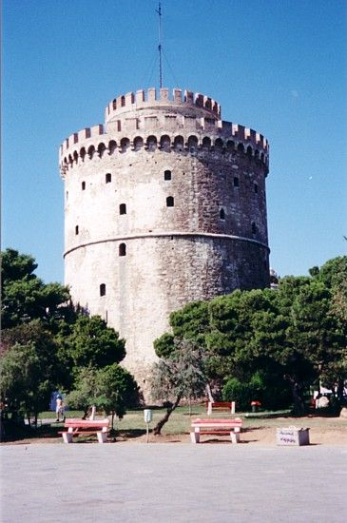
- The White Tower is Thessaloniki's most famous building, located in the eastern part of the waterfront. It is a round fort-tower, built in the 15th century as part of the fortification of the city. During Ottoman occupation, the White Tower was a place of prison and torture. In early 19th century, the tower was whitewashed and as a result it was renamed to “White Tower”. Even though the tower is no longer white, it still keeps its name and is considered to be city's landmark. Nowadays it is used as an exhibition space by the Museum of Byzantine Culture. It has got a great view from the top and a small coffee shop.

Opening Hours: Tuesday-Sunday: 08.30-15.00
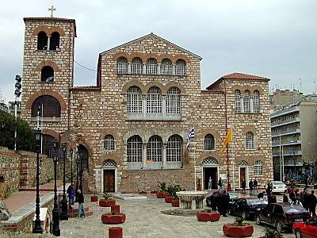
- The church of Agios Dimitrios is the largest church in Greece, dedicated to Saint Dimitrios - the patron saint of the city. The original church was built in 313 A.D. The church has been re-built twice, as twice before it was destroyed by fire, in 1917 and 1949. Visit the Crypt or “Martyrion” of Saint Dimitrios, which was discovered beneath the altar and the flaps. It includes items that survived the fire and those found in recent excavations. This church is situated on Agiou Dimitriou street (north-west of the city).

Opening Hours: Monday: 12:30-19:00, Friday-Saturday: 08:00-20:00 & Sunday: 10:30-20:00

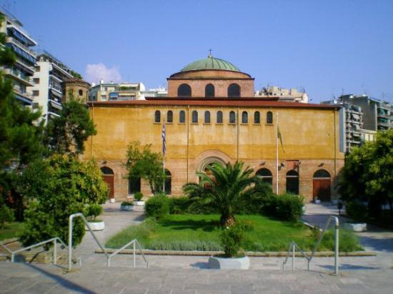
- The church of Agia Sofia is a wonderful church, built in the 8th century AD, modelled on homonymous church in Istanbul. During the Byzantine time, Agia Sofia was the cathedral of Thessaloniki. The church was built on the Roman baths, nowadays centre of Thessaloniki. Its interior is decorated by beautiful mosaics and frescoes from the early Byzantine era; admire the superb mosaic of the Ascension of Christ on the dome. It is situated in Plateia Agias Sofias south of Egnatia str.

Opening Hours: daily 08:30-14:00 &17:30-20:00

- The Monastery of Vlatadon is up the city (“Ano Poli”=Upper Town) near the walls. The monastery of Vlatadon is the only active monastery in Thessaloniki. It was founded between 1351 and 1371. A Patriarchal Institute for Patristic Studies was founded in 1965. It has a great library, a leafy, secluded location and a small museum.

Opening hours: 07:00-11:00 & 18:00-19:30

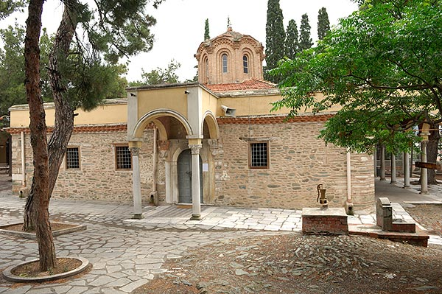

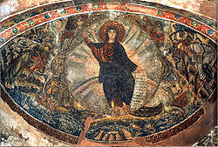
- The Church of Ossios David (late 5th century A.D.), the chapel of the Latomos Convent , an early Christian church, is just down from the Monastery of Vlatadon. It contains well-preserved mosaics and rare 12th-century frescoes depicting the baptism of Christ.

Opening hours 09:00-12:00 & 17:00-19:00

- The Church of Saint Nikolaos Orfanos (14th-century) is also in the area of Ano Poli near the Walls. Richly decorated with superb frescoes became in the 17th century the chapel of Vlatadon Monastery.

Opening hours: 09:00-12:00

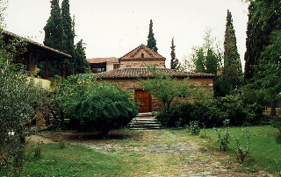

What to see/do around the city streets

Thessaloniki is a lively modern city. Large avenues, parks and squares, lines of trees that frame commercial streets with showy shop windows. Old houses, neoclassical buildings, stand side by side with modern dwellings which makes a walk through any section of the city an interesting journey. The influence of the east is very pronounced, not just in the delicious food, but in the relaxed lifestyle.

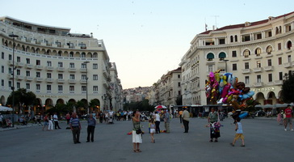
The main square is Platia Aristotelous, on the waterfront. This is the place to be at sunset. Aristotelous Square is surrounded by cafes and bars and fills with people in the evening. The large 19th century buildings on one side of the square mirror those on the other side. The square continues up the hill as a large pedestrian avenue with shops and cafes. If you walk up Aristotelous you come to the Ancient Agora Square and then the Roman Agora.

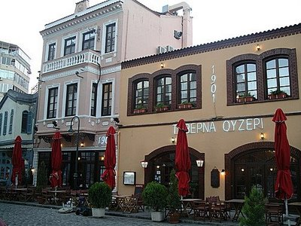
A few blocks away you meet the Ladadika district - this was the only part of the town to survive the 1917 fire. It used to serve as storage and trading place for olive oil. Today it is an entertainment focal point with many traditional or gourmet restaurants and lively bars and cafes. Buildings have been beautifully restored. Located a little after Eleftherias Square (bottom of Venizelou str.).
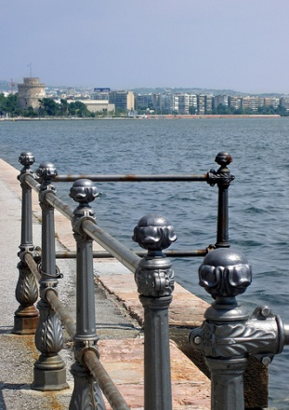
The old port area is being renovated with warehouses being turned into large restaurants and clubs and even an art gallery or two. If you follow the port road of Leoforos Nikis heading east along the bay you will come to the “Lefkos Pyrgos”, or White Tower. Every day lots of people do their “volta” (stroll) along the waterfront.

The Modiano Old Market, the lively bazaar of mostly meat and fish, around which are quaint tavernas. Outside the Modiano market are the "Louloudadika", the flower shops, that occupy and give colour and aroma to a corner of the pedestrian street. Vas. Irakliou & Komninon street.
Interesting squares and corners (always with cafes and restaurants to delight) are Kalapothaki pedestrian (between Venizelos and Aristotelous Square) and Athonos square.
Beyond the centre (taxi or bus from Eleftherias square), is the "Ano Poli" or "Kastra" (the upper city or castles). Worth visiting for the ruins, the stunning views and again the excellent small tavernas.
The neighborhood of Kalamaria is a modern area on the eastern edge of the city, overlooking a large marina and the Thermaikos Gulf. There is a green park above the sea and a number of ouzeries, restaurants, bars and cafes and is a hangout for the young as well as families.
The nightlife is exceptional, the bars and clubs play great music. The restaurants and ouzeries are among the best in Greece. Small family-run taverns and basement pastry shops offer a delicious variety of famous Macedonian specialties.

Thessaloniki Sightseeing Bus No. 50
The Organisation of Urban Transportation of Thessaloniki (OASTH) in September 2009 introduced its own version of a sightseeing bus (the No 50, aka ‘Thessaloniki on the Go!’ or the ‘Cultural Route Bus’).
The start and end point of Bus’ No 50 cultural route is the famous White Tower. The duration of the circular route is 50-60 min if taken without a stop. It is easy to follow the route as all buses are equipped with a verbal and visual system that announces every stop. The bus makes 16 official stops from which you can explore 43 points of interest.
The price of the ticket is 2 euros (1 euro concessions). The ticket is valid for 24 hours and during this period it can also be used on unlimited trips within all OASTH routes.
Bus No 50, although it is painted a pretty light blue, is not a tourist designated bus, so be prepared to mingle with the locals!
From October – May it travels every hour from 09:00 – 16:00

Useful Numbers
- Telephone area code for Greece and the city of Thessaloniki: +302310
- Greek National Tourist Organization: 8, Aristotelous Square, tel. +302310222-935, +302310271-888
- Thessaloniki International (Makedonia) Airport, tel. +302310471-170
- Tourist Police, tel. +302310544-162

