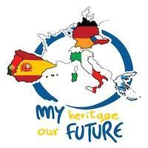

Mobility to the Czech Republic 3rd to 5th May 2022

Tuesday, 3rd May:

- 10.00h: trip to Moravian Karst - Macocha abyss, Punkva Caves
- 15:30h: visit to ZŠ Jungmannova
- 16:00h: exploring Kuřim - cooperative game in the town

Wednesday, 4th May:

- 9:15h: trip to Strážnice - Open Air museum of folk architecture and culture, folk costumes, life and traditions of the past
- 16:00h: project activities at school - national games - preparing programme for Thursday afternoon - cooperative activities

Thursday, 5th May:

- 9:30h: meeting at the Town Hall
- 10:30h: visit to tunnels in Kuřim
- 11:30h: visit to Brno
- 16:00h: project activities at school - legends of Brno and Kuřim
- 18:00h: social evening at school

Friday, 6th May:
- 08.00h: saying goodbye

