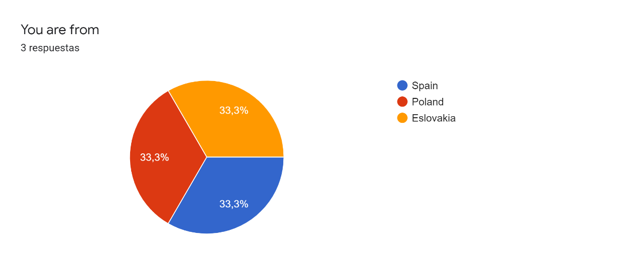

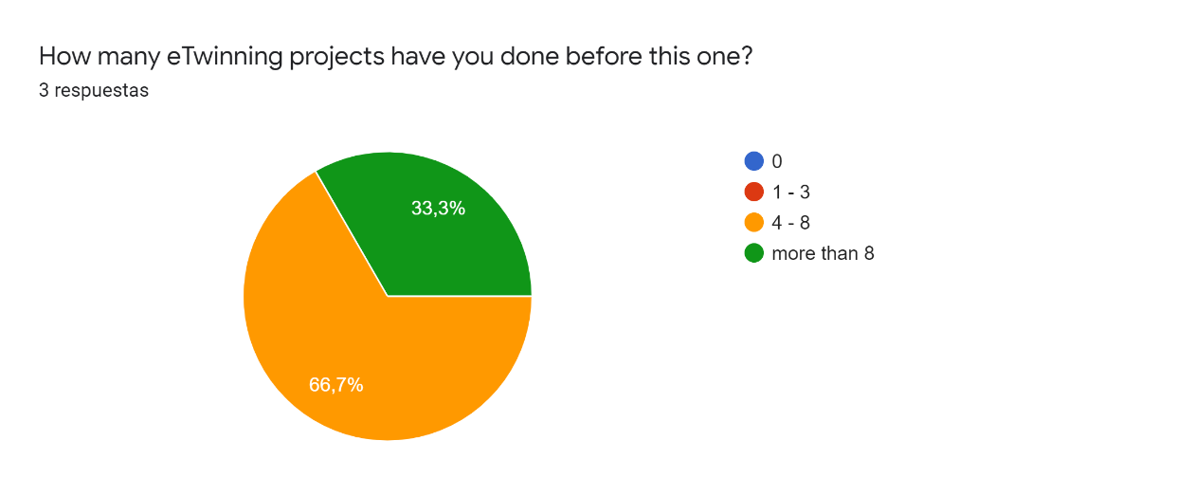

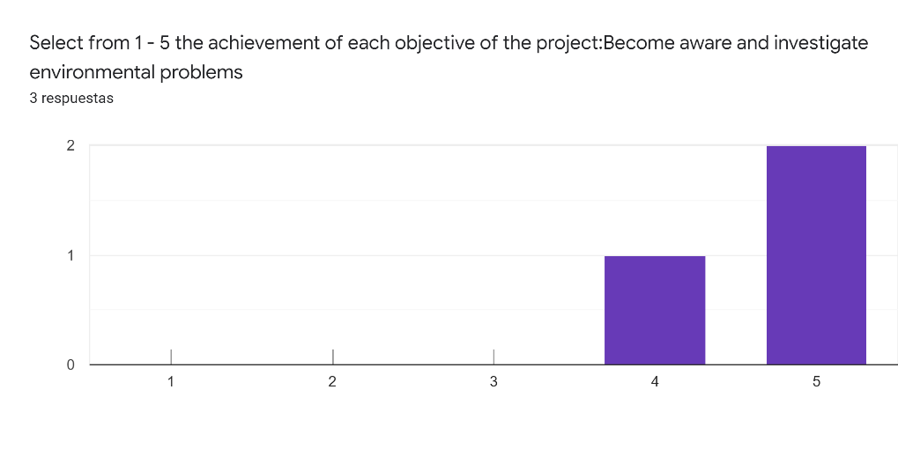

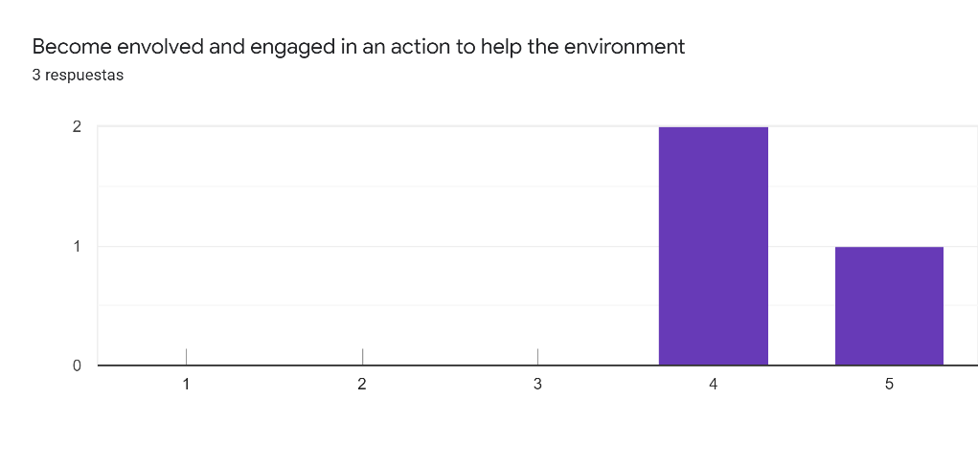

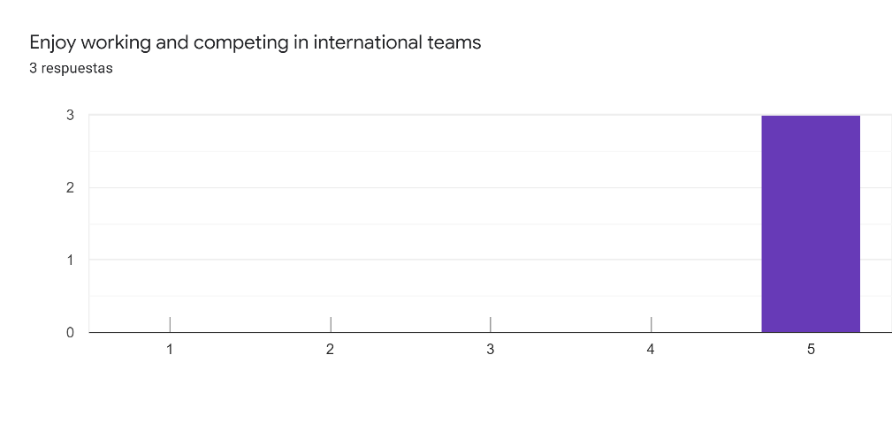

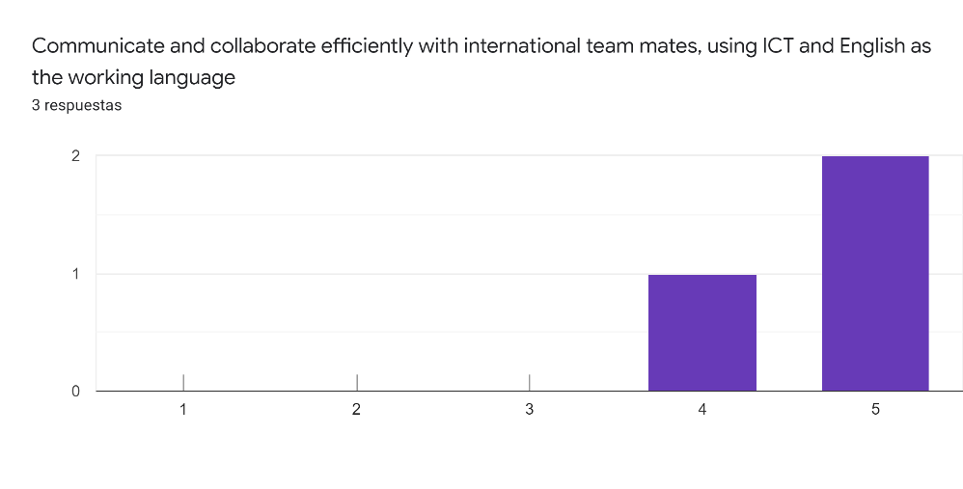

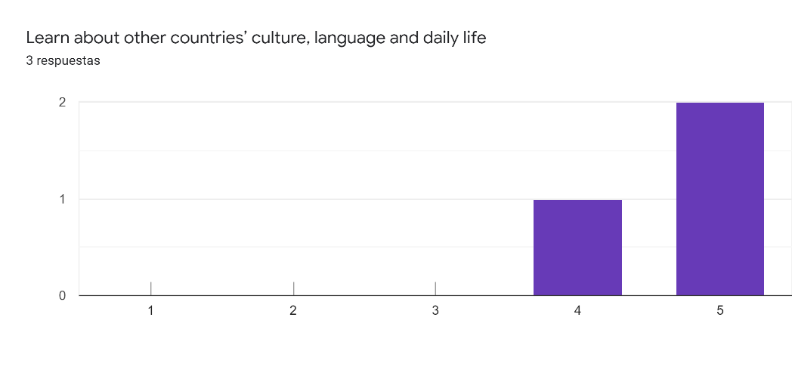

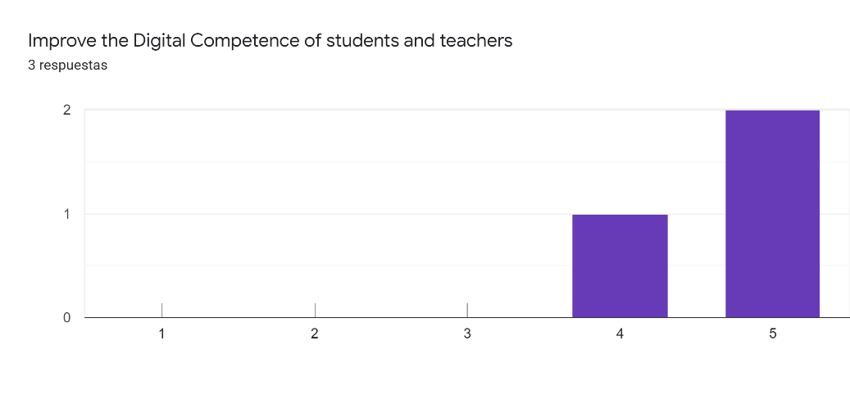

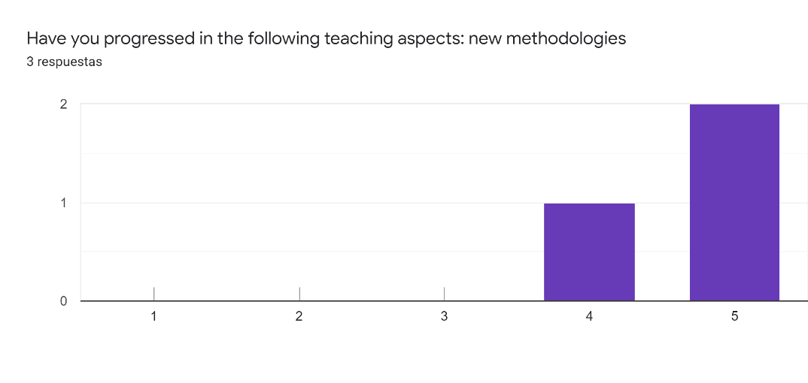

Please, comment your answer3 respuestas
My students and I have been inspired by creative activities within the project.

The lockdown of school in Europe in March - June brought a new variety of methodolgies which were used in distant teaching

Although PBL is the basic methodology of the project, some new "methods" were introduced like the learning from the experts, apart from all the necessary adaptions because of the lock down.

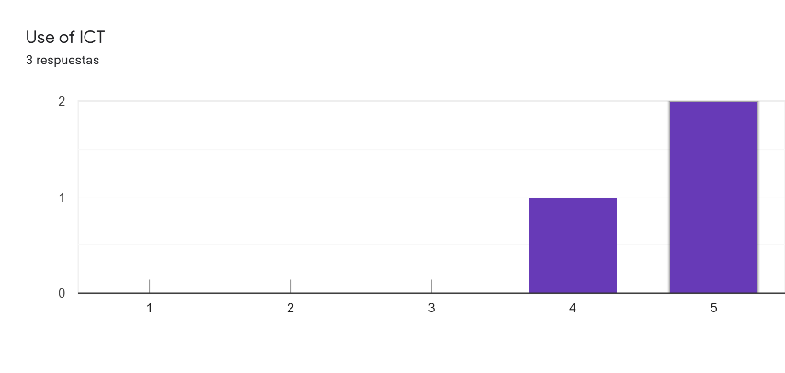
Please, comment your answer3 respuestas
I've learnt to use new applications and feel more confident, my students also.

The lockdown of school in Europe in March - June brought a new variety of ICT applications, videoconferencing which were used in distant teaching

I improved most aspects of my Digital Competence, I've used new tools, made tutorials, worked on esafety, etc

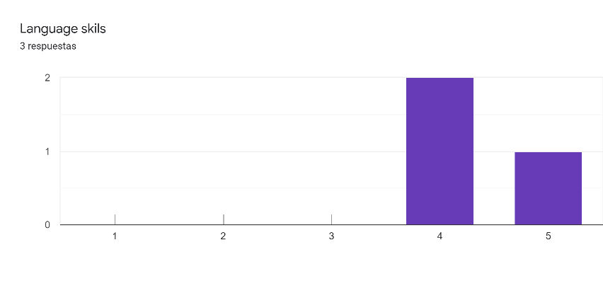
Please, comment your answer3 respuestas
My students enjoyed communicating with their peers from Spain and Slovakia.
Mainly written English, as most of communication was done by writing.
I keep improving by using;)
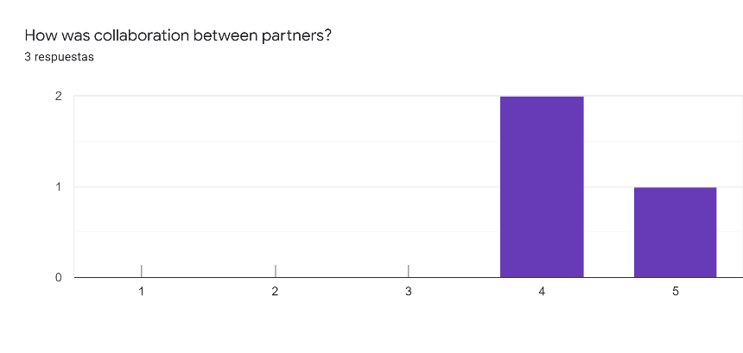

Comment your answer3 respuestas
Everything was well planned. The coordinator was helpful and supportive.
The new situation in schools had an impact on how much time the participating teachers and classes had for the project activities. The Polish school seems to have the schedule really full.
Communication and collaboration was efficient and nice. Unfortunately one partner couldn't work on the project anymore since the lock down.

What difficulties came up in the project?3 respuestas
Coronavirus related closure of schools in partner countries made us change our plans.
Due to circumstances we were not able to follow the plan of project activities since March but we found different ways how to stay in touch and continue with the project.
Coronavirus brought a different school situation between the partners. We had to change plans.

Do you have any improvement proposals?2 respuestas
The topic definitely deserves more projects like this one.
Not really

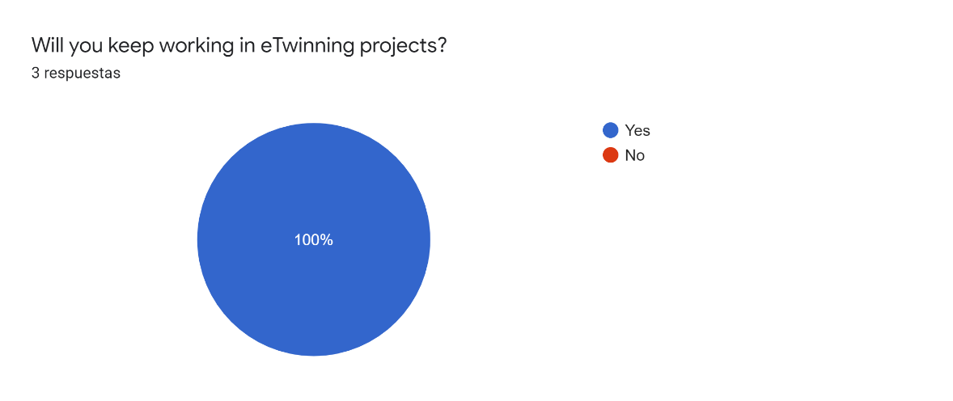

Anything you'd like to say?2 respuestas
Thank you for giving me an opportunity to be a part of this wonderful project.
I've learned a lot about bees thanks to this project:)

