Hope for Children
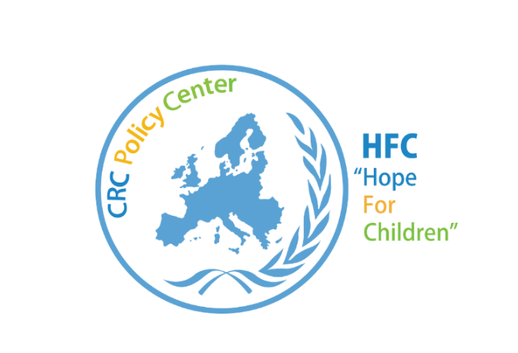
The “Hope for Children” CRC Policy Centre is an international philanthropic and independent Institution based in Nicosia, Cyprus. Our Institution is established on standards and principles of the UN Convention on the Rights of the Child and European Union Law. It works on the defence and promotion of children’s rights.

The operation of the Institution is founded on the principle of promoting and protecting the rights of children. We aim to do this through the implementation of a variety of projects on a National, European and Global level, but also through the incorporation of unaccompanied children who reside in the host country.
“Hope for Children” CRC Policy Centre works together with national, regional and international institutions to reform child welfare systems on behalf of children who depend on them for protection and care.
The organisation aims to bring together judges, lawyers, psychologists, medical practitioners, counsellors, mental health workers, media representatives, child cares, teachers & other professionals to contribute their specialized expertise in a practical manner through education, legal and other ways to promote and protect the interests of the most vulnerable amongst us, our children and youth.
https://www.youtube.com/watch?v=9Okmrguahss

Department for Social Inclusion of Persons with Disabilities
The Department for Social Inclusion of Persons with Disabilities has been established as from 1.1.2009, according to the Ministers’ Council Decision n. 66.723-dated 6.2.2008, as a new Department of the Ministry and Social Insurance.
The Department operated, at the beginning, with seconded and interchangeable staff since its permanent posts was completed for the posts of Director, Senior Social Inclusion Officer and six posts of Social Inclusion Officer, whereas the process for the posts of Social Inclusion Officer A’ and eight posts of Assistant Social Inclusion Officer is pending.
In 2011 the Department has moved is a new rented building in Latsia, which is fully accessible to Persons with Disabilities.

PASYKAF
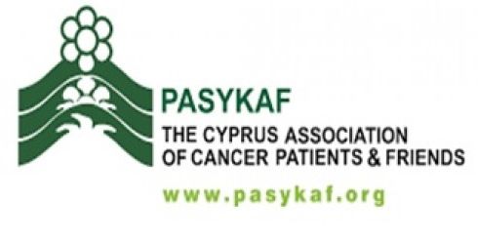
The Cyprus Association of Cancer Patients & Friends
The Cyprus Association of Cancer Patients and Friends (PASYKAF), is a voluntary, nonprofit, charity organization.
Established in 1986 from 21 experienced persons in cancer and other dedicated friends, it became one of the biggest non-profit organizations with thousands of members and supporters that offer professional health services and comforting care to patients together with various preventive programs.
With the help of the team of experienced and well-trained staff and associates, they are close to people and their family who are experiencing cancer. Their aim is to provide Relieving Care and helping to manage all factors and causes that may affect their quality of life and cause pain at any stage of the disease.
PASYKAF has an excellent relationship with its volunteers. The presence and immediate involvement of the latter in all areas, which PASYKAF provides assistance. Their driving force is the heartfelt love for fellow humans who are living with a cancer experience.
They put themselves in their place and they receive while they offer. Offering love, a bit of help, and time.
PASYKAF operate and offer free services to more than 5000 people and family members who are dealing with cancer. According to the needs of each patient, PASYKAF provides relieving care through a specialized team that has the following professionals: doctors, nurses, psychologists, physiotherapists and volunteers.
Their priority is for people to have a choice in if they want to receive support and care in the coziness of their own home whereas many patients feel more comfortable and safe to receive treatment in their environment surrounded by family.

Some free services provided by PASYKAF are:
- Home Nursing
- Lending Medical Equipment
- Psychological support for patients and their family
- Physiotherapy
- Practical help in Social Welfare matters
- Rehabilitation programs of patients
- Bringing and taking patients from all over Cyprus to the Oncology Centres in Nicosia.

Income:
PASYKAF is financially supported by various donations of members, friends and others, from the income of various events and activities, from contributions in memory, the yearly campaign of financial support ‘’Together in Life’’, and the state’s symbolic sponsorship.

Expenses:
The majority of expenses go to the services and programs of the Association while 26% are operating expenses, expenses of events, purchases, and other.

The Cyprus Anti-Cancer Society
The Cyprus Anti-Cancer Society was established in 1971. It is a registered Charity Organization (no E3951). It cares for people with cancer, helping them fight the illness and improve their quality of life.
Palliative Care is provided through a multidisciplinary team of doctors, psychologists, social workers, registered nurses, (that are employed by the Society) and volunteers. The Society, offers free of charge services, through the programmes that runs, i.e. Arodaphnousa Centre for Palliative Care, Home and Day Care Services, Transportation of patients from all districts of Cyprus, to Nicosia-the capital – for treatment etc. Last year the Society offered its services to more than 3.000 patients.
In order to be able to help people with cancer, the Society needs a lot of money. In order to raise money, the members of the Society organise several events like concerts, charity dinners, fundraisers etc. They also have shops where they sell things they make, (like bracelets, Christmas cards etc) and other things like cups.

Young Volunteers
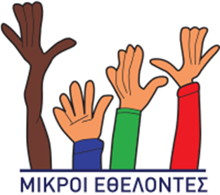
Young Volunteers consist of groups of children in different schools and communities. Up to date activities include meetings for Christmas and Easter bazaars, children's fashion shows, meals, teas, movies, lectures, youth programs, visits to children's clubs and senior citizens, pleasant meetings with children with special needs.

The aim is to raise awareness of young children in volunteering and to offer love and help to people in need. Through the activities of young volunteers, children develop their research spirit being promoted to create. They learn to respond properly to the challenges of our society and develop organizational skills. They learn to speak correctly, clearly, express feelings and take initiatives.
The importance of the work of small volunteers is immeasurable. The important thing is not that social action actions are taken, but that children learn little by little about the importance of volunteering. They learn that the simplest way to feel happiness and contentment is to give love and help other people. I am delighted to have this excellent cooperation with young volunteers and I hope their members will grow even more. The work of small volunteers is something that the world we need needs nothing else.

Vagoni Agapis
Vagoni Agapis, “wagon of love “ is a non-profit registered Charity Association run solely by volunteers. It was founded to help many of our fellow citizens living in poverty or on the margins of society, striving to exercise their human rights, assert their dignity as full citizens and take control of their lives.
Vagoni Agapis deliver immediate, one off or regular assistance to people in need, in the following ways:
- Immediate food and other day to day necessities either directly or through the distribution of pre-paid supermarket coupons
- Financial assistance with the partial or total payment of household bills
- Financial assistance with the payment of school fees for the dependent children
- Financial assistance to adult students in need
- Financial assistance for medical expenses or treatment abroad
- Financial assistance towards the purchase of desperately needed domestic appliances
- Immediate supply of clothing and/or furniture from the deposit of donated items kept at our warehouse.

Vagoni Agapis income is derived exclusively from the kindness and contribution of the public: from private donations, raffles and various fund raising activities (tea and dinner parties, charity bazaars, sale of handicrafts etc.). All of these proceeds end up as direct help to our needy, poor and marginalised fellow citizens targeted by Vagoni Agapis.
- Become a volunteer
- Food Collection Day outside major supermarkets
- Make cakes and biscuits for events. Provide us with handicrafts for our x-mas & easter events. Undertake to provide food to a specific family once a month
- Help at our desks at funeral donations

Cyprus Red Cross Society
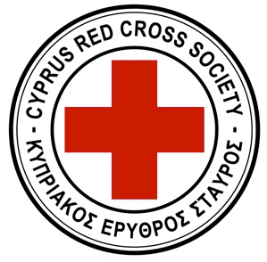
Cyprus Red Cross Society (CRCS) is the largest organization of Cyprus it helps prevent and stop human suffering. It supports people and responds to emergencies, in times of peace and war, without any discrimination as to race, gender, age, social, religion or politics. Specifically, it offers support to those who need it. It provides wheelchairs, gives special help to patients, disabled, elderly etc. It also offers First Aid lessons, organizes blood donations, helps in emergencies, offers social support services, covers the needs of migrants, organizes campaigns for various social, environmental, health issues, etc.
The people who work for the CRCS are volunteers. They work there because they WANT to.
The volunteers work selflessly in all the towns and districts of Cyprus, responding to emergency situations, helping vulnerable people and providing first aid, relief, solidarity and support to those in need.
By registering as a volunteer you will be able to help and become member of the largest humanitarian organization in the world.
In order to get money for their needs, they organize The Door to Door Fundraising Campaign, they receive donations, of clothes, money, food etc.
In this island-wide activity all Branches as well as the Youth Section of the C.R.C.S. take part, helped by hundreds of volunteers who knock on doors, but also our hearts, to remind everyone that even the smallest contribution is important as it can go towards improving the life of a fellow citizen.
For further information please visit http://www.redcross.org.cy/ .

