 | NR: 8, 15, 20, 21, 22 | NAME: Kobe Scherpereel, Henri Van Holm, Chelsea Vervaeck, Matisse Vlaeminck, Lies Vroman
 | CLASS: 6WEW6b
 | NAMETEACHER: Els Merveillie
 | DATE:09 january 2020 | We work together with: Amy, Maddalena, Michela Gambetti
VRIJE ASO.SCHOOL
PRACTICUM: Impulse of a collision between two cars
- ORIENT
  - Research question:
How does a different mass from a car driving downhill influence the impulse of the collision with the car standing at the end of the slope?
Sub-questions:
How does a different mass influence the speed of both cars?
How does a different mass influence the distance covered by the car at the bottom of the slope?
  - Hypothesis:
The heavier the car is, the bigger the impulse of the collision will be. The heavier the car is, the higher the speed of both cars will be. The heavier the car is, the bigger the distance covered by the car at the bottom of the slopewill be.
- PREPARE
  - Required material:
- scale,
- carts,
- masses,
- spring,
- sponge,
- binary air cushion,
- motion sensor
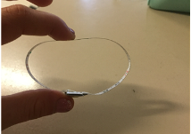
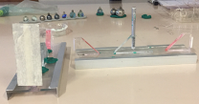
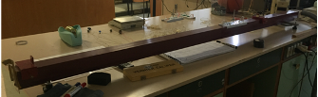
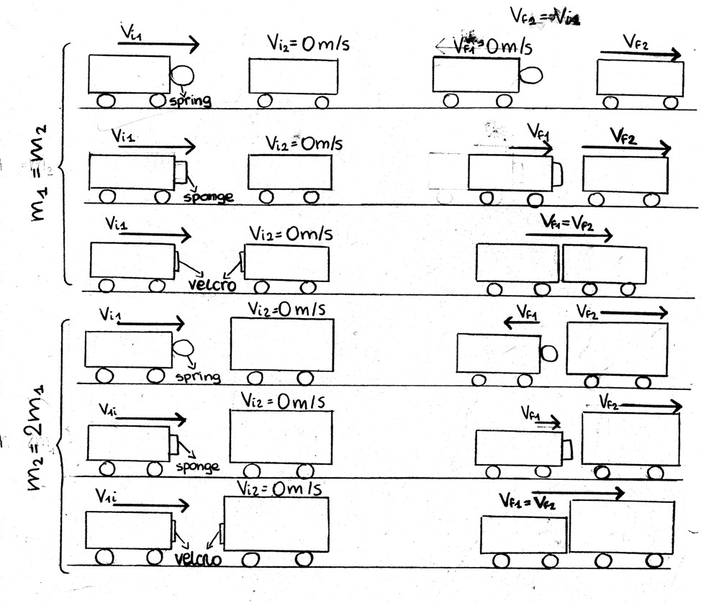
  - Method: For the experiment we will represent the impact between two carts neglecting the friction. We have chosen to do three types of collisions: elastic, anelastic and totally anelastic, but we are going to do two collisions for each one, changing the mass. In every attempt, one of the two carts will have the initial speed equal to 0 m/s. In the first three collisions we will use the same mass for every carts while in the next three collisions, one of the masses will be doubled (see figure).
To do the test we will use the binary air cushion and with a motion sensor we will measure the speeds.
For the elastic collision we use a spring, for the inelastic collision a sponge and for the totally inelastic collision we use velcro.

- CARRY OUT
  - Measurementresults:

  - Processing:

  - Review:

- REFLECT
  - Conclusion:
  - Do your decisions agree with the hypothesis that you have made?Why yes/not?
  - Evaluatie: Are you content with your approach and cooperation?

