 | TEAM: 9
 | Belgium | Fien Maeyens  Hendrik Senechal  Timo Vandenbroucke  Aiko Vandeputte  Julie Vanthournout
Smashing! Real-world clashes into physics classes | Italy | Anna Dall’ Aglio  Anna Santi  Arianna Tanesini
EXPERIMENT: Collisions of a basketball
- ORIENTATION
  - Research question:
What are the effects of a collision on a basketball when we vary the pressure inside of it?

Sub-questions:
- When the pressure is increased how does the kinetic and gravitational potential energy change?
- Does the ball lose more or less energy due to the collision?
- What is the effect of a change in pressure on the velocity of the ball during and after the collision?
- What influence does an increase of pressure have on the maximal height the ball reaches after the collision?

Sub-questions
- Before the collision, the ball with more pressure will have the same kinetic and gravitational potential energy as the ball with less pressure. When the ball is dropped, the gravitational potential energy will be converted to kinetic energy, and the velocity will increase. At the moment of the collision, the ball with the least amount of pressure will deform, and energy will be lost to the deformation. This will cause the ball to have less kinetic energy as well as less gravitational potential energy after the collision.
- When you increase the pressure of the ball, the ball won’t deform as much during the collision. Because of this, a ball with higher pressure won’t lose as much energy during the collision as a ball with lower pressure.
- A ball with a higher pressure will have a higher velocity after the collision than a ball with a lower pressure. Due to the ball’s higher pressure, it will have more kinetic energy than a ball with a low pressure because it won’t lose as much energy to the deformation of the ball.
- After the collision, the kinetic energy will be converted back to gravitational potential energy. As a result, the ball will gain height. Because the ball with higher pressure doesn’t lose as much energy to the deformation of the ball, it will gain more height due to its greater gravitational potential energy.

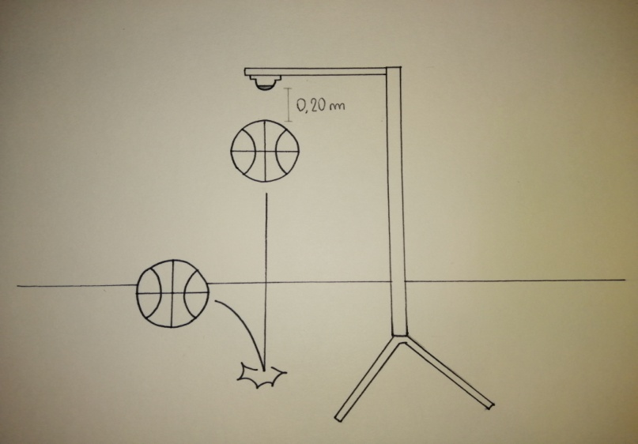
- PREPARATION
  - Material:
1. basket's ball
2. compressor
3. metal support
4. motion sensor
5. computer
6. scale

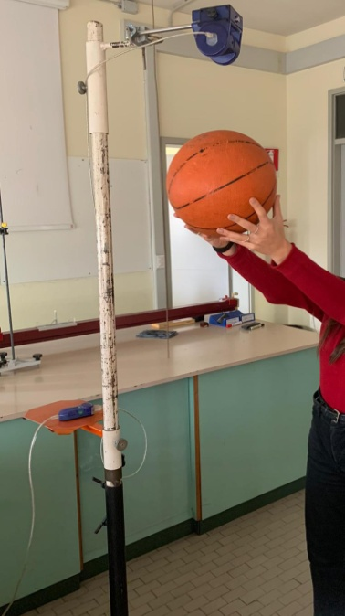
2.2 Method:
- Attached the position sensor to the metal support.
- Inflate the ball with the compressor (the pressure must be about 1 bar) and position it 20 cm from the sensor which is attached to the support.
- Initially support the ball with one hand and then drop it on the floor by bouncing it.
- Through the position sensor you can obtain the speed, the acceleration, the position and the time that the ball spends to fall.

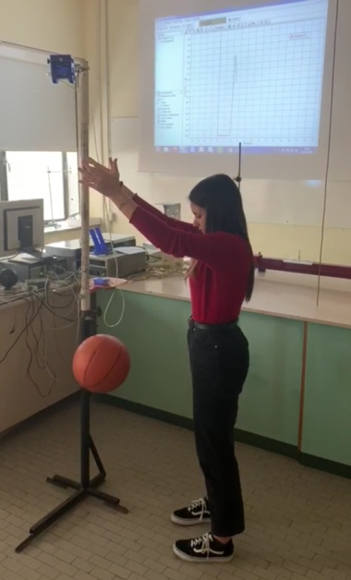
- Thanks to the values found we can obtained 3 types of graph: position-time, speed-time and acceleration-time and with these values we can calculate kinetic and gravitational potential energy of the ball and the impulse
- Afterwards deflate the ball a little and make previous procedure, obviously the impact will be different because is change the pressure of the ball. Deflating the ball further, do this same procedure again and study the impact between the basket's ball and the floor.
- If we want calculate also the change of the momentum 's ball, we'll have to weigh its mass with the scale.

- DATA ANALYSIS and DISCUSSION
  - Observations and Measurements:

  - Discussion:

- REFLECTION
  - Conclusion:
  - Comparison of the results of the different countries
  - Reflection:

- REFERENCES

