 | TEAM 8
 | Belgium | Eline Vandenbruaene  Emiel Maes  Simon Veermeer  Amber Van Eenoo
Smashing! Real-world clashes into physics classes | Italy | Camilla Barilari  Alice Berti  Alessandro Righi
EXPERIMENT:
- ORIENTATION
  - Research question:
Does the underground have an impact during a collision?
Sub-questions:
- What is the height when the ball bounces back?
- What is the velocity of the ball when it bounces back?
- What is the acceleration of the ball when it bounces back?

  - Hypothesis
Yes, the underground has. If the soil is flat we think the ball will bounce back higher than with a raw underground. We believe that the density from the underground has something to do with it, the denser the higher. The elasticity of the soil is something to take in count too, the more elastic the harder.
- PREPARATION
  - Material:
-A bouncy ball of 41.6g mass.
-Two different surfaces like a table and a towel or something soft.
-Two structures (see the photo and drawings). One with a tape measure and the other able to support the position sensor.
-A speed and position sensor.
-A computer where you can use Tracker.
-Objects such as a meter, a telephone, a calculator and a stopwatch.
  - Method:
-Make a structure like A in the photo to drop the ball (41,6g) from the same high at each fall.
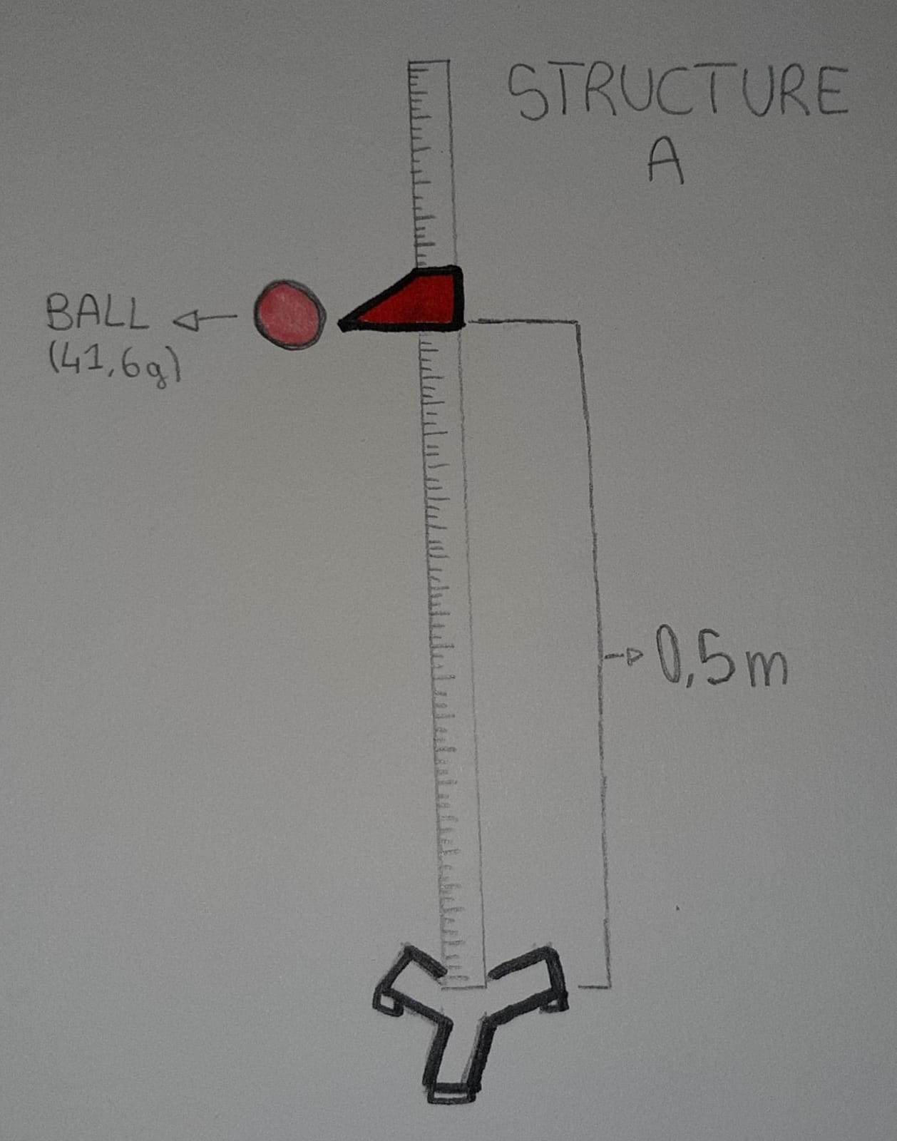

-Make another structure like B with speed and position sensor. It must be placed higher than structure A.
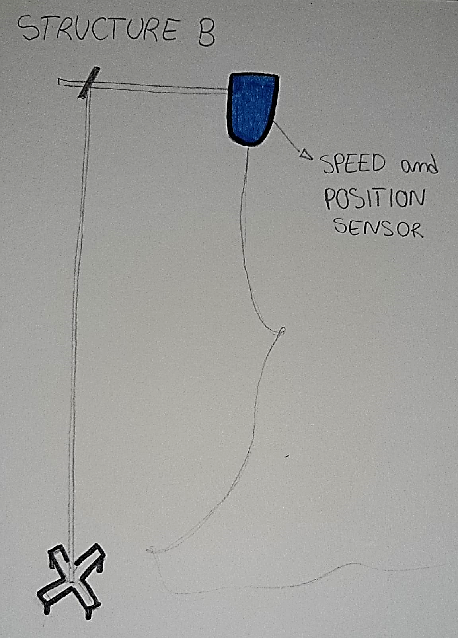

-Place a phone on a table to record a video of the falls.
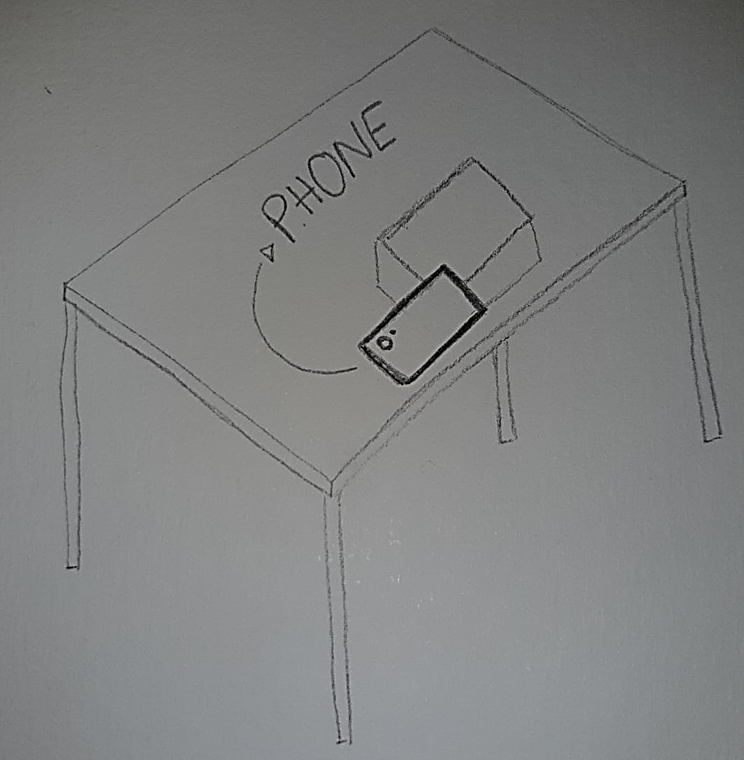

-Do 3 test for everyone of the 2 surfaces.
-Drop the ball from a height of 0,5m.
-Make a video for each fall.
-Analyze all the videos with Tracker and identify the bounce height, speed, position as time changes and acceleration.

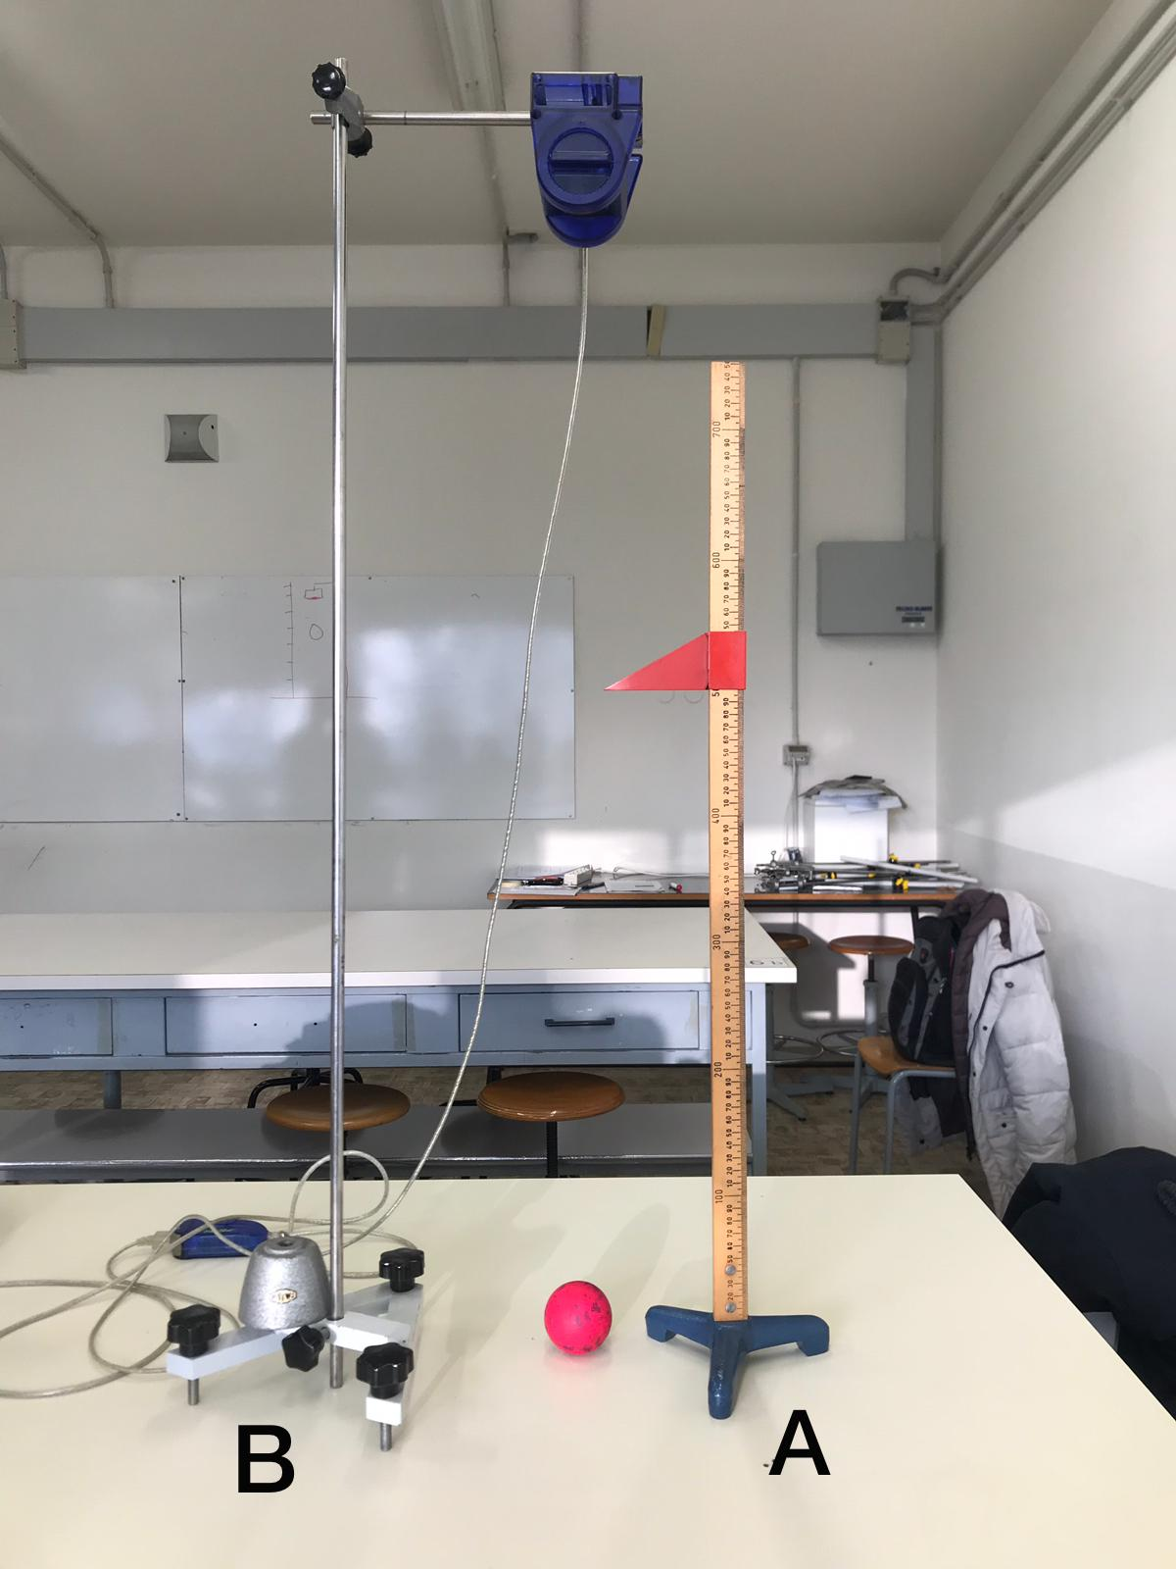
- DATA ANALYSIS and DISCUSSION
  - Observations and Measurements:

  - Discussion:

- REFLECTION
  - Conclusion:
  - Comparison of the results of the different countries
  - Reflection:

- REFERENCES

