 | TEAM: 1
 | Belgium | Margaux Bauwens, Alexander Verheule, Pieter-Jan Warnez and Elise Ferlin
Smashing! Real-world clashes into physics classes | Italy | Paolo Santandrea, Imrane Harbi and Guido Pirazzini
EXPERIMENT: COLLISION WITH A CAR
- ORIENTATION
  - Research question:
What’s the impact on a material after a collision with a small car?

Sub-questions:
What happens if you change the material?
What happens if you change the speed of the car?

  - Hypothesis
After the collision the materials will be deformed and depending on the material and speed the rebound will be larger or smaller.
If the new material is more elastic the car will have more of a rebound, but if the material is more static the car wouldn’t have as much of a rebound.
The higher the speed of the car the more force there will be on the material during the collision.

- PREPARATION
  - Material:
1. Force sensor / Accelerometer
2. Slope
3. Small car
4. Distance sensor / photocells
5. Plasticine, 1 sponge, 1 wood slat
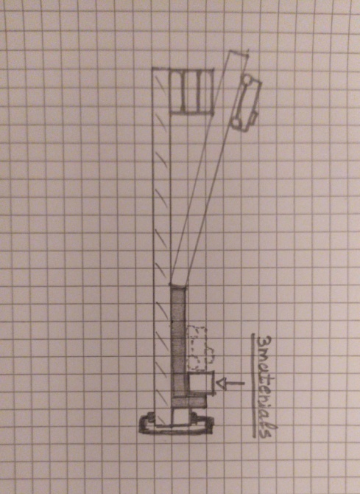
6. Clamp
  - Method:
- Mount a force sensor or an accelerometer on the car to measure the force and to estimate the time of interaction, Δt.
- Let the car start from a certain height (the same speed) from the slope, and then collide against one of the three materials (all 3 blocked with a clamp).
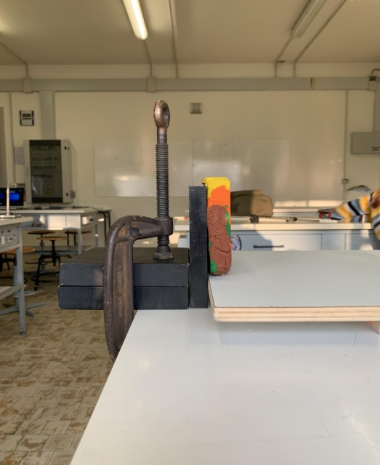
- Launch the car from the slope against the plasticine. Then repeat the same but changing the plasticine with the other 2 materials (exactly from the same height). Measure the speed before and after the collision with a distance sensor or a photocell.
- Plot a graph of the force or acceleration obtained by the force sensor or accelerometer.
- Increase the slope and repeat the action (the height must be the same for all 3 materials). Measure again the same quantities.
- Compare and discuss the data obtained and verify the Impulse-momentum theorem.

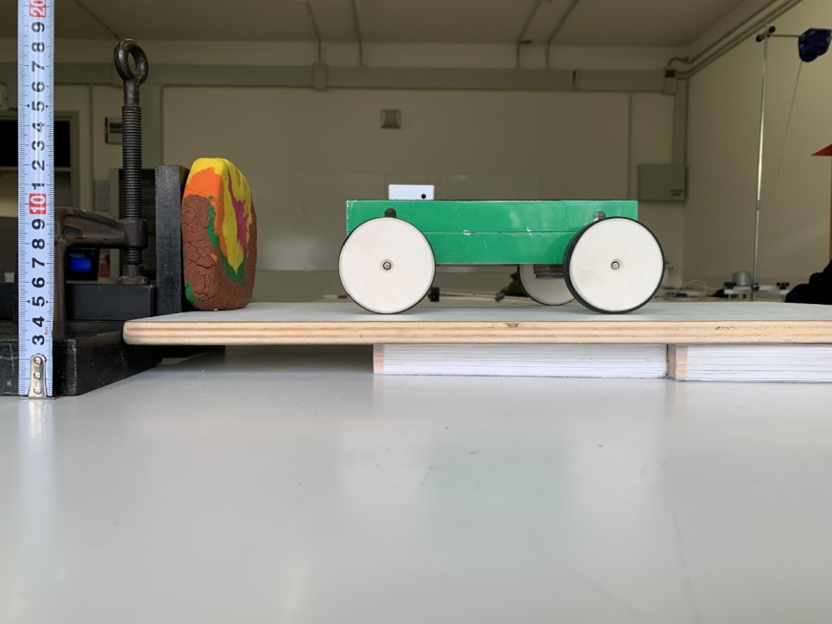
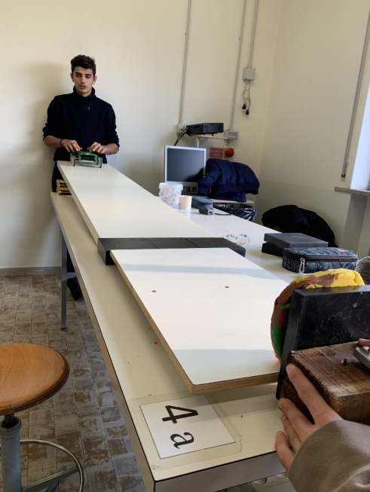

3. DATA ANALYSIS and DISCUSSION
  - Observations and Measurements:
We used the values taken with the space-time sensor, which gives us the position and the speed of the car during the experiment.
The values taken with the accelerometer weren’t very accurate so we didn’t use them.
We repeated the experiment from 2 different heights for every material, but we chose to present only the first one where the data were more precise.
To calculate Fm in the experiment of the plasticine and the wood slat, we approximated the time of interaction because there are some oscillations in the graph v(t).
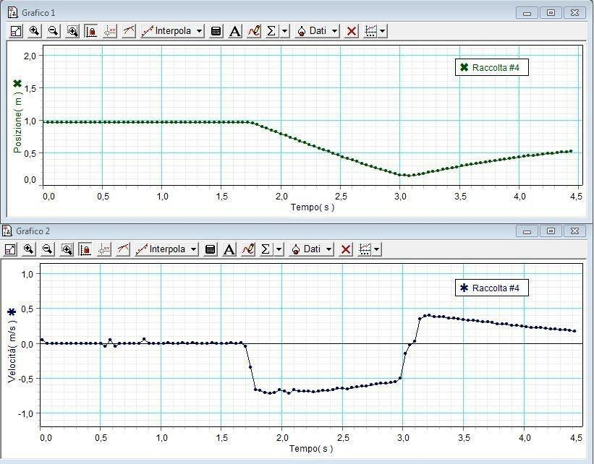
Sponge (first measurement):
Data taken with the space-time sensor.
As we can see from the graph, at t=1,7 s the motion starts, then at about t=3,0 s there is the collision, which finishes at t=3,14 s. Then in the graph s(t) we can see the rebound after the collision.
mcar=0,4285 kg
t1=3,0 s
t2=3,14s
vf=0,34 m/s
vs=0,50 m/s
Δt=0,14s
Δq=qf-qs=m(vf-vs)=0,4285 kg*(0,34+0,50 m/s)= 0,41 N*s
(Ki - Kf) / Ki * 100=(0,5*0,4825 kg*(0,50 m/s)^(2)-0,5*0,4825 kg*(0,34 m/s)^(2))/(0,5*0,4825 kg*(0,50 m/s)^(2))*100= 54%
Fm=I/Δt=0,41 N*s/0,14 s= 2,9 N

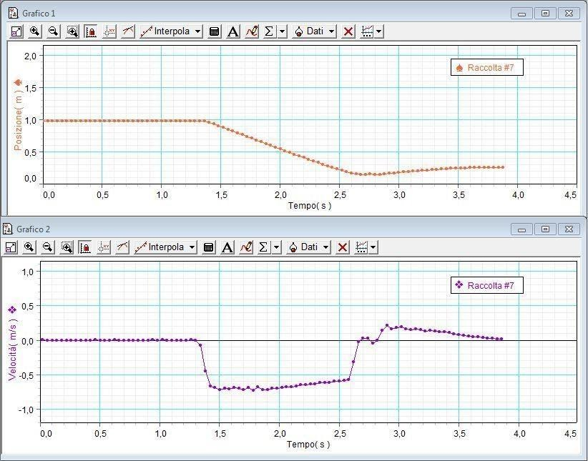
Plasticine (first measurement):
Data taken with the space-time sensor.
In this graph, the motion starts at t=1,4 s, the collision instead starts at 2,6 s and finishes at tf ≈2,75 s (we chose this time according to the medium time of interaction in a collision and the sample time that is too big to be accurate). Then in the graph s(t) we can see the rebound after the collision.
mcar=0,4285 kg
vf=0,21 m/s
vs=0,58 m/s
t1=2,6 s
t2=2,75 s (estimated)
Δt=0,15 s
Δq=qf-qs=m(vf-vs)=0,4285 kg*(0,21+0,58 m/s)= 0,38 N*s
(Ki - Kf) / Ki * 100=(0,5*0,4825 kg*(0,58 m/s)^(2)-0,5*0,4825 kg*(0,21 m/s)^(2))/(0,5*0,4825 kg*(0,58 m/s)^(2))*100= 87%
Fm=I/Δt(estimated)=0,38 N*s/0,15 s= 2,5 N

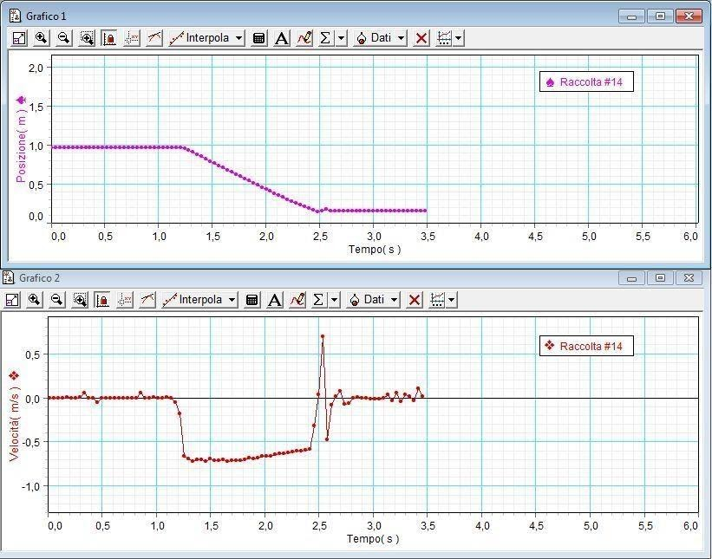
Wood slat (first measurement):
Data taken with the space-time sensor.
In this case the motion starts at about t=1,2s, then the graph is not really accurate but the collision starts at t=2,46 s and we considered as the value of the final speed vf=0,04 and as the tf ≈2,61 s (we chose this time according to the medium time of interaction in a collision and the sample time that is too big to be accurate).This time in the graph s(t) we can see that there is not a big rebound after the collision.
mcar =0,4285 kg
t1=2,46 s
t2=2,61 s (estimated)
vf=0,04 m/s
vs=0,59 m/s
Δt= 0,15 s
Δq=qf-qs=m(vf-vs)=0,4285 kg*(0,59+0,04 m/s)= 0,27 N*S
(Ki - Kf) / Ki * 100=(0,5*0,4825 kg*(0,59 m/s)^(2)-0,5*0,4825 kg*(0,04 m/s)^(2))/(0,5*0,4825 kg*(0,59 m/s)^(2))*100= 99%
Fm=I/Δt (estimated)=0,27 N*s/ 0,15s= 1,8 N

  - Discussion:
In this experiment we used the Impulse-momentum theorem to calculate the medium force during the collision with the inverse formula: Fm=I/Δt.
The rebound depends on the elasticity of the material, if the material is elastic there is more rebound.
The results are more accurate in the sponge, due to the material traits.
The data shows that the collision is more elastic with the sponge considering the higher Fm and the lower ΔK, instead is more inelastic with the wood slat, considering the lower Fm and the higher ΔK.

4. REFLECTION
  - Conclusion:
  - Comparison of the results of the different countries
  - Reflection:

- REFERENCES

