 | TEAM: group 2
 | Belgium | Tine Declerck  Mirte Bossuyt  Zeno Parmentier  Winter Clinckemallie
Smashing! Real-world clashes into physics classes | Italy | Fransesco Colombo  Alessia Guerra  Nazifa Noor Ahmed
EXPERIMENT: Boxing: a punch
- ORIENTATION
  - Research question:
What impact does the material used to punch the boxing ball have on the boxing ball itself?
Sub-questions:
What differences in -speed are there if you punch with or without boxing gloves?
-accelaration
-time before the ball stops moving

  - Hypothesis: If you hit with your fist the energy concentrates on a few points, with a boxing glove you spread it over a larger area and with a springy effect.
Sub-question hypothesis: - The speed at which the punching bag is thrown away will be greater if you hit with the punching glove than with your bare hand.
- The acceleration of the punching ball will be greater when hitting with the boxing glove than when hitting with the bare hand because the force is much greater when hitting with a boxing glove.
- Because the force is much greater when hitting with a boxing glove, the punching ball will take much longer to come to a standstill.

- PREPARATION
  - Material:
- a sack or a cushion cover
- something to stuff the sack with, like clothes or tatters
- a rope
- a boxing glove
- something with a good framerate to film the experiment with
- Tracker

  - Method:
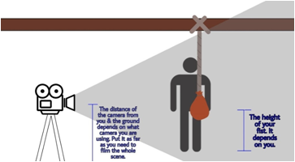

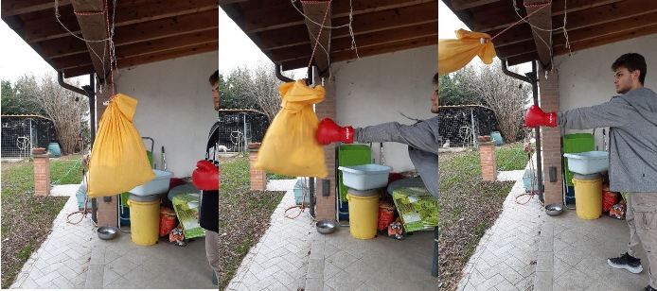
Measure the weight of the sack. Our's is 2.8 kg. The sack filled up with tatters is the boxing ball, so we hang it high somewhere so it can oscillate after being punched, and then we film while we punch it multiple times with and without the glove.Pay attention: it should not rotate and your punch must follow a straight path, to track it better.

After this we use Tracker to determine the speed of the fist before the collision, the velocity of the boxing ball immediately after the collision, and the height reached by the boxing ball.

- DATA ANALYSIS and DISCUSSION
  - Observations and Measurements:
 | Hmax  (m) | Vi fist  (m/s) | Vfball  (m/s) | K i  (J) | U f  (j) | Aball  (m/s²) | Fball  (N) | ∆t  (s) | ∆p  (kgm/s) | I  (N s)
No glove | 0,7 | 2,6 | 3,7 | 2,9 | 3,0 | 36,9 | 15,7 | 0,1 | 1,6 | 1,6
glove | 0,5 | 2,8 | 3,4 | 2,4 | 2,2 | 33,3 | 14,2 | 0,1 | 1,4 | 1,4
m=0,427 kg
Hmax=the maximum variation of the ball’s height, measured with a meter
Vi fist= estimated with tracker
Vf ball= estimated with tracker
Δt= the time it takes to the ball to reach the maximum velocity, estimated with tracker
K= ½⋅m⋅v²
U= m⋅ g⋅ h
Aball= Δv/ Δt but you can also estimate it with tracker
F ball= m ⋅ a
I= F ⋅ Δt

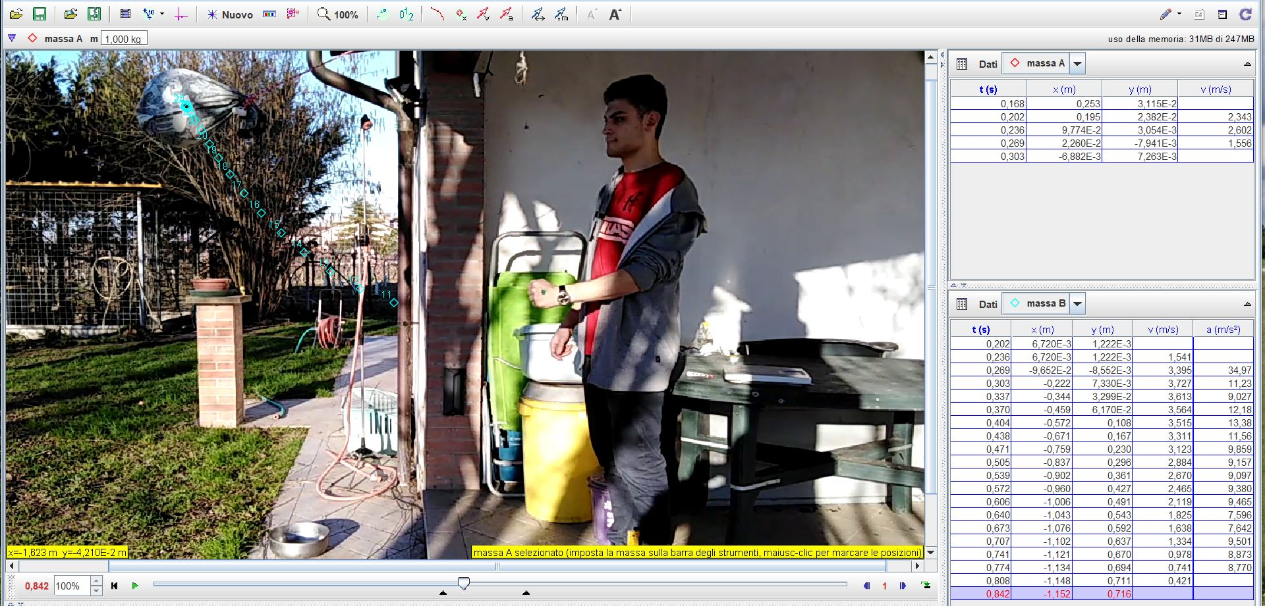 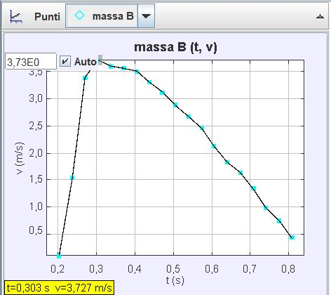Graph Velocity vs. time without the glove

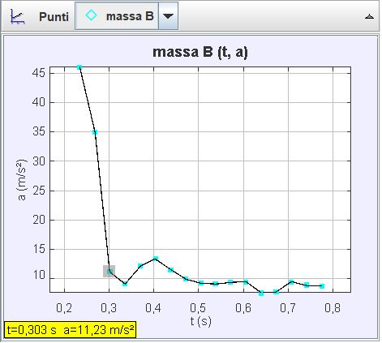 Graph Accelleration vs. time without the glove
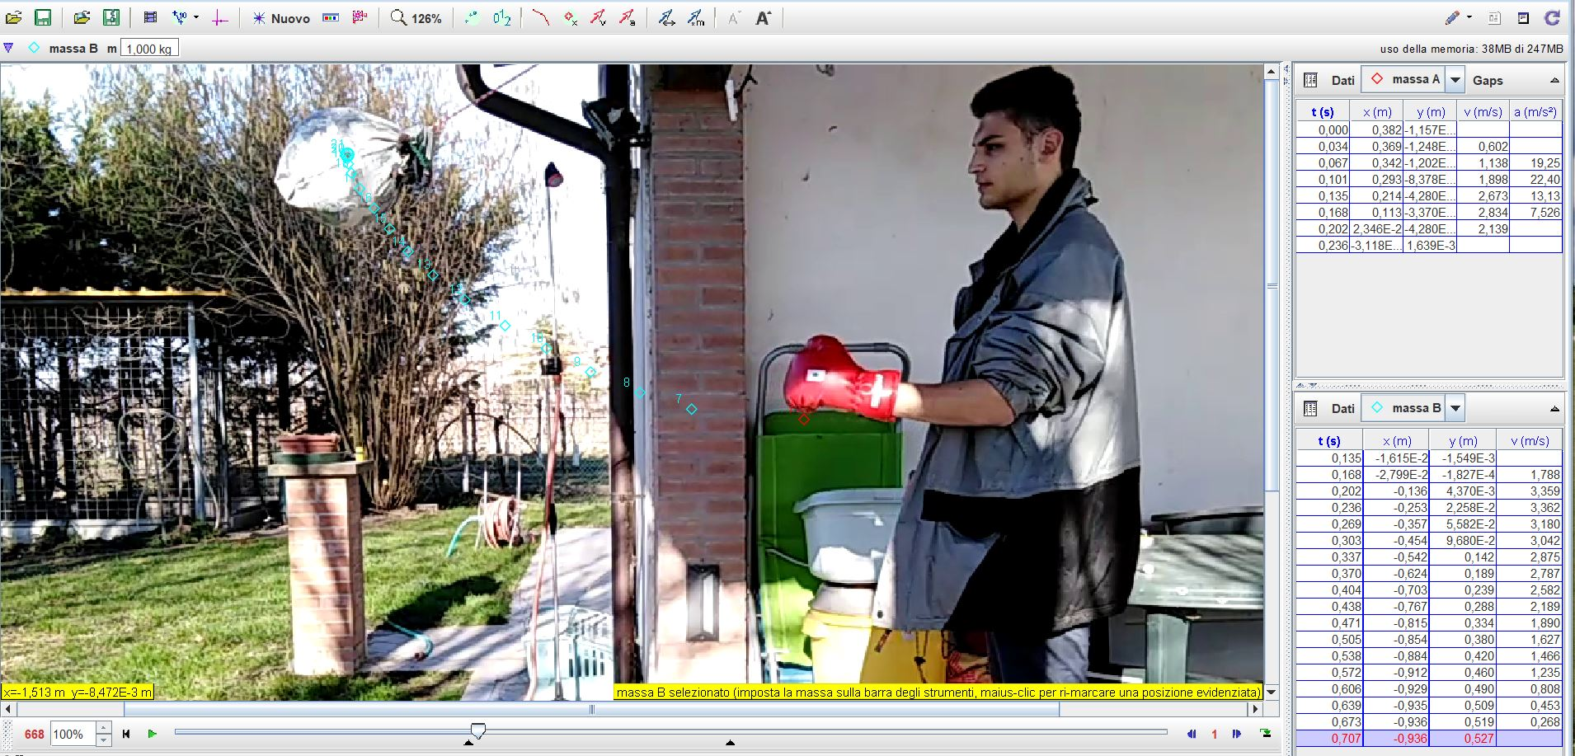
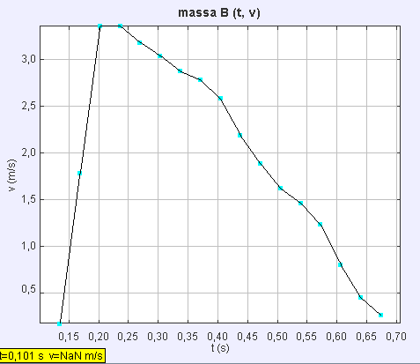Graph Velocity vs. time with the glove
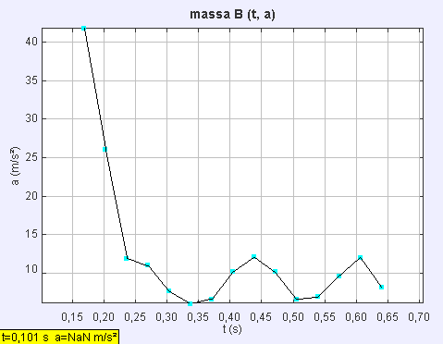 Graph Accelleration vs. time with the glove
The hit with the glove creates less movement because of the shape of the ball. In fact with the glove the energy is shared on a bigger area but part of the energy is wasted because you hit just with a part of the glove.
With the glove the hit is less elastic in fact it absorbs part of the energy making the hit more anaelastic.

3.1 Discussion:
Now with our personal data we can verify the Impulse-Momentum theorem experimentally, in fact:
No glove: (15,76 Kg m/ s²) ⋅ (0,101 ) s = 1,592 N s
F ⋅ ∆t = I
With glove: ( 14,21 Kg m/ s² ) ⋅ (0,101) s= 1,435 N s
FΔt= m⋅Δv =m⋅(v 2–v 1)=m⋅v 2–m⋅v 1=p 2–p 1=Δp

- REFLECTION
  - Conclusion:
  - Comparison of the results of the different countries
  - Reflection:

- REFERENCES

