 | TEAM: 7
 | Belgium | Sien Gryspeert, Leonita Zeqiri, Victor Van Win and Arne Vercruysse
Smashing! Real-world clashes into physics classes | Italy | Giulia Albanese, Pietro Carnevali and Caterina Zaccari
EXPERIMENT:
- ORIENTATION
  - Research question:
If you drop balls with different mass, but of the same material, from the same height, will their mass affect the impact of the collision?
Sub-questions:
1) What force will be exerted on the sand by the different balls?
2) What work will the sand do on the different balls?
  - Hypothesis
The greater the mass of the ball, the greater the force exerted during the collision, so the greater the impact of the collision.
- PREPARATION
  - Material:
•Plasticine ● Weights with different masses •Flour
•Meterstick ● Plastic container
•Metallic support
● Polystyrene ball with a hole
=> (weight 11,5 g)
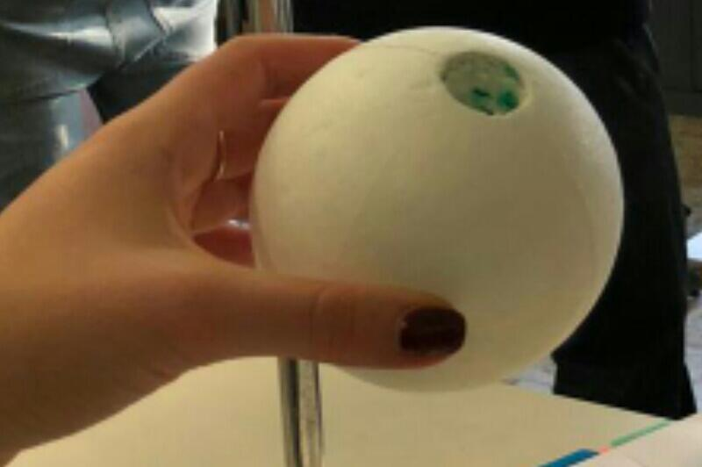

2.2. Method:
•The experiment consists on dropping a polystyrene ball from an assigned height. The ball has got a hole (1), where it’s possible to insert different weights and plasticine, thus varying the mass (2). The ball is dropped in a plastic container ¾ filled with flour (repeat the procedure two times for each mass).
•Observe the impact and measure its depth with a meterstick.
•Repeat the same procedure increasing the mass of the ball.
•Regarding the analysis part, use inverse equations of the laws of dynamics to calculate the acceleration and the interaction time between the balls and the flour during the fall, having the depth of the impact and the height of the fall.
•Use the acceleration for each mass to calculate the total force on the ball with the second Newton's law and the force on the flour by the ball with the third Newton's law.

2) 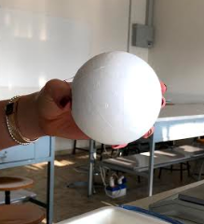 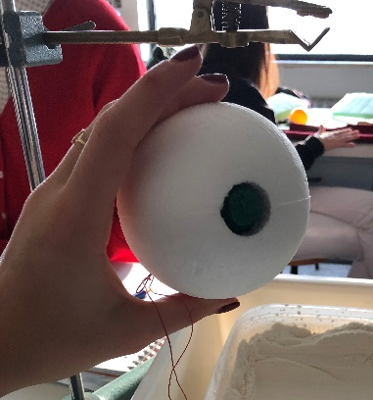 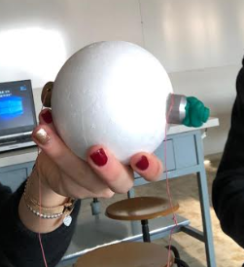
m = 30 g m = 60 g m = 120 g

- DATA ANALYSIS and DISCUSSION
  - Observations and Measurements:

  - Discussion:

- REFLECTION
  - Conclusion:
  - Comparison of the results of the different countries
  - Reflection:

- REFERENCES

