 | TEAM:3
 | Belgium | Ibe Decock, Daan Demaecker, Thijs Bruynooghe, Andreas Maton and Lore D’hulster
Smashing! Real-world clashes into physics classes | Italy | Sara Gentilini, Viviana Matei and Rebecca Capelli
EXPERIMENT: Collision of petanque balls
- ORIENTATION
  - Research question:
- How much force is necessary to bounce the other ball away?

Sub-questions:
- At what angle should a slope be placed in order to bounce another petanque ball on a flat surface away?

- How much speed does the first ball need so that the second would roll away?

- How much energy is transferred to the second ball?

- Examine the Impulse-Momentum theorem for the second ball.

  - Hypothesis
The bigger the force of the rolling ball the further the other ball will bounce away.
The first ball must have only a small amount of speed before the second ball will roll away.
The smaller the angle the further the ball will bounce away.
The amount of energy that passes to the second ball will be equal to the amount of energy that the first ball possesses.

- PREPARATION
  - Material:
  - Ramp
  - 2 petanque balls (mass 1: 215,8 g; mass 2 : 219,8 g )
  - Wood thickness ( put it under the ramp)
  - Concave plastic rod
  - Sponge
  - Balance
  - Long ruler
  - Cloth
  - Motion sensor

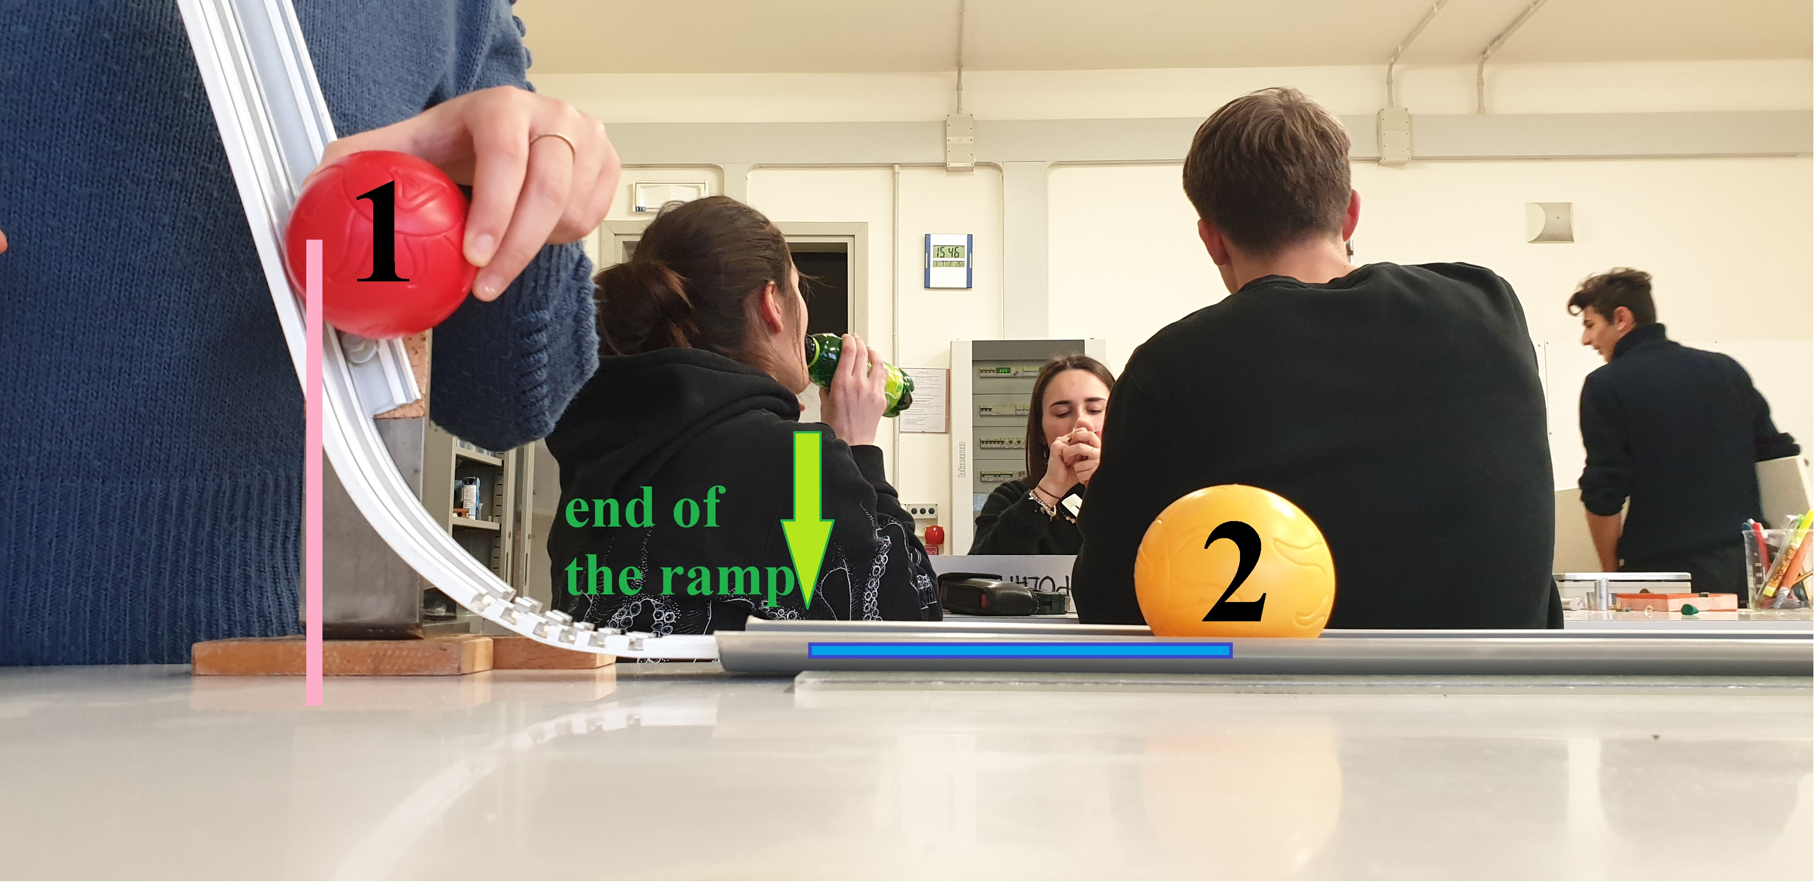
  - Method:
- With the first surface we use the concave plastic rod. Place the ball 1 at a certain high on the ramp. See the figure where you are doing the experiment, from the end of the ramp place the ball 2 a certain distance. With the motion sensor measure the speed of ball 2 and estimate the speed of ball 1 from its initial potential energy.
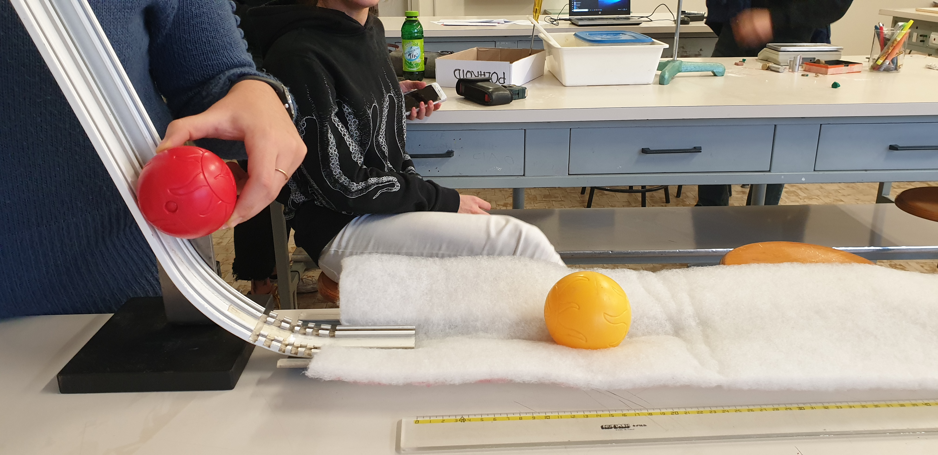
- With the second surface use a sponge (see the figure) and place it at the end of the ramp. Do the same procedure performed with the first surface and write down the data obtained.
2
1

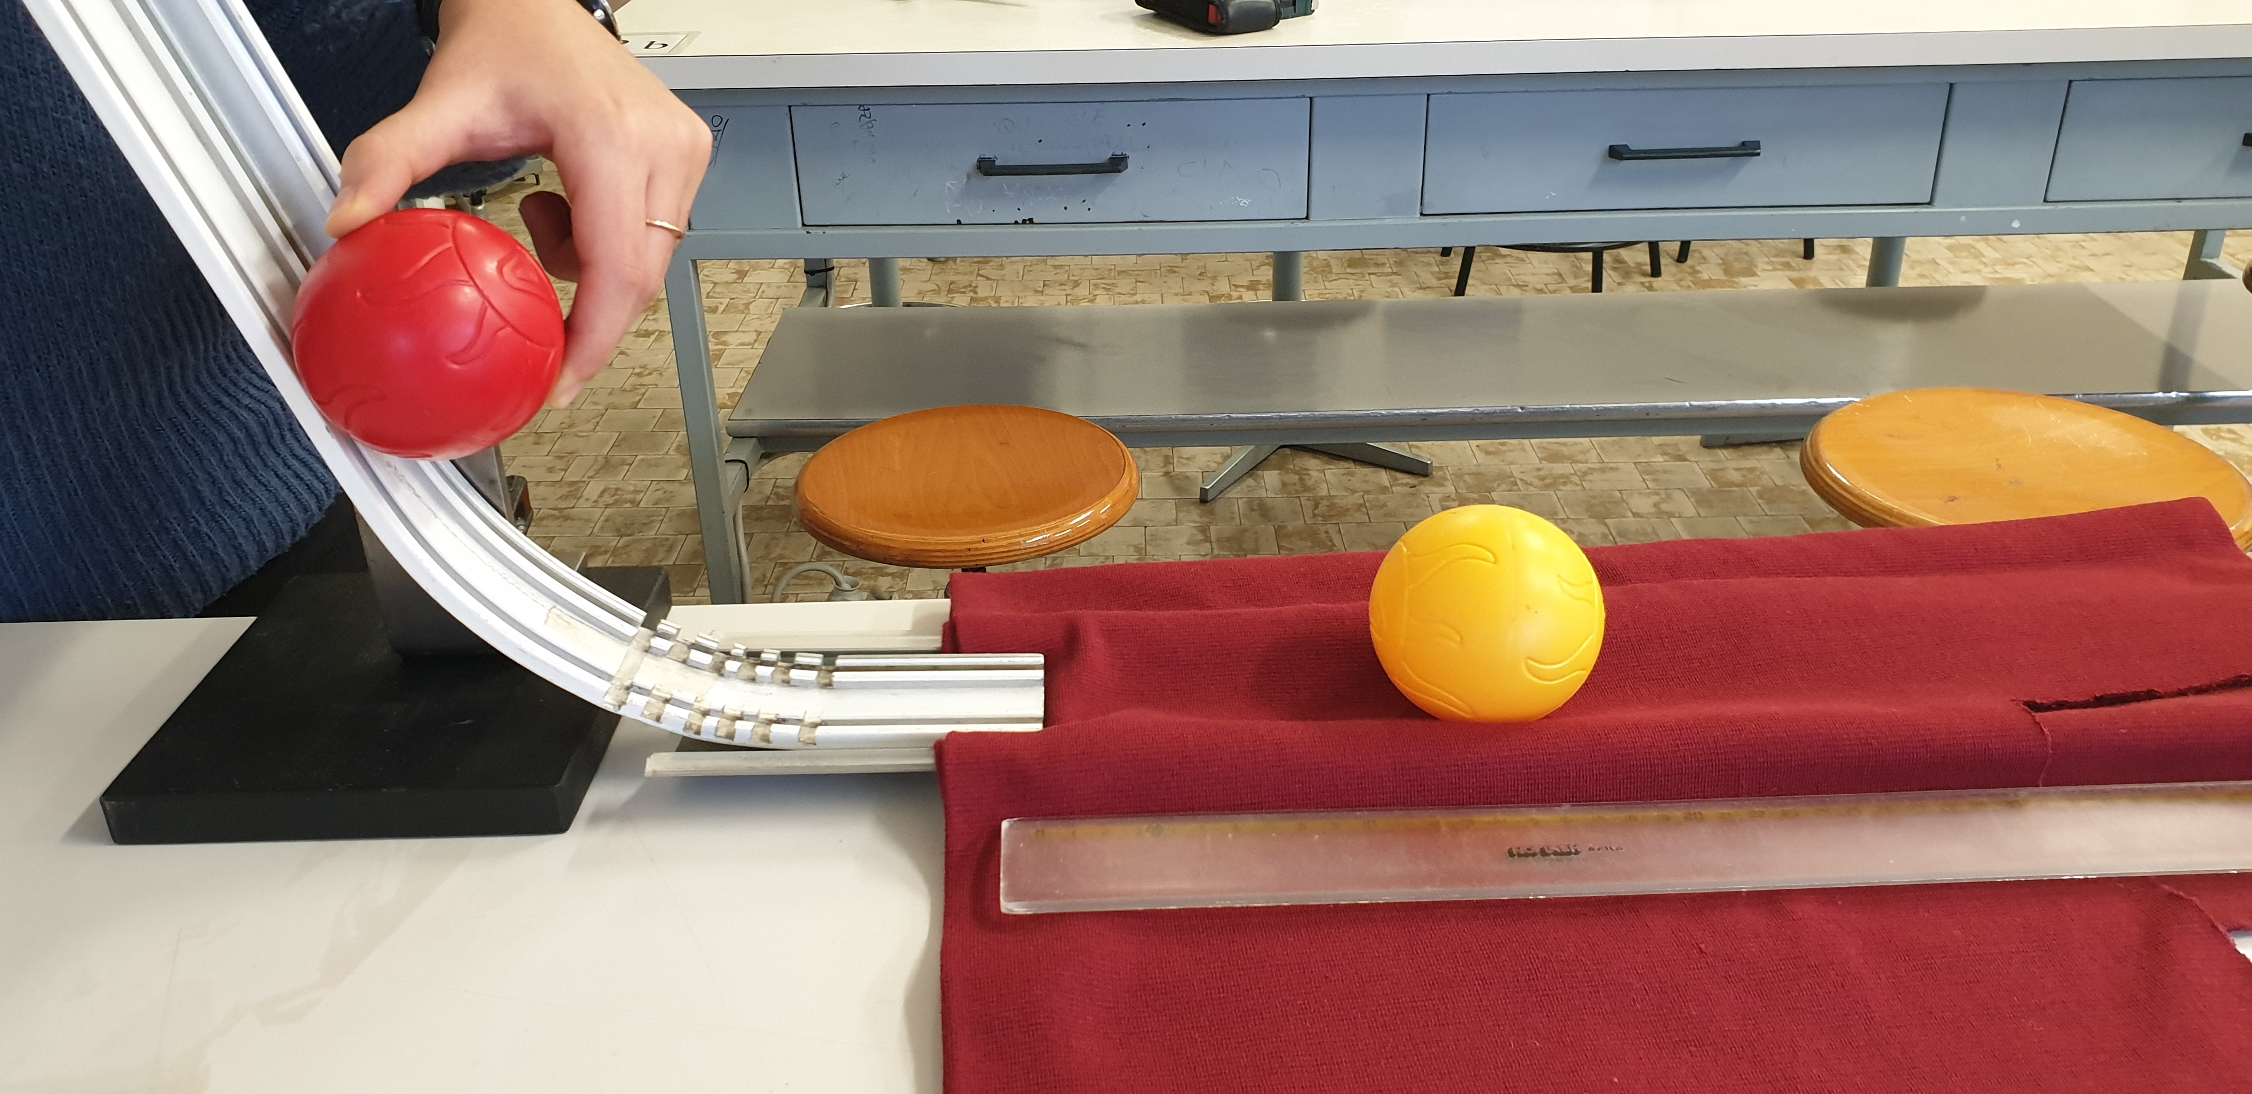
- With the third surface use a cloth and place it a little bit under the ramp so it won’t move when the balls will roll. Do the same procedure performed with the first surface and write down the data obtained.
2
1
- Calculate the transferred momentum and energy (from the velocities V_{1i} and V_{2f}).
- From the graph a₂(t) (obtained by the motion sensor) estimate a limit for the interaction time Δt and use the Impulse-momentum theorem to estimate a limit to the mean force.

- DATA ANALYSIS and DISCUSSION
  - Observations and Measurements:

  - Discussion:

- REFLECTION
  - Conclusion:
  - Comparison of the results of the different countries
  - Reflection:

- REFERENCES

