 | TEAM: 5
 | Belgium | Anna Huysman  Charlotte Vanhoutte  Elien Wallican  Emma Vandendriessche
Smashing! Real-world clashes into physics classes | Italy | Rambelli Alessia  Sartoni Elena  Sartoni Serena
EXPERIMENT: The collision of a tennis ball
- ORIENTATION
  - Research question:
- If we hit a tennis ball once with a tennis racket, once with our hands and once with a baseball bat, which equipment will cause the biggest impact on the ball?

Sub-questions:
- How come is the impact the greatest with that equipment?

  - Hypothesis
We think that the impact of the tennis ball will be greatest with the tennis racket, because a tennis racket is specially designed for a tennis ball to make it go fast. because the racket has strings, we can give more powerful strokes and more controlled.

- PREPARATION
  - Material:
- 1 tennis ball (mass=6,6x10⁻²kg)
- 1 tennis racket (mass=2,18x10⁻¹kg)
- 1 cricket bat (mass=3,40x10⁻¹kg)
- a hand
- a scale
- Software Tracker
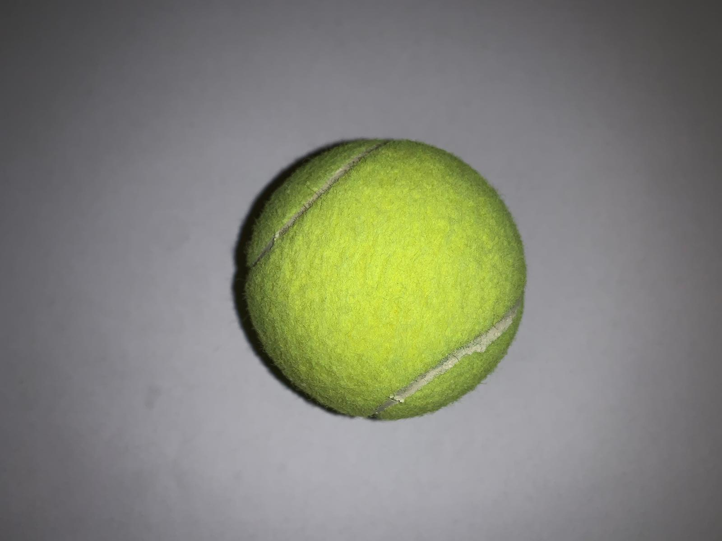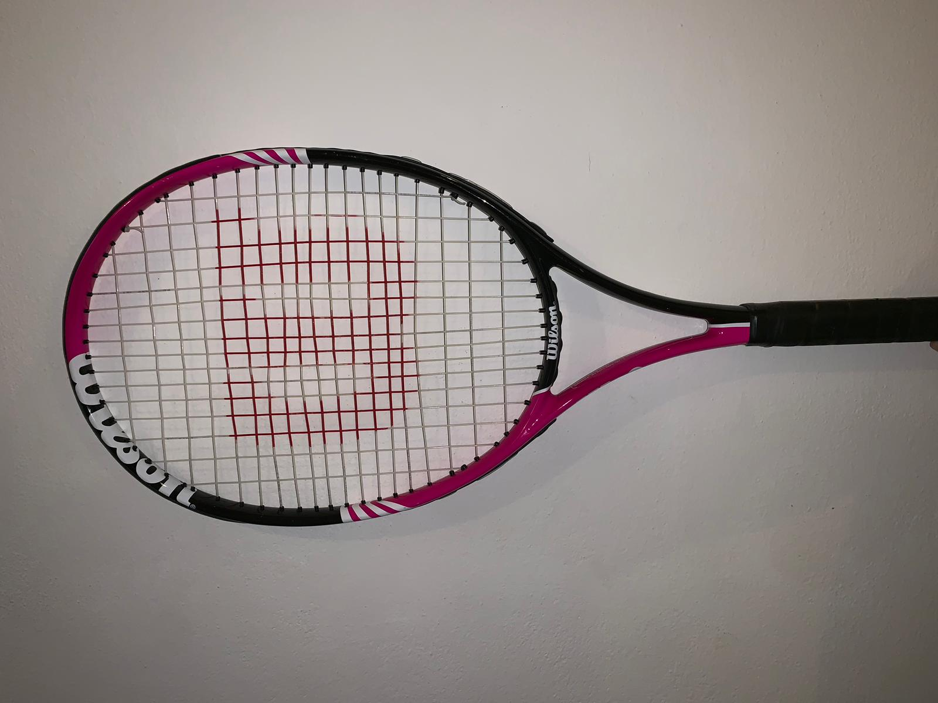
tennis ball cricket bat tennis racket

  - Method:
- Weigh all the materials with the scale.
Make a video of sequence 2-5.
- Throw the tennis ball with a hand making a parabolic motion.
- Hit the tennis ball with the tennis racket, possibly making a straight motion.
- Repeat the action once with the cricket bat and once with the hand.
- Repeat it many times until the initial speeds of the ball are as similar as possible in all the three cases.

- Finally calculate the speeds of the tennis ball, the tennis racket, the cricket bat and the hand before and after the collision, using the Software Tracker and select the videos with similar initial speed.
- Discuss the conservation of total momentum and the impulse-momentum theorem.
- Discuss in which of three cases the momentum transfer to the ball is largest.

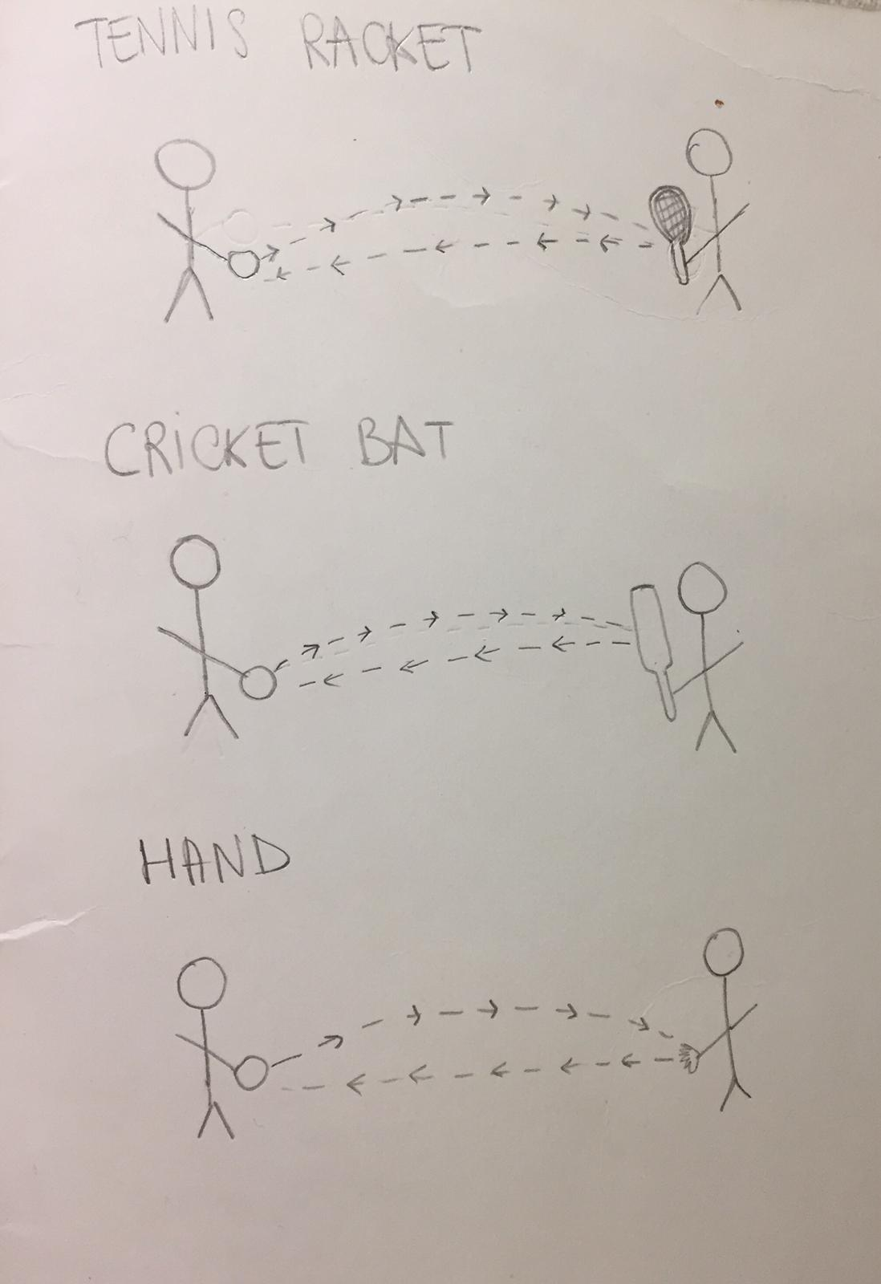

- DATA ANALYSIS and DISCUSSION
  - Observations and Measurements:

  - Discussion:

- REFLECTION
  - Conclusion:
  - Comparison of the results of the different countries
  - Reflection:

- REFERENCES

