 | TEAM: 6
 | Belgium | Kaat Keymeulen  Fleur Tack  Rob Delmotte  Karsten Maselis
Smashing! Real-world clashes into physics classes | Italy | Jessica Cenni  Elena Tognetti  Filippo Servidei
EXPERIMENT: Newton’s Cradle
- ORIENTATION
  - Research question:
If you move one balls of Newton’s cradle and make it collides with the other. It goes on for a while. Is there energy loss during the collision?
Sub-questions:
Is the height of the balls the same on both sides?

  - Hypothesis
Because the bolls smash against each other they lose energy. The air-resistance may also play his part. Because of this energy loss the bolls will lose their speed and height.
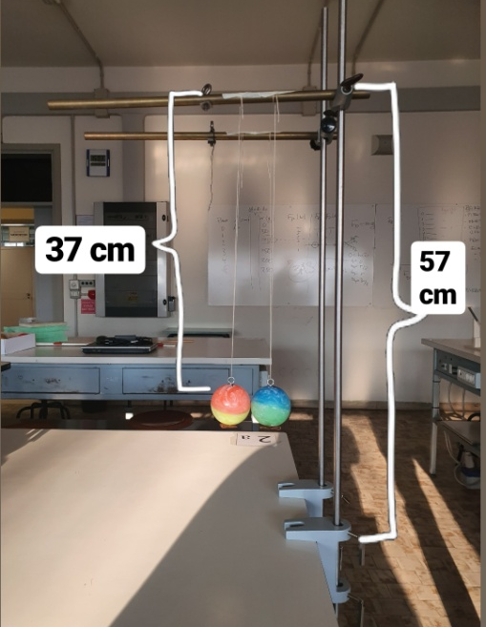
- PREPARATION
  - Material:
- 2 bouncing rubber balls with the same size
- 2 very thin twine threads
- Scotch tape
- 4 iron bars ( 2 bars 1 meter long)
- 2 iron hooks
- 2 supports for iron bars
- 2 supports for connecting the vertical bars with the horizontal bars

2.2 Method:
- Set the supports to the table and insert the 1 meter long iron bars so that they are 14 cm away from each other.
- Place the supports to connect the vertical bars with the horizontal bars so that the small horizontal bars are 57 cm from the table.
- Attach the hooks to the two balls and tie them with the string of twine to the two horizontal bars. Adjust the height of the hooks to 20 cm from the table.
- Fix the strings to the small bars with adhesive tape at a distance equal to the diameter of the balls.
- Launch one of the two balls and make a video of the motion.
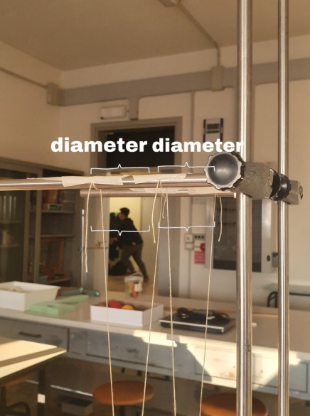
- Make the video with a good camera on a pedestal, (the camera should be firm).
- Analyse the video with the software Tracker to extract the velocities and positions of the balls.
- Study the conservation of total moments and total kinetic energy.
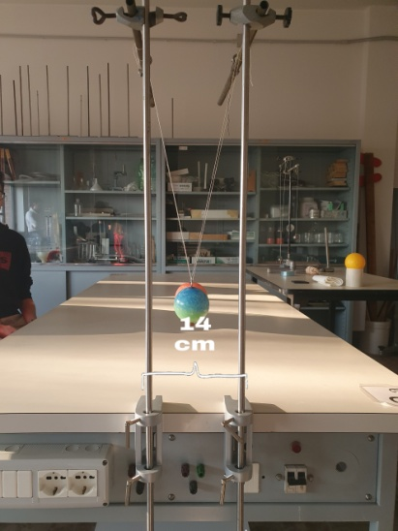

From another point of view

- DATA ANALYSIS and DISCUSSION
  - Observations and Measurements:
Graphs of pupils from Belgium:
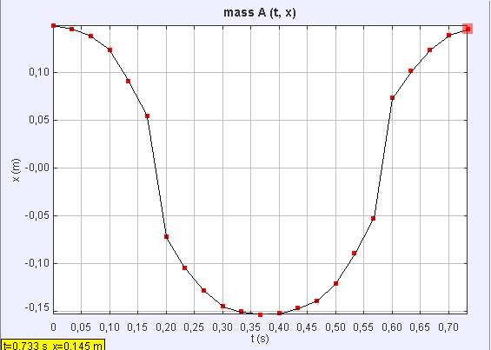
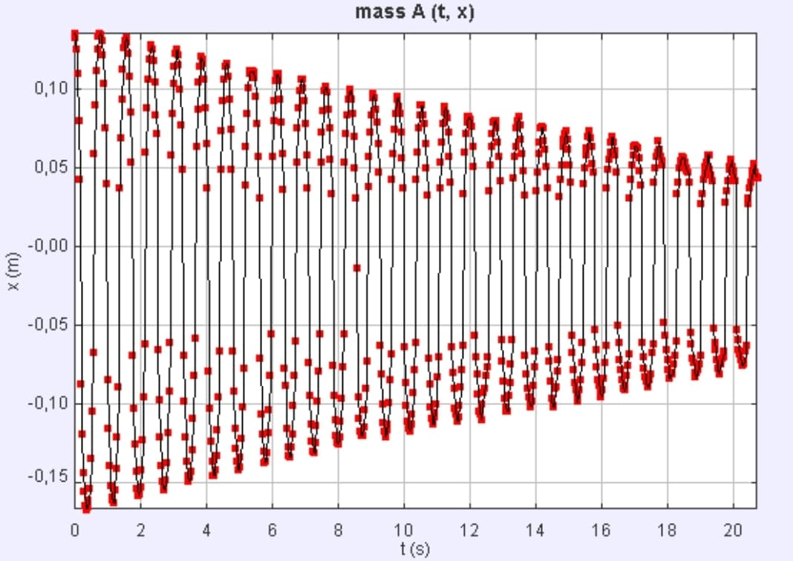
Fig.1. The x(t)-graph of one movement
Fig.2. The x(t)-graph of several movements.

Both graphs show a sort of sinus function. The first graph is one period of this function and the second graph shows us several period. But it is not perfect, because the last period doesn’t go up the same height as the first period.

Observations and Measurements from the Italians
After making the video, we have analyzed it with Tracker. This application allows you to find the various coordinates of the spheres in an instant of time or the various speeds. We have the origin of the Cartesian plane at the point where the two spheres touch each other. So we have chosen the unit of measurement thanks to the measuring rod, which we have positioned at the vertical metal rod and gave the value of 57 cm. We have fixed various mass points for each ball, to derive the displacement in x and y in the various time intervals during the course of the video. Then we have calculated the velocities of the balls before and after the impact, ΔP and the amount of kinetic energy that is lost during the impact. Thanks the position in y of the balls, we have calculated the potential energy for each sphere to arrive at the speed of each ball after the impact. Then we have calculated, thanks to the speeds previously found, the difference in kinetic energy to understand how much energy is lost during the impact and and we have checked if the P is preserved.
FORMULAS WE HAVE USED:
mgh = ½ mv²
p_{iB} = m_{B} v_{Bi =} p_{iTOT}
K_{i} = ½ m_{A} v_{Ai}² + ½ m_{B} v_{Bi}²
K_{f} = ½ m_{A} v_{Af}² + ½ m_{B} v_{Bf}²
ΔK = K_{f} - K_{i}
p_{i} = mV_{i}
p_{f} = mV_{f}
%= (ΔK / K_{f}) _{x} 100

  - Discussion:
In the graphs and particular in the second graph is it clear that there is energy loss during the collisions and during the movement of the ball. This is very clear because you see that the ball goes less and less high and the amplitude of the sinus function drops. This is because you have air friction. The one dot in the second graph who is in the middle is an fault during the use of Tracker and is not something the ball did.
The height of the balls on both side are not equal. This you can see in the first graph. The end of the function is a little bit lower dan the beginning. Also the second graph shows us clearly that the ball doesn’t go up that far as in the beginning.
Calculations from the Italians:
BLUE BALL =mass B = 0,1kg h_{B} = 0,14 m
- mgh = ½ mv² → 0,1kg _{x} 9,81 N/kg _{x} 0,14m = ½ 0,1kg _{x} v² →
v_{Bi} = √0,1kg _{x} 9,81 N/kg _{x} 0,14m / 0,05kg = √0,13734 Nm /0,05kg =√2,7468 = 1,66 m/s

RED BALL =mass A = 0,1kg h_{A} = 0,114 m
- mgh = ½ mv² → 0,1kg _{x} 9,81 N/kg _{x} 0,114m = ½ 0,1kg _{x} v² →
v_{Af} = √0,1kg _{x} 9,81 N/kg _{x} 0,114m / 0,05kg = √0,11834 Nm / 0,05kg = √2,23668= 1,5m/s

V_{Ai} = 0 m/s V_{Af} =1,5 m/s V_{Bi} = 1,66 m/s V_{Bf} =?

- p_{Bi} = m_{B}V_{B} = p_{TOTi} → p_{Af} + p_{Bf} = p_{TOTf} = p_{TOTi} → m_{B}V_{Bi} = m_{A}V_{Af} + m_{B}V_{Bf} → V_{Bf}=(m_{B}V_{Bi} - m_{A}V_{Af})/ m_{B}
V_{Bf} = (0,1kg _{x} 1,66 m/s – 0,1kg _{x} 1,5 m/s) / 0,1kg = (0,166 kgm/s – 0,015 kgm/s) / 0,1kg = 0,016 kg/ms / 0,1kg = 0,16 m/s

V_{Ai} = 0 m/s V_{Af} =1,5 m/s V_{Bi} = 1,66 m/s V_{Bf} =0,16m/s
- ΔK = K_{f} - K_{i}
K_{i} = ½ m_{A} v_{Ai}² + ½ m_{B} v_{Bi}²= ½ _{x} 0,1kg _{x} 0m/s + ½ _{x} 0,1kg _{x} (1,66 m/s)² = 0,13778 J
K_{f} = m_{A} v_{Af}²+ ½ m_{B} v_{Bf}²= ½ _{x} 0,1kg _{x} (1,5m/s)² + ½ _{x} 0,1kg _{x} (0,16 m/s)² = 0,11378J
ΔK = K_{f} - K_{i} = 0,11378J – 0,13778J = - 0,024J
%= (ΔK / K_{i}) _{x} 100 = (-0,024J / 0,13778J ) _{x} 100= - 17,4%
- Δp_{A} = p_{Af} – p_{Ai} = m_{A}v_{Af} - m_{A}v_{Ai} = 0,1kg _{x} 1,5 m/s – 0,1kg _{x} 0m/s = 0,15 kgm/s
Δp_{B} = p_{Bf} – p_{Bi} = m_{B}v_{Bf} - m_{Bi}v_{AiBi} = 0,1kg _{x} 0,16 m/s – 0,1kg _{x} 1,66m/s = - 0,15 kgm/s
Δp_{TOT} = 0 kgm/s
- We can estimate the mean force during the collision from the
impulse-momentum theorem:
I = F_{m x} Δt → F_{m} = I / Δt_{int}
I = Δp → F_{m} = Δp/ Δt_{int}
From the video we see that Δt_{int} << Δt_{frame} = 0,132 s
Thus we obtain:
F_{m} >> Δp / Δt_{frame} = 0,15 kgm/s / 0,132 s = 1,1 N

REFLECTION
  - Conclusion:
The conclusion you can take out of this experiment is that you have energy loss during the collision of the balls of Newton’s cradle. During the movement of the cradle, the height of the balls decreases. This is because of the air friction.
After the analysis of the video we can say that we lost kinetic energy due to the throw of the ball that could have been not exactly straight and to the two balls, that don’t have the same characteristics of the classic iron balls of the Newton’s cradle.

  - Comparison of the results of the different countries
The Italians made their own cradle, so it’s normal that the results are different from the results of the Belgians. The cause of the loss of kinetic energy is air friction. The balls that are not the classic iron balls, and the throb that could have been not exactly straight caused more energy loss by the self- made cradle. The rest of the results are the same.

- REFERENCES

