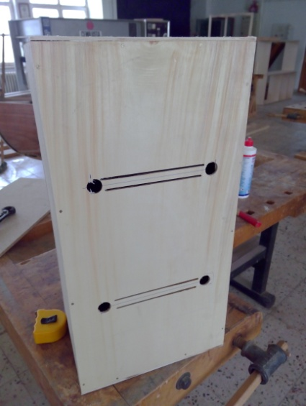
Required Materials
- Slim Wood (100*100 cm)
- Wood (200*200 cm)
- Wood Adhesive
- Strings of Instrument
- Nail
- Screw

Step 1
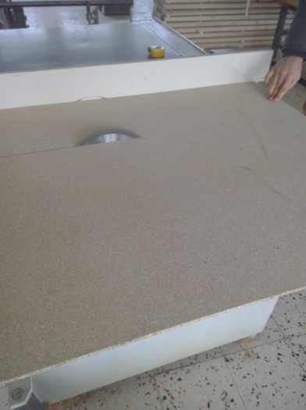
Wood is cut for base and lateral surfaces.

Step 2
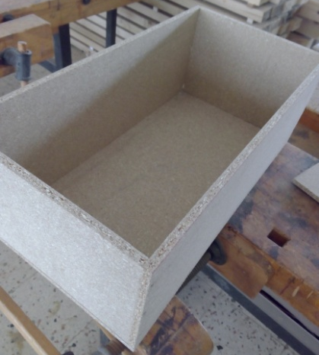
Interrupted surfaces are nailed

Step 3 (Make Upper)
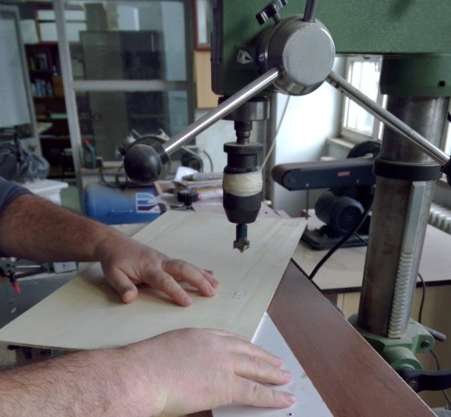
Mixed Guitar’s upper is cut and it’s holes are opened.
Step 4
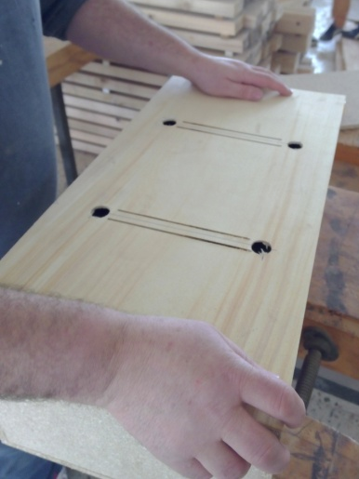
Upper is nailed to the box which had made before.

Step 5 (Make Bridge)
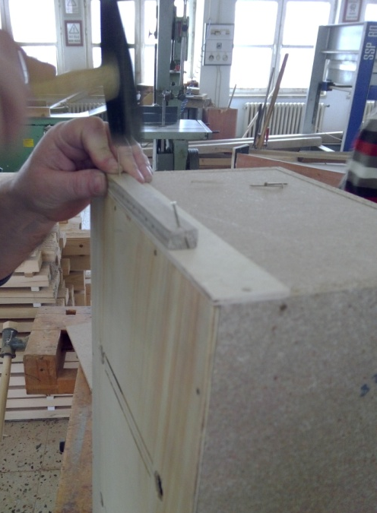
The lower bridge is holed to pass the strings and nailed to the side of the box.

Step 6 (Make Pegbox)
Roller stick is cut each 4 cm, inside of them are carved.
Pegboxes are holed to pass the string

Step 8
Strings are attached on the bridge by streching.

